2.3.4.8.4.6 Pure Methods
Return to Operation Data

Overview
Return to Top
Pure methods are limited to are often referred to as Pure Functions. Pure Functions are a cornerstone in Functional Programming and are designed to produce no Side Effects. Pure Functions are characterized as follows1):
Are dependent only onDeclared input parametersAlgorithm to be implementedValues within the scope of the function, therefore, it can notDepend on accessing any values defined outside the function scope (i.e., another field in the same class, or global variables)Modify mutable values outside the function scope (i.e., other fields in the same class, or global variables)Use external input or output (I/O). It can’t rely on input from files, databases, web services, UIs, etc; it can’t produce output, such as writing to a file, database, or web service, writing to a screen, etc.Do not modify input parametersFigure provides a graphic representing a Pure Function. Basically, the Pure FUnction is an isolated piece of logic that given the same input always produces the same output. Its isolation means it has no unintended side effects outside of itself and only the inputs determine the processing. Another way to think of a Pure Function is at their center there is a Deterministic Algorithm (Also see Black Box Testing).
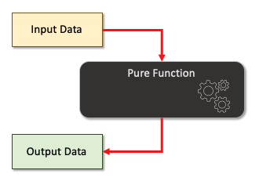
Pure functions
In some languages (i.e., C, C++, Rust, PHP, JavaScript/ECMAScript), it is possible to have methods (i.e., procedures or functions) existing outside the class container. Java and C# require operations to exist within a class container, and therefore do not support General Methods. C++ does not recommend having General Methods outside of a class, but because C++ is more or less an extension of C, it does support them.
Often, the architecture and design of Functional Programs depends on the identification, design and creation of pluggable, reusable functions. Many of the frameworks used in modern applications reaching across many tiers rely heavily on stateless, client-server Representational State Transfer (REST) models and Command Line Interfaces (CLIs) .
Figure graphically represents pure functions used in a Functional Program.
The pure functions used in the Functional Program are identified (See items A, B, and C)The functions are from a reuse repository (i.e., library), or they can be created especially for the new Functional ProgramThe Functional Program is responsible for the lifecycle of each data element (i.e., State Variables)The order of the functions is established in the Functional ProgramThe association is made of the functions with appropriate the State Variables (which are Input Data and which are Output Data)The Functional Program is executed:The Functional Program is startedCalls are made to the functions in the desired order (i.e., steps 2-4) and the State Variable values are passed into or out of the functionsThe Functional Program is terminated
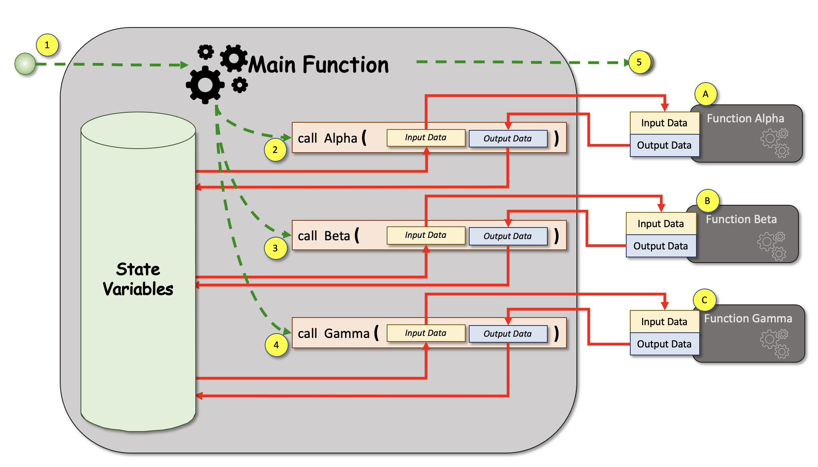
The use of pure Functions in a Functional Program

DIDO Specifics
Return to Top
Ethereum's Solidity is an Object-Oriented Programming (OOP) supporting four closely related object container types (Java and C++ have just one class):
contract | Contracts, in Solidity, are similar to classes in object-oriented languages. They contain persistent data in state variables and functions that can modify these variables. Calling a function on a different contract (instance) will perform an EVM function call and thus switch the context such that state variables in the calling contract are inaccessible. A contract and its functions need to be called for anything to happen. There is no “cron” concept in Ethereum to call a function at a particular event automatically.
interface | Interfaces are similar to abstract contracts2), but they cannot have any functions implemented. There are further restrictions:  They cannot inherit from other contracts, but they can inherit from other interfaces.All declared functions must be external.They cannot declare a constructor.They cannot declare State Variables.They cannot declare function modifiers modifiers.Some of these restrictions might be lifted in the future.  Interfaces are basically limited to what the Contract ABI can represent, and the conversion between the ABI and an interface should be possible without any information loss.  Note: The difference between an Interface and an Abstract Contract is the interface has no implementations for the function. And abstract contract can have some functions with implementations and some without implementations. The following is an examle Interface called EIP 20: ERC-20 Token Standard3).
library | Libraries, in Solidity, are similar to contracts, but they are deployed only once at a specific address and their code is reused using the delegatecall operation4) is a low level function similar to call.When contract A executes delegatecall to contract B, B's code is excuted with contract A's storage, msg.sender and msg.value. Solidity By Example, Versoin 0.8.10, Delegatecall, Accessed: 2 January 2022 )) feature of the Ethereum Virtual Machine (EVM).  Therefore, when a library functions are called, the code is executed in the context of the calling contract, i.e. this points to the calling contract, and especially the storage from the calling contract can be accessed. A library is an isolated source code and only has access State Variables defined by the calling contract when the variables are explicitly supplied. Library functions are only called directly (i.e. without the use of delegatecall) when the function does not modify the state (i.e. in other words, the functions are view or pure functions).  To contracts that use Libraries, the library behaves as base contracts. The libraries are not explicitly visible within the inheritance hierarchy of the derived contract, but calls made to the library functions appear calls to functions of explicit base contracts and require the use of qualified names such as Library.function(). Naturally, calls to internal functions follow the usual internal calling convention allowing all internal types to be stored stored in memory raather than passed by reference (i.e., not copied).  An example:
struct | Structures, in Solidity, is not unlike a simple struct in C, C++ or C#. Sometimes, structs are thought of as a contract that does not allow the inclusion of functions in the definition. In other words, it is a datatype that is a collection of other datatypes referenced by a single name.Structs are defined as stand-alone entities in Solidity, or they can be encapsulated within a library or a contract. Structs declared outside a contract facilitates reuse.Struts are generally contiguous memory and can be used in collections such as arrays. An example:
does have support defining and using General Methods, those functions not directly pertaining to the Smart Contract, but can be used by the smart contracts but it does support being able to create libraries of reusable functions that support a way to provide operators for specific types.

Pure Functions
Return to Top
Ethereum's Solidity has a special label to identify functions that qualify for the pure classification meeting the definition of Pure Function given earlier. Not surprisingly, they are identified with pure label. The purity rules are enforced by the Solidity compiler. The pure function in solidity can be thought of as a black box and only relies on the data pased into it for processing. It can use local variables defined within the pure function. The compiler throws an error if the pure function tries to5):
read or update State Variablesaccess the contract's addressacccess the contract's balanceaccess any global variable blockaccess the msgcall a function that is not pureIn the below example, the contract Test defines a pure function to calculate the product and sum of two numbers.

Libraries
Return to Top
As of Solidity 8.1, it is possible to defines a library. A library is a kind of contract, that has no Ethereum Storage associated with it and in addition, it cannot hold ether. One way to think bout a solidity library is as a Singleton in the Ethereum Virtual Machine (EVM). In other words, it is a piece of code callable from any contract without the need to redeploy it. 6)
Libraries in Solidity contracts are blocks of reusable code containing functions usable by other contracts on the blockchain network. When used correctly, libraries support modular, Object-Oriented Programming (OOP) designs.
The main advantage of using library is code reusability across multiple contracts preventing duplication of code and the reuse of testing snd documentation of the code. In addition, libraries save on gas by not deploying the code multiple times on the blockchain.
Libraries are a special form of contracts with the following restrictions:
Are singletonsNot allowed any storage or state variables that changeCannot have fallback functionsHave no event logsDo not hold etherAre statelessCannot use destroyCannot inherit or be inheritedLibraries allow for the addition of functionality to the basic types (i.e., uint) or complex user defined types (i.e., struct). Libraries are isolated from other blocks of code (i.e., contracts) that have no rely on the storage (i.e., state variables) from the calling contract and supplied to the functions.7)
Libraries support different Data Types:
User defined strutUser derinde enumUser defined immutable variables (i.e., constant)Note: Library constants become part of the Bytecode rather than in storage (i.e., not as variables on the blockchain itself)

Example of Defining a Library
Return to Top
The following code provides examples for:
Creates a library called StudentRecord (Line 4)Creates a user defined type (i.e., struct) defining a StudentRecord concept adding the following fields: (Lines 5-9)name (Line 6)studentNumber (Line 7)totalClassPoints (Line 8)Defines a function named addPoints that accepts two parameters (Lines 11-17):An instance of a StudentRecord in storage (Line 12)The earnedPoints to add to the students record (Line 13)The actual calculation of the students totalClassPoints (Line 16)The end of the definition of addPoints functionEnd of the definition of the library (Line 17)

Example of Importing and Using a Library
Return to Top
In the example, the library code is saved iin the same file as contract MyClass. It could be stored in a separte file and then imported iinto the contract MyClass file. If the StudentLibrary file is kept in its own file in the same directory as the contract MyClass file StudentLibrary.sol.
In the folowing exaple, both the import and the using are used:
The entirity of the library StudentLibrary is replaced by an import statement (Line 4)The Using statements extends the instances of StudentRecord with the operations iin the StudentLibrary (Line 7)The code is modified to use the cleaner, more easily read StudentLibrary defined function (Lines 11-13)This form of defining and using a library facilitates the reuse of the library by multiple Smart Contracts, helps with the maintenance by only having the code defined once, and helps with creating Object-Oriented (OO) architectures and designs.

1) Alvin Alexander, AlvinAlexander.com, The Definition of “Pure Function”, Accessed: 30 December 2021, https://alvinalexander.com/scala/fp-book/definition-of-pure-function/
2) Abstract contracts are contracts that have at least one function without its implementation. An instance of an abstract cannot be created. Abstract contracts are used as base contracts so that the child contract can inherit and utilize its functions. GeeksForGeeks, Solidity – Abstract Contract, 13 July 200, Accessed: 2 January 2022, https://www.geeksforgeeks.org/solidity-abstract-contract/
3) Crypto Market Pool, Blockchain Engineer Resource, Interface in Solidity smart contracts, Accessed: 2 January 2022, https://cryptomarketpool.com/interface-in-solidity-smart-contracts/
4) delegatecall
5) GeeksForGeeks, Solidity – View and Pure Functions, 13 July 2020, Accessed: 2 January 2022, https://www.geeksforgeeks.org/solidity-view-and-pure-functions/
6) Jorge Izquierdo, Aragon Association, Library Driven Development in Solidity, 13 February 2017, Accessed: 28 December 2021, https://aragon.org/blog/library-driven-development-in-solidity-2bebcaf88736
7) Crypto Market Pool, Blockcahin Engineer Resource, Libraries in Solidity smart contracts, Accessed 28 December 2021, https://cryptomarketpool.com/libraries-in-solidity/

