4.1.1 Governance Requirements Model
Return to Requirements
In addition to this definition, requirements can be applied to various aspects of a project from a governance perspective. There are three different aspects of governance: Regulation, Execution and Compliance (See xapend.j_gov_model. 1)
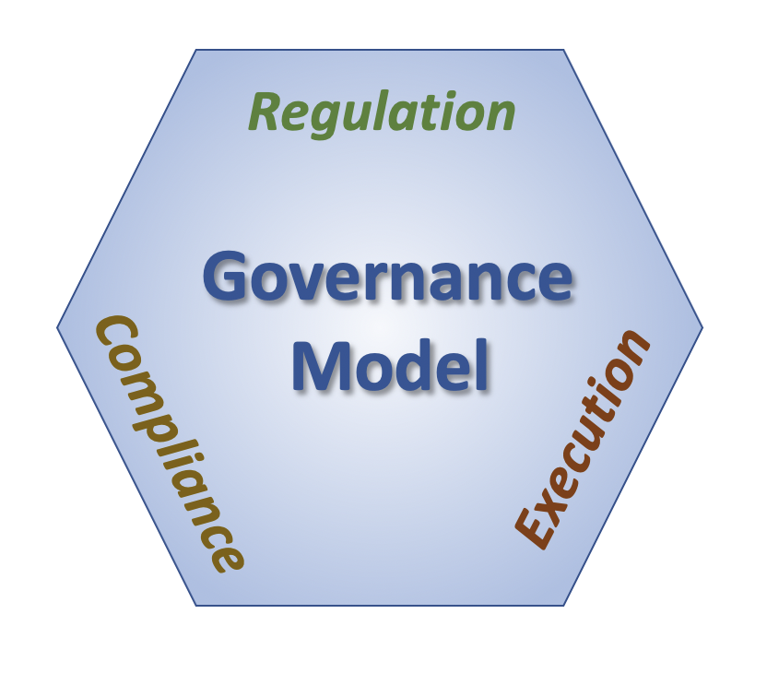
General Governance Model
Regulation covers the specification of the requirements of the product or service. This can be either formal government regulation such as U.S. ADA compliance2)3), or it can be project specific such as the contract or the technical specification of a contract or can be as detailed as the steps defined for a particular test plan.Execution covers the lifecycle of a product or service being governed (i.e., design, building, maintenance, etc). This covers the functional and non-functional requirements of the product or service and can be in terms of static or dynamic compliance pointsCompliance covers the oversight of the product or service being governed. This covers the not only the product or service itself but also the process of Regulation and Execution. For example, is the contract or technical specification well written and maintained throughout the lifecycle of the product or service. Understanding requirements is an important part of specifying, building, using and maintaining any product. And when the System is Distributed on multiple machines, supporting multiple stakeholders the need for the proper governance is essential. The requirements must cover all three aspects of governance. For example, there can be a requirement that is expressed in the regulatory aspect which requires reporting of information. The Compliance aspect will have a corresponding requirement that validate and verifies the reporting of the information. These are then also reflected in the Execution Aspect that has to have processes and systems designed to collect and report the proper data.

1) Stavros, Robert W. and Albrant, Jeremiah; Engineering Governance, SPAWAR, October 9, 2007,
2) ADA Website Accessibility Under Title II of the Americans with Disability Act (ADA) - ADA Best Practices Tool Kit for State and Local Governments, Website Accessibility Under Title II of the ADA, Chapter 5, https://www.ada.gov/pcatoolkit/chap5toolkit.htm
3) Accessibility of State and Local Government Websites to People with Disabilities, U.S. Department of Justice, Civil Rights Division, Disability Rights Section https://www.ada.gov/websites2.htm

