4.1.2 Cognitive Requirements Model
Return to About Requirements
In addition to the definition of a requirement and the specification of the requirements at each of the Governance Aspects, there is a need to further refine the requirements according to the level of specificity of the requirement. There are five different layers to specificity which are based upon the layers of the Cognitive Model. (See Appendix I: Cognitive Model).
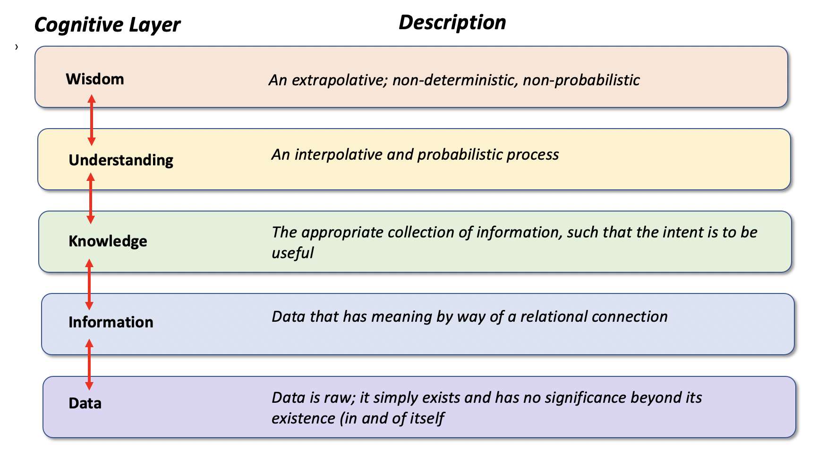
Cognitive Model
Wisdom - An extrapolative and nondeterministic, non-probabilistic concept which is built upon Understanding concepts.Understanding - An interpolative and probabilistic concept that reflects Wisdom conceptsKnowledge - A concept relating appropriate collection of Information concepts together, such that it's intent is usefulInformation - A concept aggregating data concepts together, in other words, Data that has been given meaning by way of relational connectionData - Data that is a raw concept; it simply exists and has no significance beyond its existence (in and of itself). It is the basis upon which Information concepts are builtThe flow between the cognitive layers is bidirectional and can have many-to-many relationships. For example, any particular Wisdom concept can be associated with any number of Understanding concepts. The inverse is also true; Understanding concepts can also be used to help support any number of Wisdom Concepts.

