4.1.4 Example of a Using the Combined Requirements Model
Return to About Requirements
The following is a Normative1) example of using the Combined Requirements Model to review requirements for any Federal Deposit Insurance Corporation (FDIC) regulation. The actual data may be invalid or based on some convenient assumptions but is included as an example of how the combined model can be used. ]
In the example, the regulation starts with Wisdom. Within Regulation, the Wisdom is the U.S. Code of Federal Regulations. Although we can make light of Federal Regulations as being Wisdom try and think about it this way: “when working within the confines of a government, it is not wise to ignore or marginalize regulation”. When working within the banking industry, Understanding is knowing that there are U.S. Federal Regulations that pertain to banking in general. Knowledge is to know the specific laws that pertain to the Area-of-Interest (AoI), in this case banking and Federal Insurance covering banking(i.e, FDIC). There is knowledge that is provided within the FDIC legislation the that specifies which laws must be followed by an institution wanting to be insured (i.e., Section 18 of the FDIC regulations). Finally, at the Data layer, there are specific rules about what needs to be reported and how it is to be reported.
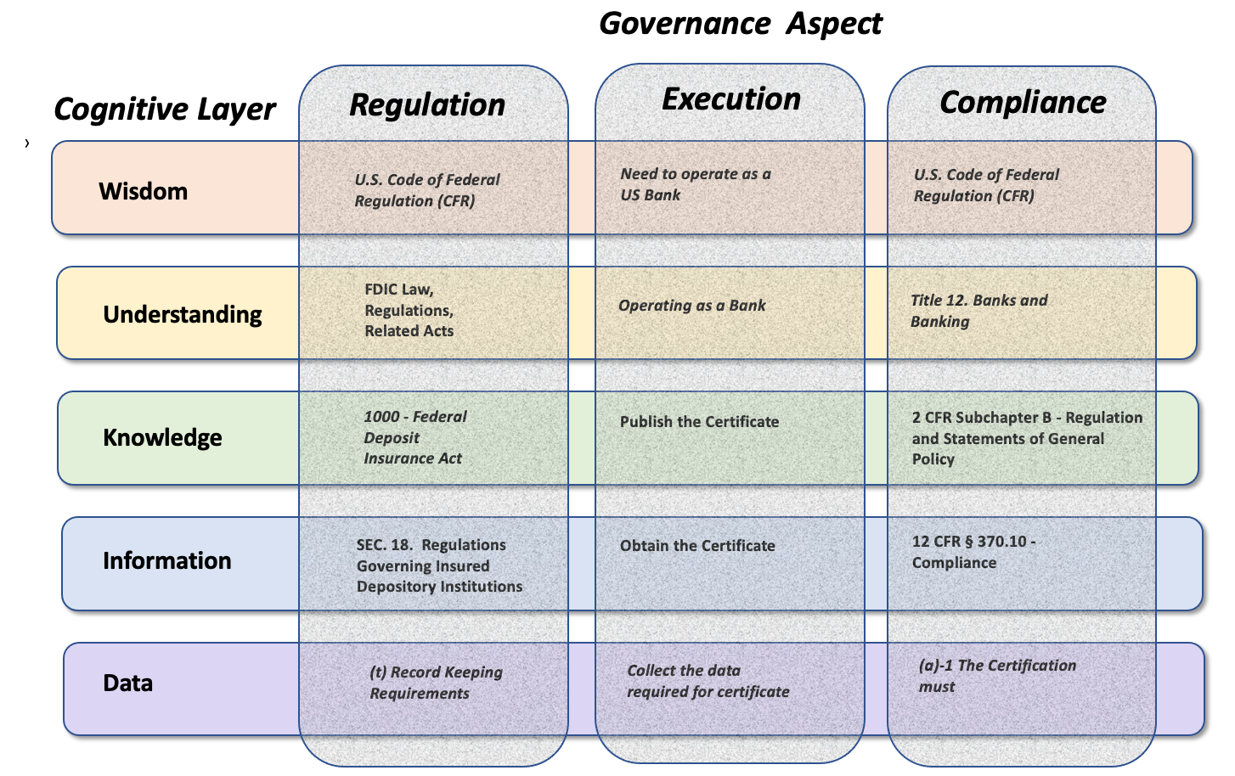
Normative Example of the Combined Governing and Cognitive Models
Figure roughly lays out a “straw man” of what the overall combined governance could be like. Within each governing Aspect and within each Cognitive layer there are specific requirements that covers that Role (i.e., cell).

1) Normative - are statements based on opinions about what should happen. They are subjective rather than objective because they involve value judgment about what is right and what is wrong.

