4.4.2.1 How to Use the Non-Functional Requirements Boilerplate
Return to Non-Functional Requirements
To use either the Microsoft Excel or Google Sheets workbook to support a Trade Study, click on one of the links below. To fill out the workbook, go to each individual sheet in the workbook and evaluate the requirement using a rating of 1-5: 1 for poor and 5 for excellent. The sheet will then calculate the average, total score, and number of samples that were used to calculate both previous values for this sheet. In the comments section you can add additional information about that specific topic. The Master sheet includes links back to the DIDO Wiki to describe each of the non-functional requirements (e.g. Portability). Each of the sheets associated with a specific non-functional requirement (e.g, Portability) includes links back to the DIDO RA Wiki for more information about whichever sub-requirement (e.g., Fault Tolerance) is needed and being rated.

Using Google Sheets
Return to Top
If you would like to use the Google Sheets Workbook for the DIDO RA...
1. Go to the Google Sheets link that has the template.
2. Click on File
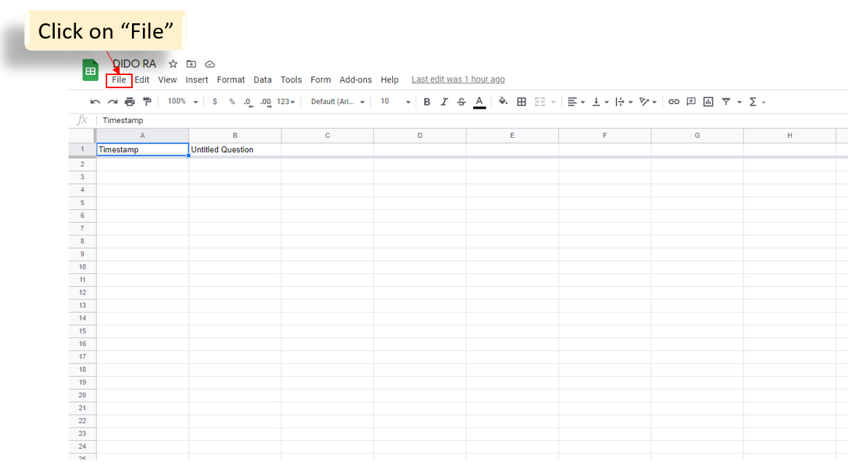
3. Click on Make Copy
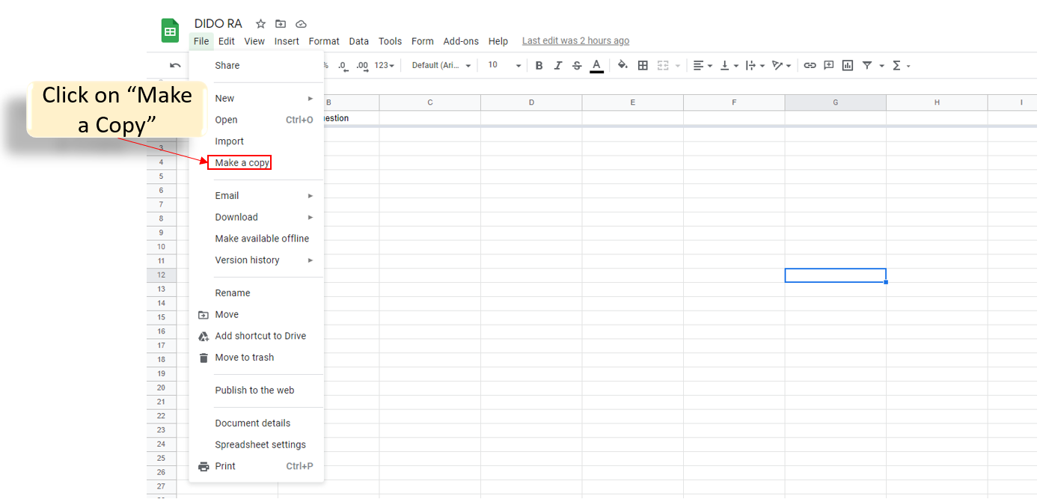
4. A window will pop up. You must rename the workbook to a different name, and then save this copy to your Google Drive. That way you can immediately start working on your own version with your team.
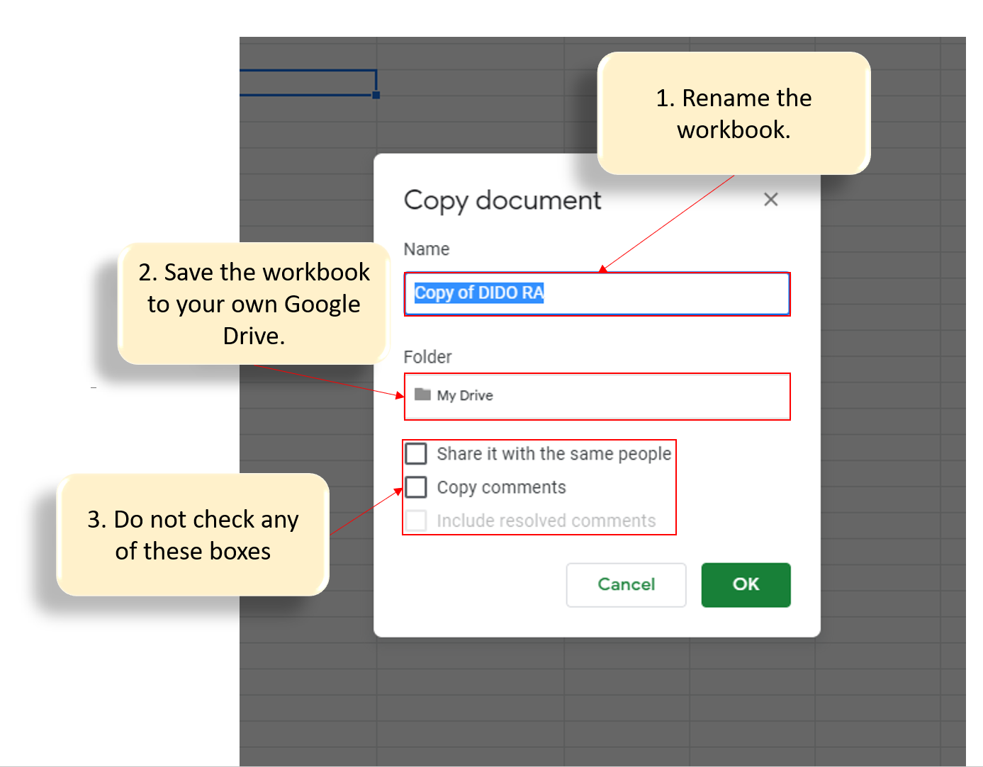
NOTE: It is not recommended to download the Google Sheet as a Microsoft Excel sheet. Use the Microsoft directions below.

Using Microsoft Excel
Return to Top
ATTENTION:
It is not recommended to use the Microsoft Excel method for the following reasons...
Limited ability to place data inside a cell Only one link per cellRow height and Column width limit is restrictiveLimited ability to format cells.
If you still wish to proceed, click on the link below to download a copy of the Microsoft version of the workbook

