Automation Pyramid
Return to Glossary
The Automation Pyramid classifies the different IT layers of industrial automated production plants. Every layer or level has is own tasks and IT infrastructure within the production plants. In general, the automation pyramid is divided into 6 layers.
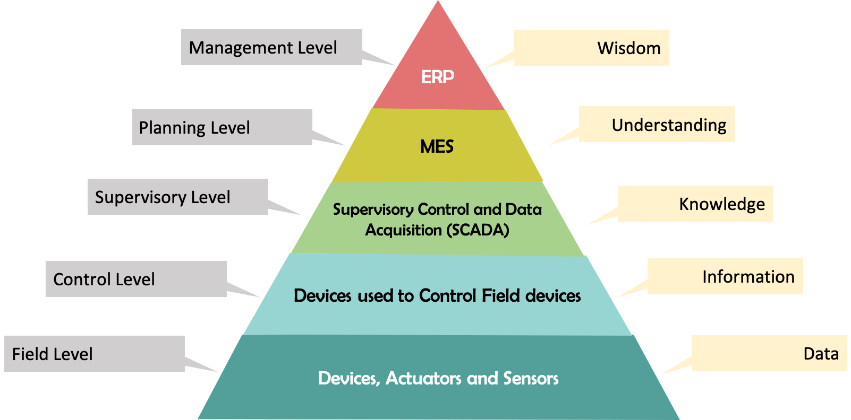
Automation Pyramid
Source: Automation Pyramid

