Clearinghouse
Return to Glossary
Clearinghouse is a designated intermediary between a buyer and seller in a Financial Market. The Clearinghouse validates and finalizes the transaction, ensuring that both the buyer and the seller honor their contractual obligations.
Every Financial Market has a designated Clearinghouse or an internal clearing division to handle this function.
The responsibilities of a Clearinghouse include “clearing” or finalizing trades, settling trading accounts, collecting margin payments, regulating delivery of the assets to their new owners, and reporting trading data.
The Clearinghouse enters the picture after a buyer and a seller execute a trade. Its role is to accomplish the steps that finalize, and therefore validate, the transaction. In acting as a middleman, the clearinghouse provides the security and efficiency that is integral to stability in a financial market.
In order to act efficiently, a Clearinghouse takes the opposite position of each trade, which greatly reduces the cost and risk of settling multiple transactions among multiple parties. While their mandate is to reduce risk, the fact that they have to act as both buyer and seller at the inception of a trade means that they are subject to default risk from both parties. To mitigate this, clearinghouses impose margin requirements.
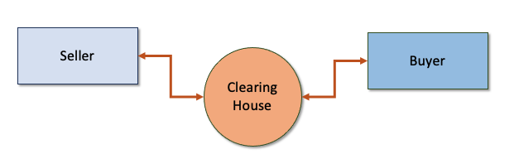
<caption>The relationship between a buyer, a seller and a Clearinghouse.</caption
Source: https://www.investopedia.com/terms/c/clearinghouse.asp

