Hypertext Transfer Protocol (HTTP)
Return to Glossary
Hypertext Transfer Protocol (HTTP) is a fundamental Protocol used on the Internet in order to control data transfer to and from a hosting Server, in communication with a web browser Client.
HTTP is the essential means of communication between web users and the servers or services that maintain the websites themselves.
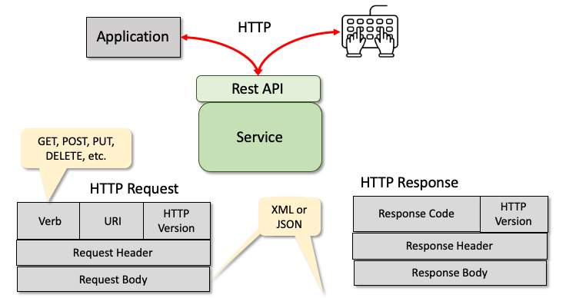
The HTTP Request/Response Model
See:
See: RFC7235 - Hypertext Transfer Protocol (HTTP/1.1): Authentication
Source: https://www.techopedia.com/definition/2336/hypertext-transfer-protocol-http

