Hypertext transfer protocol (HTTP) Request
Return to Glossary
Hypertext transfer protocol (HTTP) Request is the message that is sent by a client to a server or service over Hypertext Transfer Protocol (HTTP). When these requests are being sent, clients can use various methods.
Source: https://rapidapi.com/blog/api-glossary/http-request-methods
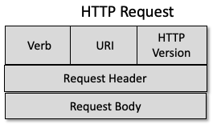
HTTP Request
An HTTP Request has five major parts −
Verb − Indicates the HTTP methods such as GET, POST, DELETE, PUT, etc.URI − Uniform Resource Identifier (URI) to identify the resource on the server.HTTP Version − Indicates the HTTP version. For example, HTTP v1.1.Request Header − Contains metadata for the HTTP Request message as key-value pairs. For example, client (or browser) type, format supported by the client, format of the message body, cache settings, etc.Request Body − Message content or Resource representation (usually XML or JSON)Source: https://www.tutorialspoint.com/restful/restful_messages.htm

