Protection Rings
Return to Glossary
Protection Rings, also known as Hierarchical Protection Domains, are mechanisms to protect data and functionality from faults (by improving fault tolerance) and malicious behavior (by providing computer security).
Operating Systems (OSs) provide different levels of access to resources. A Protection Rings is one of two or more hierarchical levels or layers of privilege within the architecture of a computer system. This is generally hardware-enforced by some CPU architectures that provide different CPU modes at the hardware or microcode level. Rings are arranged in a hierarchy from most privileged (most trusted, usually numbered zero) to least privileged (least trusted, usually with the highest ring number). On most operating systems, Ring 0 is the level with the most privileges and interacts most directly with the physical hardware such as the CPU and memory.
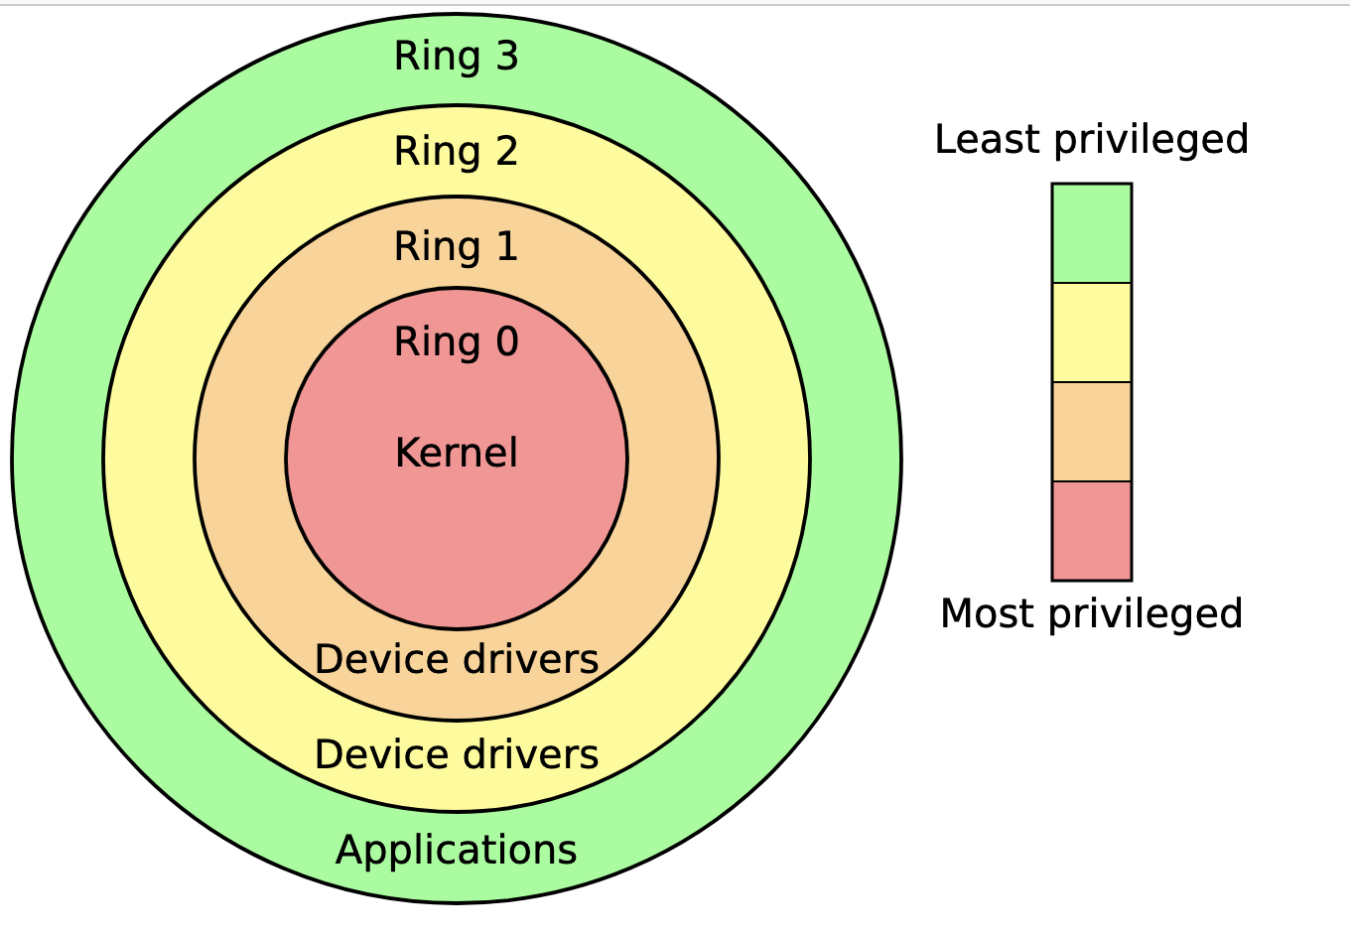
x86 Protection Rings or layers(From Wikipedia)
Special call gates between rings are provided to allow an outer ring to access an inner ring's resources in a predefined manner, as opposed to allowing arbitrary usage. Correctly gating access between rings can improve security by preventing programs from one ring or privilege level from misusing resources intended for programs in another. For example, spyware running as a user program in Ring 3 should be prevented from turning on a web camera without informing the user, since hardware access should be a Ring 1 function reserved for device drivers. Programs such as web browsers running in higher numbered rings must request access to the network, a resource restricted to a lower numbered ring.
Source: https://en.wikipedia.org/wiki/Protection_ring

