TCP/IP Conceptual Model
Return to Glossary
Transmission Control Protocol (TCP) / Internet Protocol (IP) helps determine how a specific Endpoint should be connected to the Internet and how to transmit data between Endpoints. It helps create a virtual network when multiple networks are connected together.
It is specifically designed as a model to offer highly reliable and end-to-end byte stream over an unreliable internet.
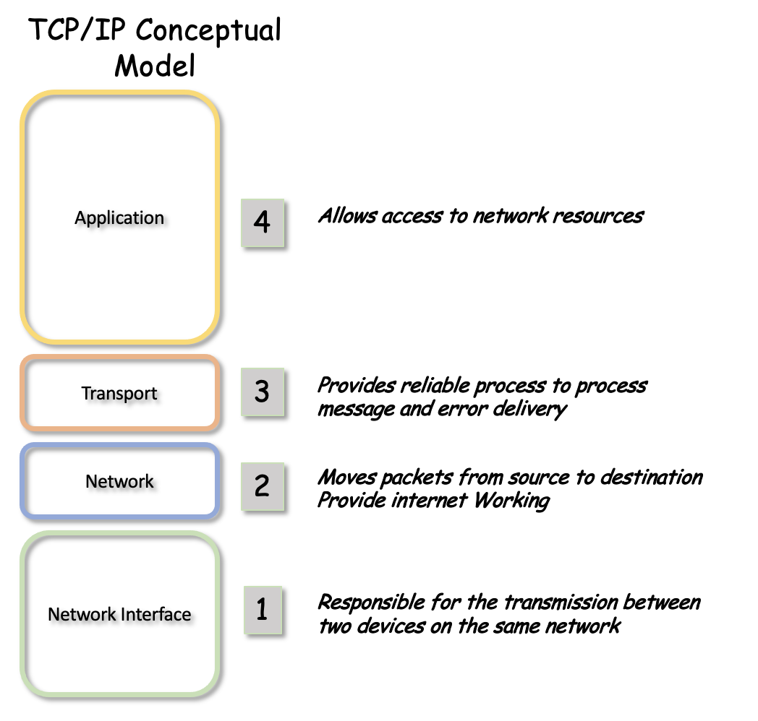
The four layers of the TCP/IP Conceptual Model
Source: https://www.guru99.com/difference-tcp-ip-vs-osi-model.html#2

