ISO/IEC 7816-12 Identification cards - Integrated circuit cards — Part 12: Cards with contacts — USB electrical interface and operating procedures
return to the ISO Standards
Data sheet for Identification cards - Integrated circuit cards — Part 12: Cards with contacts — USB electrical interface and operating procedures
Title | Identification cards - Integrated circuit cards — Part 12: Cards with contacts — USB electrical interface and operating procedures
Acronym
Version | 2005
Document Number | 7816-12
Release Date | 2005
Reference | https://www.iso.org/obp/ui/#iso:std:iso-iec:7816:-12:ed-1:v1:en
Note: The following is an excerpt from the official ISO catalog. It is provided here as a convenience and is not authoritative. Refer to the original document as the authoritative reference.

Scope
This part of ISO/IEC 7816 specifies the operating conditions of an integrated circuit card that provides a USB interface. Figure 1 shows the assignment of the contact fields for a USB interface and - to illustrate interoperability - the assignment as used in ISO/IEC 7816-03 Identification cards — Integrated circuit cards — Part 3: Cards with contacts — Electrical interface and transmission protocols.
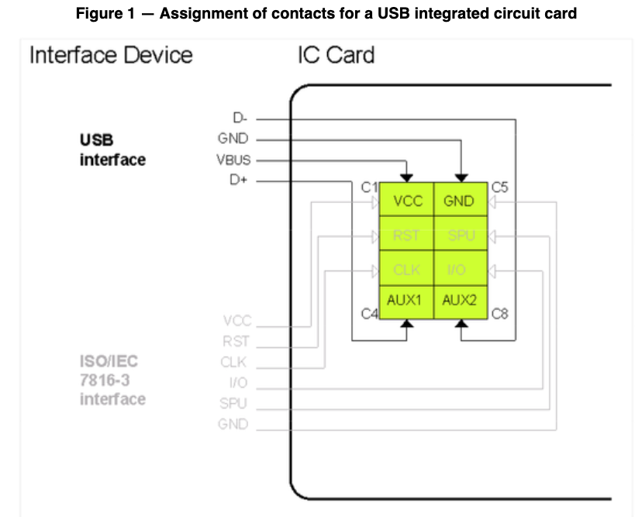
Assignment of contacts for USB Integrated Circuit Card

