C.6 Network Devices
Return to Hardware Architectures

About
Networking Devices, also known as Network Equipment or Computer Networking Devices, are electronic devices required for communication and interaction between devices on a computer network. In essence, these devices mediate data transmission in networks. An Endpoint is an Network Node and is the last receptor or generator of the network traffic.
Figure is an example of a network that represents many of the components of a network. Many of these devices have their own operating systems tailored specifically to optimize the flow and control of network traffic. In addition to the devices shown in the diagram, there are other network devices such as Network Attached Storage (NAS).
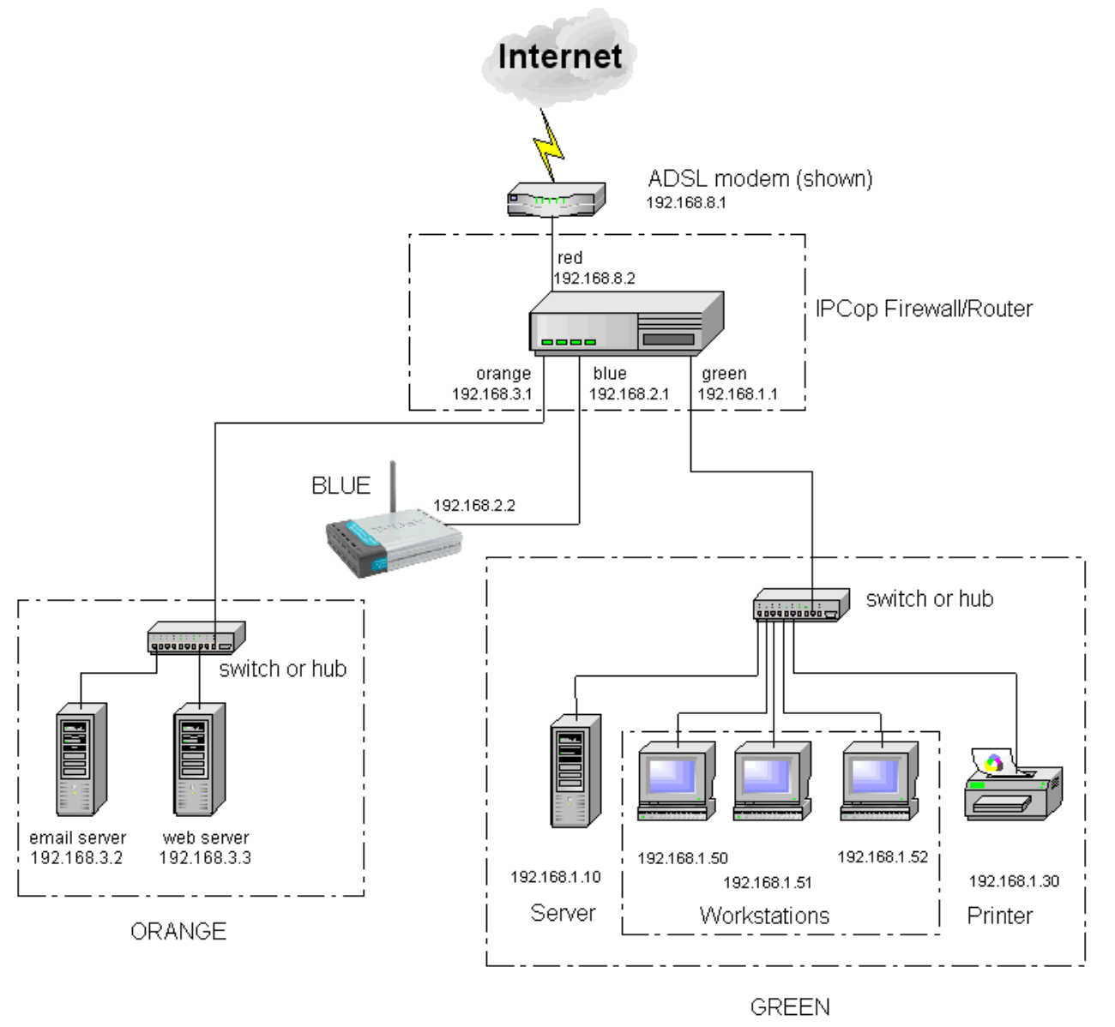
Example of a network Architecture1)
Table Provides a summary of the device found in the example network depicted in Figure .
<table netDevSumary> <caption>A summary of common devices found in networks.</caption>
Network Component | Description2)
Hub | A hub is basically a multiport repeater. A hub connects multiple wires coming from different branches, such as, for example, the connector in a star topology that connects different stations. Hubs cannot filter data, so data packets are sent to all connected devices.
Switch | A switch is a multiport bridge with a buffer and a design that can boost its efficiency (a large number of ports imply less traffic) and performance. A switch is a data link layer device.
Router | A router is a device like a switch that routes data packets based on their IP addresses. A Router is mainly a Network Layer device. Routers normally connect LANs and WANs together and use a dynamically updated routing table to make decisions regarding data packet routing. Routers divide broadcast domains of hosts connected through it.
Bridge | A bridge operates at the data link layer. A bridge is a repeater, with the ability to filter content by reading the MAC addresses of source and destination. It is also used for interconnecting two LANs using the same protocol. It has a single input and single output port, thus making it a 2 port device.
Gateway | A gateway, as the name suggests, is a passage to connect two networks together that may work in accordance with different networking models. A gateway basically functions as a messenger agent that takes data from one system, interprets it, and transfers it to another system. Gateways are also called protocol converters and can operate at any network layer. Gateways are generally more complex than a switch or router.
Modem | Transmission mode refers to the manner by which data is transferred between between two devices. It is also known as communication mode. Buses and networks are designed to allow communication to occur between individual devices that are interconnected. There are three types of transmission modes:  • Simplex Mode  • Half-Duplex Mode  • Full-Duplex Mode
Repeater | A repeater operates at the physical layer. Its job is to regenerate the signal over the same network before the signal becomes too weak or corrupted so as to extend the distance over which the signal can be transmitted over the same network.
Network Appliance | A type of computing appliance that aids in the flow of information to other network-connected computing devices. Services that may be provided by a network appliance include firewall functions, caching, authentication, network address translation and IP address management. 3)

DIDO Specifics
Return to Top
To be added/expanded in future revisions of the DIDO RA

1) Vorgu Topology, Accessed 10 December 2020, https://wiki.itcollege.ee/index.php?title=File:Vorgu_topoloogia.png&limit=500
2) FeekForGeeks, Network Devices (Hub, Repeater, Bridge, Switch, Router, Gateways and Brouter), 12 January 2020, Accessed: 10 December 2020; https://www.geeksforgeeks.org/network-devices-hub-repeater-bridge-switch-router-gateways/
3) Gartner, Network Appliance, Accessed: 10 December 2020; https://www.gartner.com/en/information-technology/glossary/network-appliance#:~:text=A%20type%20of%20computing%20appliance,translation%20and%20IP%20address%20management.

