F.22 Reader Data Lifecycle
Return to DDS Quality of Service
The READER_DATA_LIFECYCLE policy controls the behavior of the DataReader with regards to the lifecycle of the data-instances it manages, that is, the data-instances that have been received and for which the DataReader maintains some internal resources.
The DataReader internally maintains the samples that have not been taken by the application, subject to the constraints imposed by other QoS policies such as HISTORY and RESOURCE_LIMIT.
The DataReader also maintains information regarding the identity, view_state and instance_state of data-instances even after all samples have been ‘taken.’ This is needed to properly compute the states when future samples arrive.
Under normal circumstances the DataReader can only reclaim all resources for instances for which there are no writers and for which all samples have been ‘taken.’ The last sample the DataReader will have taken for that instance will have an instance_state of either NOT_ALIVE_NO_WRITERS or NOT_ALIVE_DISPOSED depending on whether the last writer that had ownership of the instance disposed it or not. The following figure provides a state chart describing the transitions possible for the instance_state.
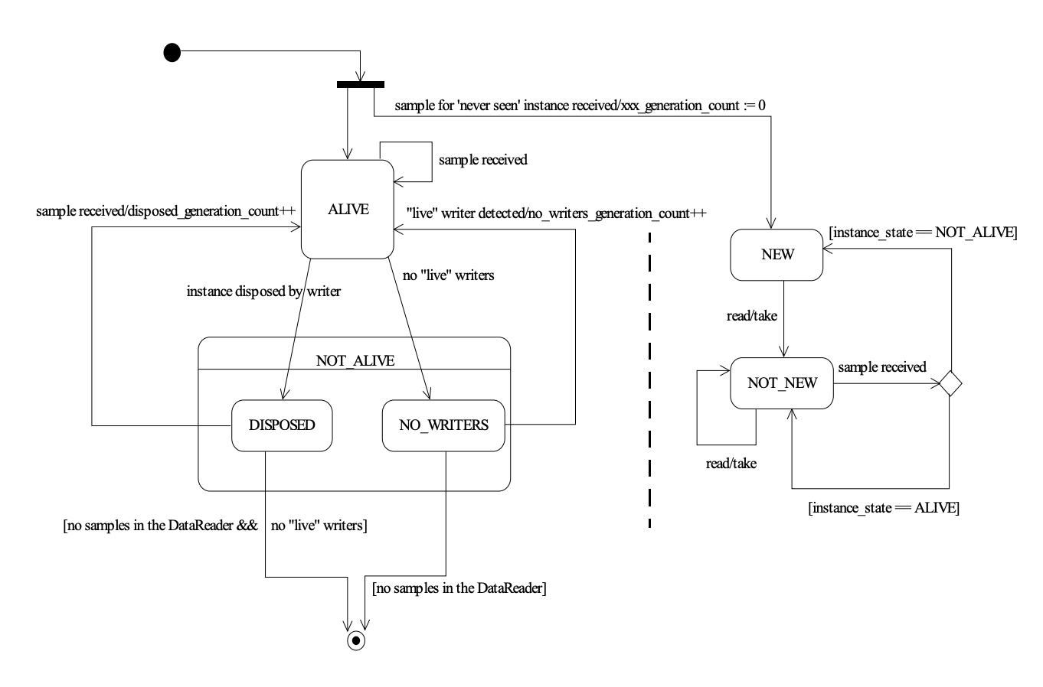
Statechart of the instance_state and view_state for a single instance.
In the absence of the READER_DATA_LIFECYCLE QoS this behavior could cause problems if the application “forgets” to ‘take’ those samples. The ‘untaken’ samples will prevent the DataReader from reclaiming the resources and they would remain in the DataReader indefinitely.
The autopurge_nowriter_samples_delay defines the maximum duration for which the DataReader will maintain information regarding an instance once its instance_state becomes NOT_ALIVE_NO_WRITERS. After this time elapses, the DataReader will purge all internal information regarding the instance, any untaken samples will also be lost.
The autopurge_disposed_samples_delay defines the maximum duration for which the DataReader will maintain samples for an instance once its instance_state becomes NOT_ALIVE_DISPOSED. After this time elapses, the DataReader will purge all samples for the instance.
Source: DDS 1.4 Spec

