Appendix I: Cognitive Model
Return to Reference Architecture (RA) or Return to Appendices
Note: The following is based on an Engineering Governance Model developed at US Navy SPAWAR1).The Cognitive Model abstractly represents human cognition defined in the dictionary as2):
The mental process of knowing, including aspects such as awareness, perception, reasoning, and judgmentThat which comes to be known, as through perception, reasoning, or intuition; knowledgeCognition roughly maps to the Information Science and Knowledge Management DIKW (Data, Information, Knowledge and Wisdom) hierarchies3).
Table highlights the alignment of the two models to each other.
Mapping Cognitive Aspects to DIKW Hierarchy
Cognitive Aspects | DIKW Hierarchy
Awareness | Data
Perception | Information
Reasoning | Knowledge
Judgment | Wisdom
In addition to the basic layers in the DIKW Hierarchy, Russell Ackoff4) and Milan Zeleny5) propose an additional layer between Knowledge and Wisdom. Ackoff refers to it as Understanding. Zeleny adds one more layer above Wisdom called Enlightenment. For the purposes of Governance, there does seem to be a need for an Understanding Layer to the hierarchy. However, adding an Enlightenment Layer when referring to governance always seems to elicit smiles.
The result is termed the Cognitive Model instead of the original DIKW (or DIKUW) Hierarchy for a several reasons. The word hierarchy implies an order or precedence and this hierarchy always starts with data. This is a useful concept when thinking in terms of Information Science and Knowledge Management, which generally tries to organize and classify large amounts of data and extract wisdom or, in Zeleny’s case, even enlightenment. In governance, the hierarchy is applicable in both directions (i.e., from Wisdom to Data and from Data to Wisdom). Another problem with the hierarchical approach is that although the relationship of data to wisdom, in some cases, is many-to-one (i.e., many pieces of data contribute to a single piece of wisdom), the reality is that the relationship is more of a network where one piece of data may ultimately be part of many pieces of wisdom.
The acronym DIKW (or DIKUW, etc.) is not very pronounceable and the term specifically captures the model as we currently understand it. Consequently, as our understanding of the model evolves, as with the acceptance of having an Understanding Layer, the name of the model must also change.
The Cognitive Model is depicted below in Figure . It has the five layers of the original DIKUW Hierarchy, and this view is from Wisdom to Data. However, the model could just as well be presented in the reverse, starting with Data and ending in Wisdom. The directionality through the model is inconsequential and reflects the higher level human cognitive process.
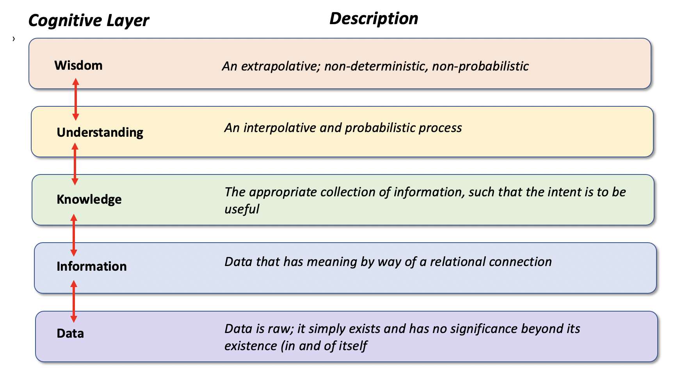
Cognitive Model

Bottom-Up Cognitive Model Example
Return to Top
The simple Bottom-Up Cognitive Model example presented in Figure illustrates how bottom-up cognition applies in our lives, usually as part of analytical processes. It is bottom-up because the process described starts with Data and ends with Wisdom. At the Cognitive Data Layer, a temperature of 100° means little. Adding that the temperature is in degrees Fahrenheit provides a bit more data; however, it still has little relevance until the temperature is put in the context of a person’s temperature and becomes Information. Adding that information with other information like the normal temperature for a person is 98.6° Fahrenheit starts to provide us some Knowledge of the situation. This knowledge, combined with other knowledge, allows us to understand that the person has flu. The final step is adding this knowledge with what we already know about the individual allowing a decision that the temperature is not serious and that the solution is to take two aspirin and call the doctor in the morning if symptoms persist. In reality, there is more data than information, more information than knowledge, etc.
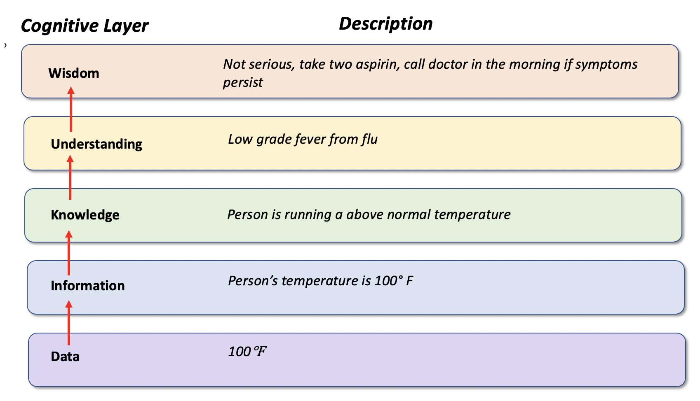
Example of Cognitive Model – Data to Wisdom

Top-Down Cognitive Model Example
Return to Top
The simple Top-Down Cognitive Model example presented in Figure illustrates how top-up cognition applies in our lives, usually as part of educational or regulatory processes. It is top-down because the process described starts with Wisdom and ends with Data. At the Cognitive Wisdom Layer, there needs to be a uniform policy to protect people at risk from influenza. To support this policy (i.e., Wisdom), there are many different kinds of things to understand, such as people can be immunized against flu. As a part of the Understanding, there is Knowledge that vaccines are made from eggs. This leads to the need to disseminate Information that people who are allergic to eggs can not use the vaccine and ultimately the collection of Data (i.e., evaluation criteria) about egg allergies from people receiving the vaccine.
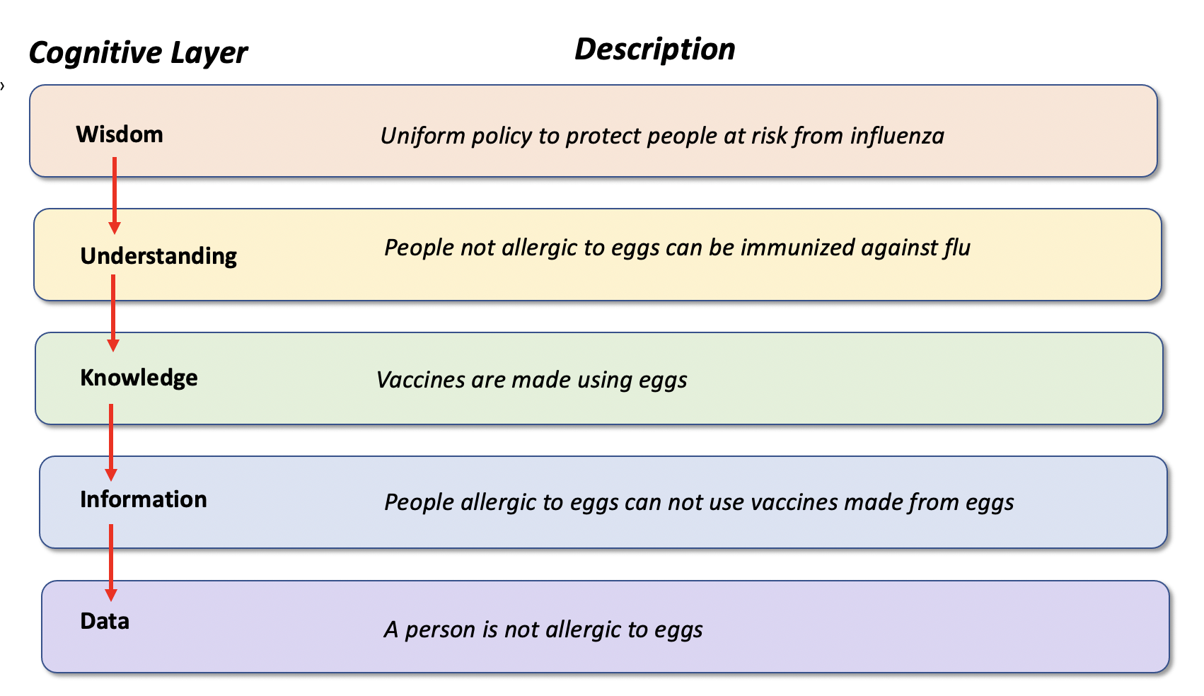
Example of Cognitive Model – Wisdom to Data

1) Stavros, Robert W. and Albrant, Jeremiah; Engineering Governance, SPAWAR, October 9, 2007,
2) ((American Heritage Dictionary, Accessed 10 February 2021, http://dictionary.reference.com/help/ahd4.html
3) Nikhil Sharma, The Origin of the “Data Information Knowledge Wisdom” Hierarchy, 2008 https://www.researchgate.net/publication/292335202_The_Origin_of_Data_Information_Knowledge_Wisdom_DIKW_Hierarchy
4) Ackoff, Russell; 1981, pp. 15-16
5) Zeleny, M., ed. (1981) Autpoiesis: A theory of living organization, vol.3, New York, New York, American Elsevier

