K.3 Consensus Mechanisms
Return to DIDO Consensus

Overview
Return to Top
Consensus Mechanism, in DIDOs, is any of a number of general-purpose Consensus Mechanisms that have been developed with each DIDO Platform choosing the mechanism best suited for its needs. Some examples are Proof of Work (PoW), Proof of State (PoS), PoS, etc.
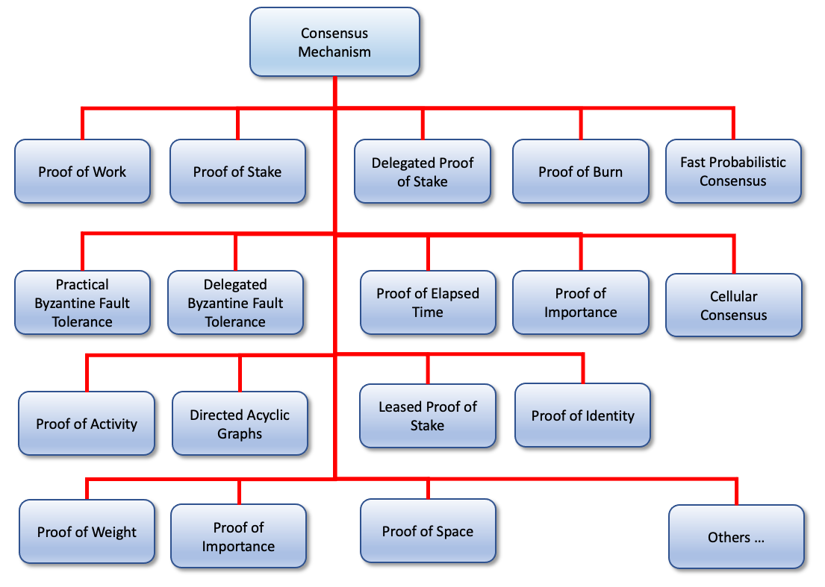
Some of the more common Consensus Mechanisms.

Common Consensus Mechanisms
Return to Top
- Cellular Automaton Consensus
- Delegated Byzantine Fault Tolerance (dBFT)
- Delegated Proof of Stake (DPoS)
- Directed Acyclical Graphs (DAGs)
- Fast Probabilistic Consensus (FPC)
- Leased Proof of Stake (LPoS)
- Other Consensus Methodologies
- Practical Byzantine Fault Tolerance (pBFT)
- Proof of Activity (PoA)
- Proof of Authority (PoAuth)
- Proof of Burn (PoB)
- Proof of Capacity (PoC)
- Proof of Elapsed Time (PoET)
- Proof of Importance (PoI)
- Proof of Stake (PoS)
- Proof of Weight (PoW)
- Proof of Work (PoW)

