a. Cover Page
return to DIDO CLI Front Matter
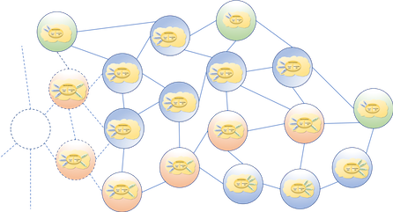
<center style="font-size:30px"> <b>DISTRIBUTED IMMUTABLE DATA OBJECT</b> </center> <center style="font-size:30px"> (DIDO) </center> <center style="font-size:30px"> Command Line Interface (CLI) </center> <center style="font-size:15px"> for </center> <center style="font-size:20px"> Cryptocurrencies, Blockchains, Distributed Ledgers, Tangles, and Supply Chains </center> <center> Object Management Group (OMG) </center> </center> <center> Discussion Paper </center> <center> <i>Version 1.0</i> </center> <center> <i>June 2021</i> </center> <center style="font-size:12px"> R. W. “Nick” Stavros<br/> Ian T. Stavros<br/> Bryan Turek <br/> Char Wales </center> <center style="font-size:10px"> <b><i>Jackrabbit Consulting</i></b> </center>
<center style="font-size:10px">This material is based upon work supported by the</center> <center style="font-size:10px">U.S. Army Small Business Innovation Research Program Office, </center> <center style="font-size:10px">Defense Advanced Research Projects Agency (DARPA) and the </center> <center style="font-size:10px">Army Research Office under Contract Number: W911NF-17-P-0029. </center> <p/> <center style="font-size:10px"> The views and conclusions contained in this document or website</center> <center style="font-size:10px"> are those of the authors and</center> <center style="font-size:12px"><b>should NOT be interpreted as representing</b> </center> <center style="font-size:12px"><b>the Official Policies, either expressly or implied,</b> </center> <center style="font-size:10px">of the</center> <center style="font-size:12px"><b>DEFENSE ADVANCED RESEARCH PROJECTS AGENCY (DARPA)</b> </center> <center style="font-size:10px">or the</center> <center style="font-size:12px"><b>U.S. GOVERNMENT </b></center>

