2.1.3 Definition: Platform
Return to Common Definitions
Platform is a group of technologies that provide a base for other other applications, processes or technologies are developed. In many ways they can act as an accelerated to meet the requirements of the application, program or system.
There are different kinds of platforms, for example:
PlatformsWeb Service PlatformsDatabase Management PlatformsRuntime PlatformsLanguage PlatformsDIDO platforms are a combination of operating system, runtime, language platforms and the specific DIDO software (i.e., Ethereum, Hyperledger, Itota, etc.).
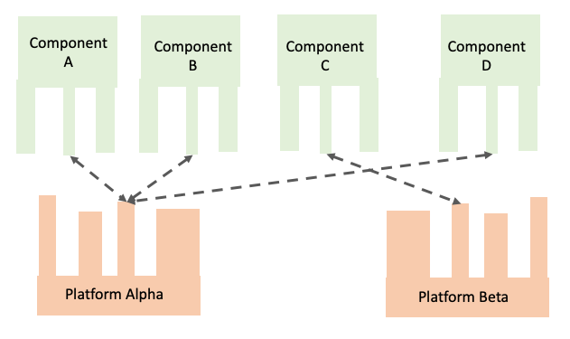
Platforms “host” components designed to work with the Platform.

