4.0 DIDO Data Lifecycle Language (DDLL)
Return to Part I
The DIDO Lifecyle Language (DDLL) is responsible for controlling the Lifecycle of the DIDO instances distributed across the Nodes in the DIDO Network. The DidoLL does not cover the System Lifecycle which is responsible for the system conception, design and development, production and/or construction, distribution, operation, maintenance and support, retirement, phase-out and disposal. Although there is some overlap, the System Lifecycle covers also covers the development of the DIDO Platform while the DidoLL only covers the deployment and execution of the DIDO software on the individual nodes.
Although there is no requirement for a DIDO to be implemented as a Virtual Node (i.e., Virtual Machine (VM) or Application Container), the basic steps would be the similar. MeGee 1) has proposed the following steps for application containers (i.e., Docker).
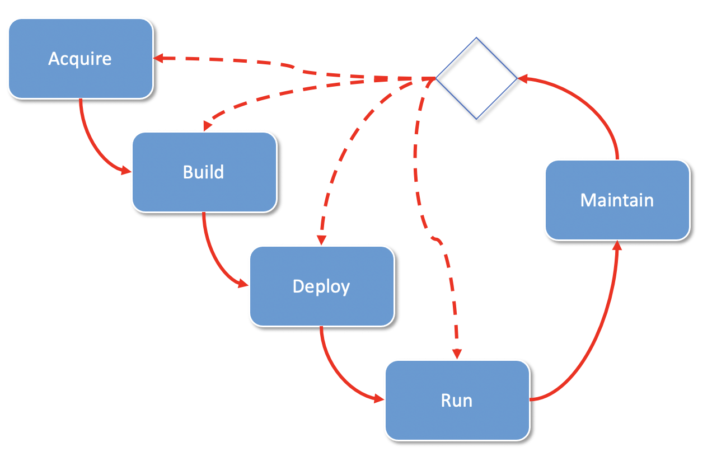
The 6 steps of a container's lifecycle.
Acquire - Gathering the products (i.e, requirements, laying out a system plan, hardware, software or content)Build - Assemble the acquired products in to system that can be deployed.Deliver - The assembled system is delivered for validation and verification Deploy - is the distribution of the approved system to the initial set of nodes nd the verification and validation that the system id properly deployed.Run - The deployed system is started and the nodes are working as a system. The operating states (starting, running, shutdown, etc) are reported. Maintain - Anomalies and faults are detected, reported for further remediation. Note: Although the steps are presented as a linear progression from steps 1-6, the steps 3-6 (i.e., Deploy, Run, and Maintain) are repeated for every node within the DIDO network. If a flaw is repaired as a result of an anomaly or fault reported and a fix is identified, then the Build Step might need to be repeated. Sometimes, the flaw might require that the Acquire step be repeated. The DidoLL needs to support the entire Lifecycle of the DIDO on each individual Node.
DDLL Commands
- 4.1 NetworkProtocol
- 4.1 PortNumberType
- 4.2 Port
- 4.3 Machine
- 4.4 Resource
- 4.5 Volume
- 4.6 Virtual Machine
- 4.7 Container

1) Jason McGee, IBM, The 6 steps of the container lifecycle, 8 February 2016, Accessed: 29 March 2021, https://www.ibm.com/blogs/cloud-computing/2016/02/08/the-6-steps-of-the-container-lifecycle/

