2.1 Activities
Return to Existing System
The following are a list of the activities associated with the Travel workflow and the use of Identity. The activities are summarized in Figure :
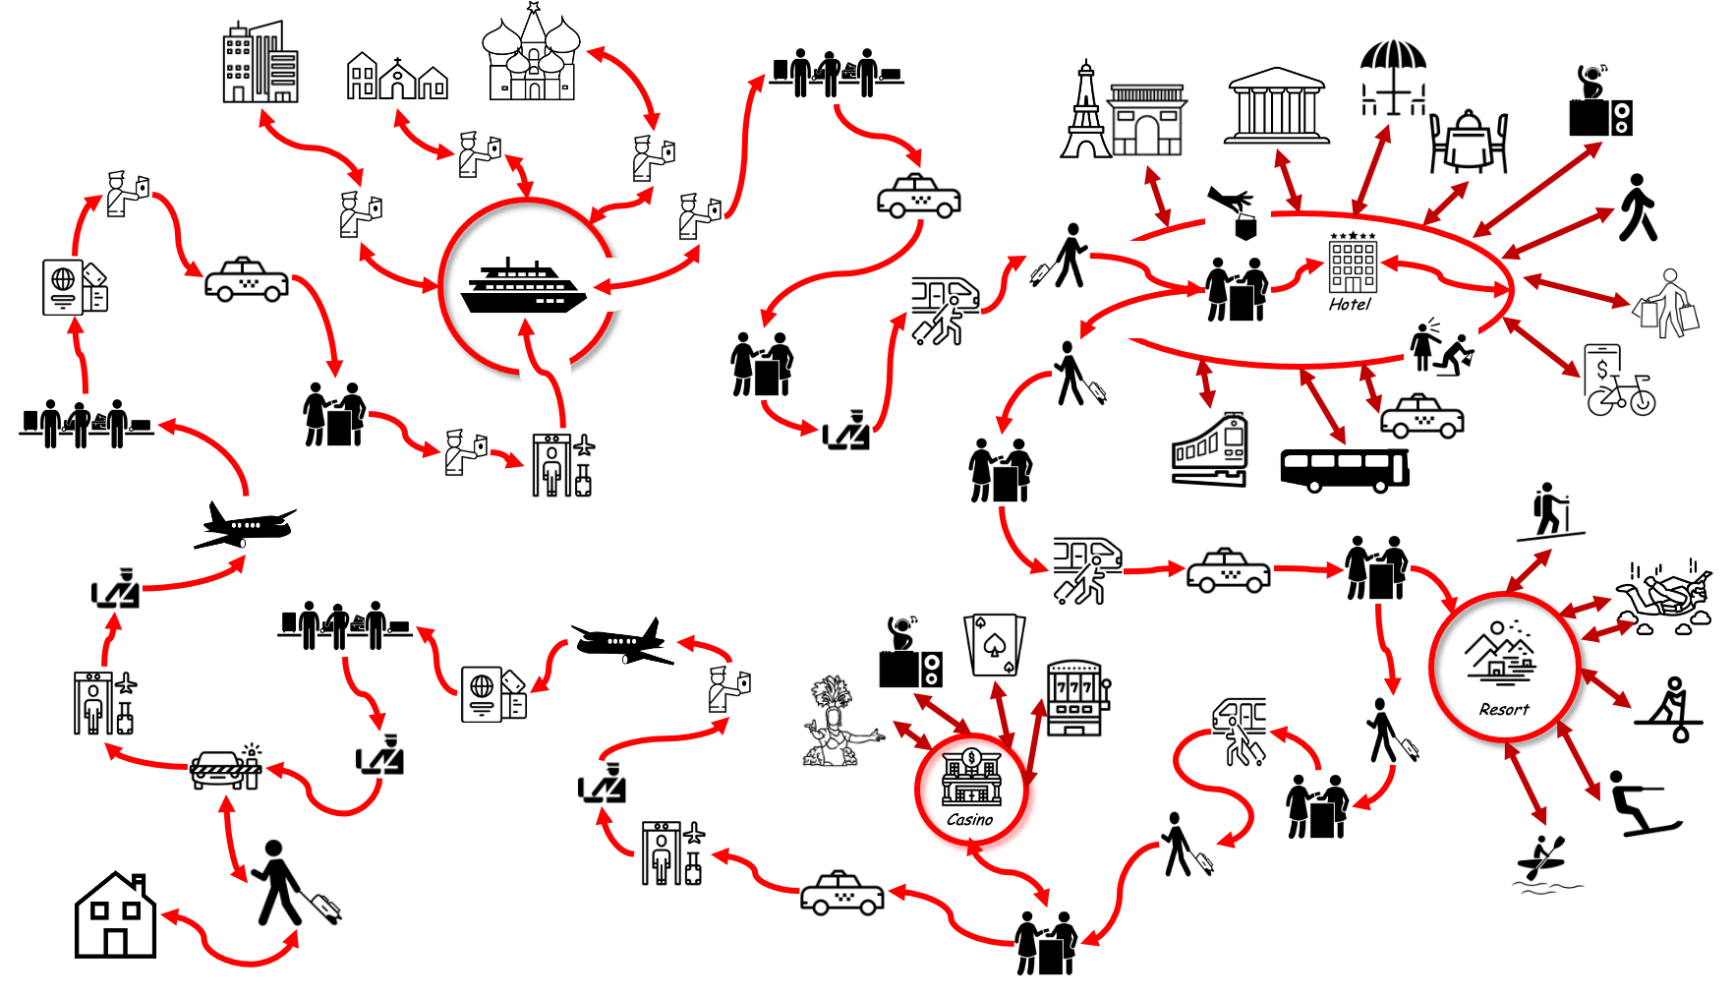
Nancy leaves home using her own car and parks in long-term parkingShe goes through airport security showing her airplane ticket and passportShe boards the plane showing her passport and ticket againShe arrives at the major City and claims her bagsShe shows her passport at border controlShe goes through customsShe takes a taxi to the cruise shipGoes to the Ticket CounterGoes through a passport checkGoes through securityShe spends the next few days visiting:CitiesVillagesCultural and heritage sightsEach time she leaves the ship, her passport is checkedAs she leaves the cruise ship, she shows her passport again and claims her luggageWhen the cruise is over, she shows her passport againShe claims her luggage Takes a Taxi to the Inter-City train stationShe checks in at the ticket counterHer baggage is checkedShe boards the train to ParisWhile in Paris, She uses ground transportationMetroBussesTaxisHire BikesDoes a lot of walkingShe goes to:MuseumsGaleriesHistoric SitesRestaurantsBistrosCafesDiscothequeShopsWhen she leaves, she walks to a train station to go to the ResortTo get to the resort from the train, she takes a taxi to the ResortAt the resort, she checks in, then goes: HikingSki DivingPaddle BoardingWater SkiingCancels KayakingShe checks outShe walks to the Train Station and buys a ticket to the CasinoShe takes the train to the CasinoShe Walks to the CasinoShe Checks into the CasinoShe goes to the Cabaret showShe Cancels the DiscothequeShe Plays some slot machinesShe skips pokerShe checks out of the CasinoShe Takes a Taxi to the airportShe goes through SecurityShe Checks her bagsShe shows her ticket and passport to get into the planeShe Flies Home and Buys some Dutyfree on the planeBuys some Food on the planeShe arrives at her local airportShe goes through Border Control (passports)She gets her bagsShe goes through customsShe arrives at the long term parking lotShe picks up her car and drives home
The existing workflow for Identity

