2.1 Existing Activities
Return to Existing Simplified System without DIDO
The following is only a simplified list of the steps involved in providing Lilly's healthcare needs that stem from a fall.
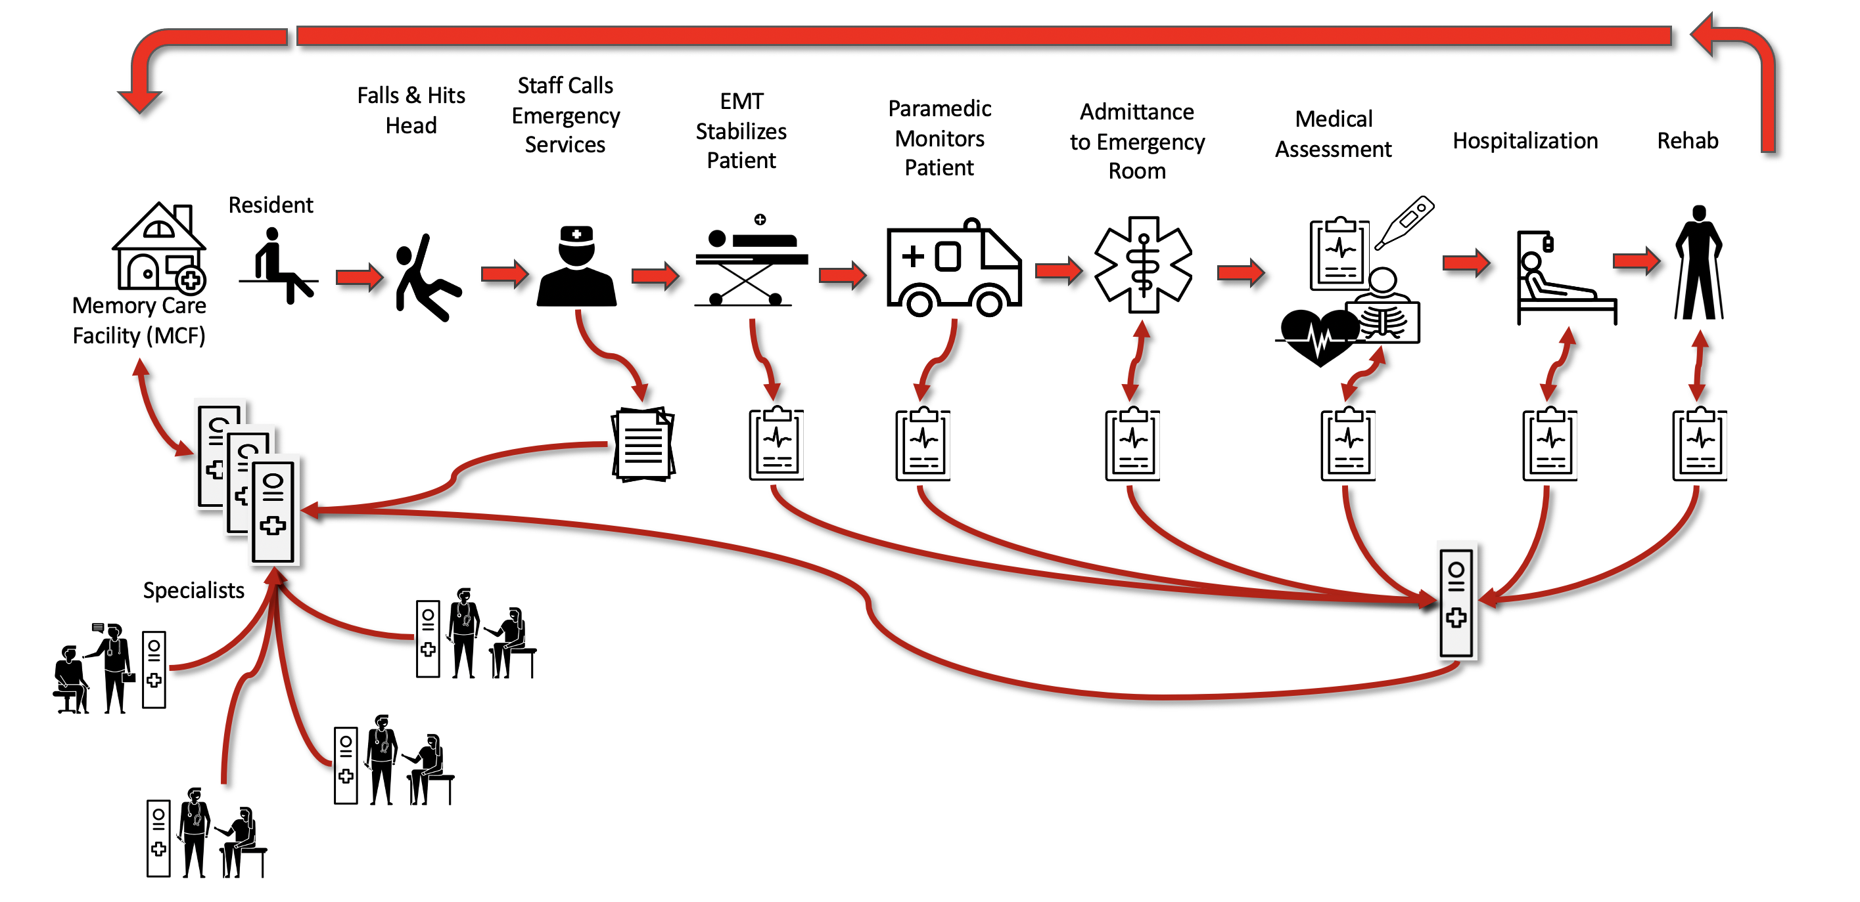
Lilly is a resident of the Memory Care Facility (MCF)She routinely see's her doctors and the write simple diagnostic reports and prescription for her. Each doctor keeps their own records and provides a diagnostic summary and prescriptions which are recorded at MCF in Lilly's Medical RecordsLilly has a fall and hits her head and it is bleeding. An MCF staff member helps her to the bed and looks at the wound. Determines the would is not serious but follows MCF protocols and calls for an ambulance to take Lilly to the Emergency Room. She files a incident report and sees Lilly safely to the Ambulance where she provides some information about Lilly to the paramedics and EMT in the ambulanceLilly's vital signs are checked in the ambulance and initial first aid is given with the IV and a sedative.The ambulance arrives t the Emergency Room (ER) where Lilly's is transferred along with original medical records from MCF and vitals obtained while Lilly was in AmbulanceMedical tests and procedures are conducted to determine the severity of Lilly's injuries. She is asked some basic memory questions where Lilly appears confused. It is determined that Lilly will be placed in the Hospital for observation and to assess the severity of her fractured pelvis. Lilly is discharged from the hospital and transferred to a rehabilitation hospital where she receives physical and occupational therapyLilly is finally released from the Rehab hospital and returned to the MCF.
A simple, idealized traditional record flow for a Memory Care Resident patient incident.

