A.1.1 Block Class
Basic Ethereum Data Store
The Block Class represents a block used by Ethereum Blockchain. A block is a package of data that contains zero or more transactions.
See: https://docs.google.com/spreadsheets/d/1ehCIQxjSZcVLnddDWHBzhPb8h83mHWZxvyX9eckghbU/edit#gid=293649320
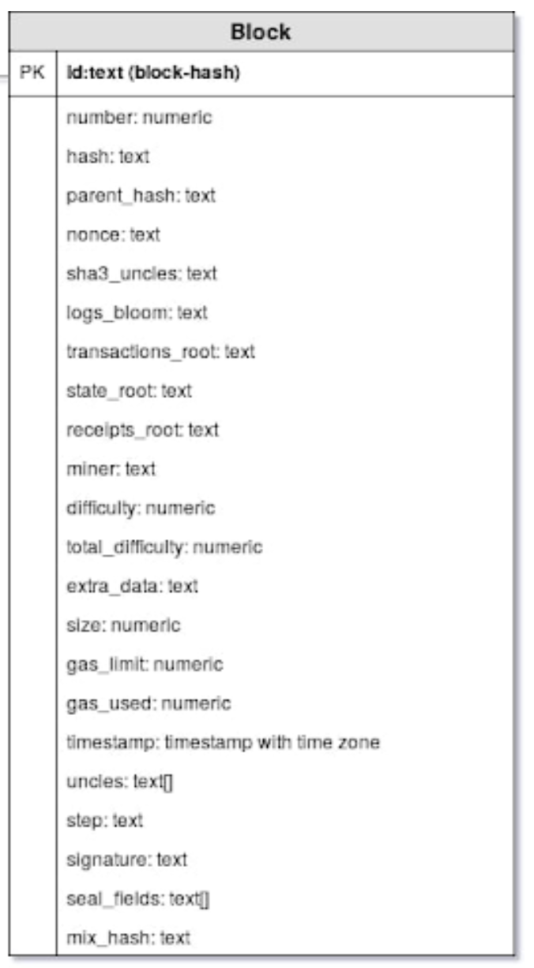
The Ethereum Block Class

Id
Return to Top
Description | The unique id for the Block
Datatype | text (block-hash)
Example | 0x000000708550f340a1297eefe721a3b0631d8dc4cc5a3462abaeef1a79726f6b

Number
Return to Top
Description | Block height
Datatype | numeric
Example | 5537029

Hash
Return to Top
Description | Hash of the Block Headwr
Datatype | text
Example | 0x000000708550f340a1297eefe721a3b0631d8dc4cc5a3462abaeef1a79726f6b

Parent Hash
Return to Top
Description | Hash of the preceding Block
Datatype | text
Example | 0x3102ee1ed005d33fecb07105fb36d4b3113f6cf0c8a87316095bbc2fb15f717d

Nonce
Return to Top
Description | Value in a block which can be adjusted in order to try to satisfy the proof of work condition. Guard against replay attacks.
Datatype | text
Example | 0x7cd714340ea379db

Step
Return to Top
Description
Datatype | text
Example | NULL

Signature
Return to Top
Description | The identifier of the sender. This is generated when the sender's private key signs the transaction and confirms the sender has authorised this transaction
Datatype | text
Example | NULL

Sha3 Uncles
Return to Top
Description | SHA3 hash of the uncles data in the block
Datatype | text
Example | 0x1dcc4de8dec75d7aab85b567b6ccd41ad312451b948a7413f0a142fd40d49347

Logs Bloom
Return to Top
Description | A kind of index about the data contained in the block, used in native queries to the blockchain via the node
Datatype | text
Example | 0x22293840281b28808259200ec8300080202058ac0a10094400002f01002a84680808027610e5cd202212068002310c4212536420008584840040220000e1280 c024002412902149d5110490881048895540e410200a84140801343e40305109008200620024e401012484010000908010344a0044e2da0e44004101505b42020 3320900050010082942001010404d01413a0803152c802b4cc048000000ea0000204165e004961341750a0095d40980400008413000280020b32c040041c50032 01a0702090c62120031000408002202280a200c900a808504000026200460090071011220e68c4c04008ce19423e9a4d26e6222008000810428100408004114

Transaction Root
Return to Top
Description | A kind of index about the data contained in the block, used in native queries to the blockchain via the node
Datatype | text
Example | 0x044c55caebe5fd0bc30584ee7d9f1ee2477ffde2ff4e5d7952b6af9fbc4a8f21

State Root
Return to Top
Description | A kind of index about the data contained in the block, used in native queries to the blockchain via the node
Datatype | text
Example | 0xbc7f1066555871619efdb379b00cbb6ff97fc54a27ba6ca7e7da579aa1f1f0c0

Receipts Root
Return to Top
Description | A kind of index about the data contained in the block, used in native queries to the blockchain via the node
Datatype | text
Example | 0x199d5e3930ce6e90e07a156cb23bf653f5edf5041d28cc56c6375d2fab004928

Miner
Return to Top
Description | Miner address that solved the block
Datatype | text
Example | 0x5a0b54d5dc17e0aadc383d2db43b0a0d3e029c4c

Difficulty
Return to Top
Description | Difficulty to solve the block
Datatype | numeric
Example | 3.12393E+15

Total Difficulty
Return to Top
Description | Total difficulty of the chain until this block
Datatype | numeric
Example | 3.94E+21

Extra Data
Return to Top
Description | Additional data to provide from the miner
Datatype | text
Example | 0x7433

Size
Return to Top
Description | Block size in byte
Datatype | numeric
Example | 19739

Gas Limit
Return to Top
Description | Maximum set gas limit
Datatype | numeric
Example | 8000029

Gas Used
Return to Top
Description | Used gas
Datatype | numeric
Example | 7983637

Timestamp
Return to Top
Description | Timestamp of the block
Datatype | timestamp with time zone
Example | 2018-05-01 09:17:18+00

Uncles
Return to Top
Description | Hashes / IDs of uncles (/ ommers)
Datatype | text
Example | {0xcc73f71a3244c4d2ac023850e827eca055bfa5945f4670a5bf947f51c68f029d}

Seal Fields
Return to Top
Description
Datatype | text
Example | {0xa06ba3d921ce91951e59aca3406eee2da806c2e6596d12cca02a2b88c0830104e9,0x887cd714340ea379db}

Mix Hash
Return to Top
Description | A 256-bit hash which, combined with the nonce, proves that a sufficient amount of computation has been carried out on this block;
Datatype | text
Example | 0x6ba3d921ce91951e59aca3406eee2da806c2e6596d12cca02a2b88c0830104e9

