A.1.5 Log Class
Basic Ethereum Data Store
Reads from the Ethereum blockchain. Logs are created for contract based transactions and creates events in the table “Events”.1)
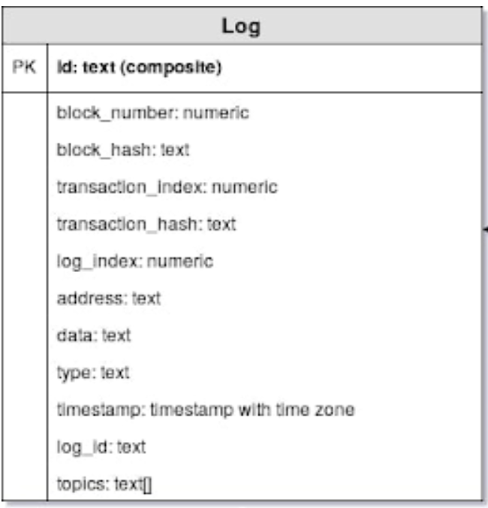
The Ethereum Log Class

Id
Return to Top
Description | Identifier Hash
Datatype | Text ( Composite)
Example | 0x00000000cc7c3b7faeca2e5059320a584cedbafe55c82ced3e57948ae21e3609

Block Number
Return to Top
Description | Block number where this log was in. null when its pending. Block height shows lenght of blockchain
Datatype | Numeric
Example | 9529604

Block Hash
Return to Top
Description | Hash of the block where this lg was in. null when its pending.
Datatype | text
Example | 0x7eaea3baacd3b5ffb9833abf9c77a851db0feb874a93d97cfca89c9e891adaa2

Transaction Index
Return to Top
Description | Integer of the transaction index position log was created from
Datatype | numeric
Example | 33

Transaction Hash
Return to Top
Description | Hash of the transactions this log was created from
Datatype | text
Example | 0xeaf089acba8a7ca74feee1b35ca0ab62aa42c5ba3c746a4aed94a308d6a674fb

Log Index
Return to Top
Description | Integer of the log index position in the block
Datatype | numeric
Example | 82

Address
Return to Top
Description | Address from which this log originated
Datatype | text
Example | 0x4D58b1E8007078eCc6eaf6DF7527b64E46831D23

Data
Return to Top
Description | payload
Datatype | text
Example | 0x000000000000000000000000000000000000000000000000000000000000011b

Type
Return to Top
Description
Datatype | text
Example | mined

Timestamp
Return to Top
Description | Timestamp of log entry
Datatype | timestamp with time zone
Example | 2020-02-21 23:34:19+00

Log Id
Return to Top
Description | Log ID
Datatype | text
Example | log_8e2768f6

Topics
Return to Top
Description | a type of indexing of max 3 parameters for easier access
Datatype | text[]
Example | {0xddf252ad1be2c89b69c2b068fc378daa952ba7f163c4a11628f55a4df523b3ef, 0x0000000000000000000000006cdfb19632e4d0805064b741d39c6ff0a9141952, 0x00000000000000000000000035cdcbdb6a5aef115b9306ce9c79a69321300203 }

1) https://docs.google.com/spreadsheets/d/1ehCIQxjSZcVLnddDWHBzhPb8h83mHWZxvyX9eckghbU/edit#gid=408398242

