A.1.9.1 Args
Return to JSON
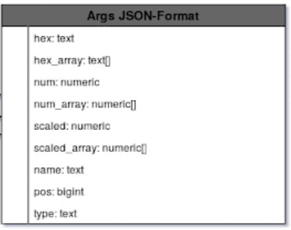
The Ethereum JSON Argument Formats

Hex
Return to Top
Description | Hexidecimal Value
Datatype | text
Example

Hex Array
Return to Top
Description | Array of Hexidecimal Values
Datatype | text[]
Example

Num
Return to Top
Description | Numeric Value
Datatype | numeric
Example

Num Array
Return to Top
Description | Array of Numeric Values
Datatype | Numeric[]
Example

Scaled Numeric
Return to Top
Description | Scaled Numeric Value
Datatype | numeric
Example

Scaled Array
Return to Top
Description | Array of Scaled Numeric Values
Datatype | numeric[]
Example

Name
Return to Top
Description | Name Value
Datatype | text
Example

Pos
Return to Top
Description | Positive Value
Datatype | BigInt
Example

Type
Return to Top
Description | Type Name Value
Datatype | text
Example

