A.1.9.2 Links
Return to JSON
Example of an array of Links:
[ {"link": "https://invictuscapital.com/crypto10hedged", "description": "website"},
{"link": "https://etherscan.io/token/images/c10_28.png", "description": "logo"},
{"link": "team@invictuscapital.com", "description": "email"},
{"link": "https://medium.crypto20.com/", "description": "blog"},
{"link": "https://www.reddit.com/r/invictuscapital", "description": "reddit"}
]
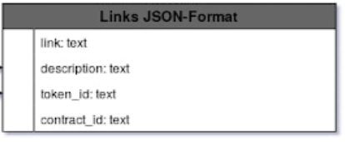
The Ethereum JSON Link decription

Link
Return to Top
Description | Hypertext Link
Datatype | Text
Example | https://invictuscapital.com/crypto10hedged

Description
Return to Top
Description | Description of the link
Datatype | text
Example | website

Token Id
Return to Top
Description | Token associated with the Link
Datatype | text
Example

Contract Id
Return to Top
Description | Contract associated with the link
Datatype | text
Example

