Test Environment (TE) Systems Description

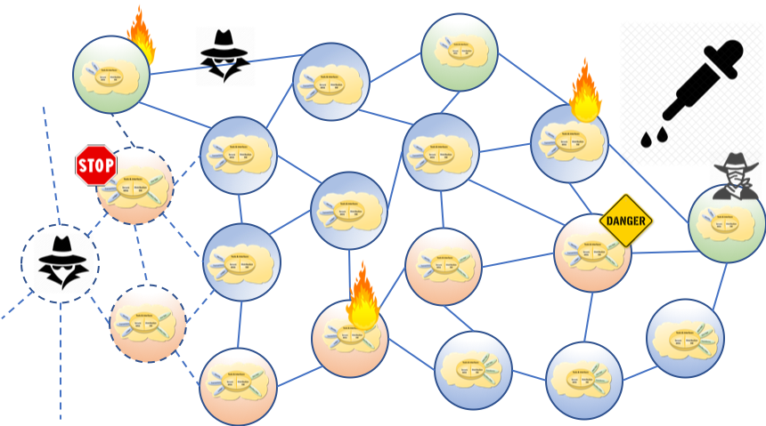
<center style="font-size:30px"> <b>DISTRIBUTED IMMUTABLE DATA OBJECT</b> </center> <center style="font-size:30px"> DIDO </center> <center style="font-size:30px"> Test Environment (TE) <br/> System Description </center> <center> <i>Version 0.2</i> </center> <center> <i>August 2019</i> </center>

Abstract
The excitement, expansion, and advancement in Distributed Computing resulting from Satoshi Nakamoto’s paper Bitcoin: A Peer-to-Peer Electronic Cash System 1) paper has highlighted the need for a Reference Architecture (RA) focused on Distributed Immutable Data Objects (DIDO)s, where it is understood that DIDOs include, but not limited to cryptocurrencies, the original blockchain, and distributed ledger technologies. This paper, an OMG Discussion paper, presents an RA for DIDOs.

1) S. Nakamoto, “Bitcoin: A Peer-to-Peer Electronic Cash System,” 24 May 2009. [Online]. Available: https://bitcoin.org/bitcoin.pdf.

