Welcome to DIDO WIKI
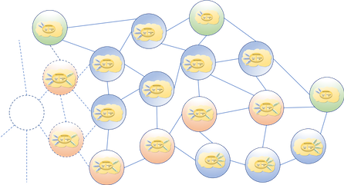

Contact Us:
Emailmailto: DDSFoundation@omg.org

About
The term Distributed Immutable Data Objects (DIDO) refers to the underlying technologies supporting distributed data and computation across a distributed network of peers using consensus algorithms to maintain integrity and consistency across the network. After the publication of Satoshi Nakamoto’s paper Bitcoin: A Peer-to-Peer Electronic Cash System 1) and the exponential growth of other cryptocurrencies, there is a need to understand, in general terms, the underlying DIDO architectures and provide a framework to enable engineering due diligence of DIDOs. DIDOs are not limited to cryptocurrencies, the original blockchain, or distributed ledger technologies. DIDOs are applicable to other non-cryptocurrency domains such as supply chain, registries for birth, deaths etc., and lists of authentication and identification (IA) acceptable certificates including those that have been revoked. The DIDO concepts are captured within a Reference Architecture (RA), intended to represent any architectures relying on distributed networks of peers that store data and allow parallel computation. The DIDO RA is not intended as a physical “must-have” requirements list, but more as a conceptual catalog of what “can-be”.

WIKI Organization
The DDS Foundation WKI site is organized into a private and a public area.
Private Area for internal use only and is never intended for migration from the sitePublic Area is a sandbox/development area. The information here is ultimately intended for public consumption DIDO
NoteFollow this link to the official DDS Foundation site.

1) S. Nakamoto, “Bitcoin: A Peer-to-Peer Electronic Cash System,” 24 May 2009. [Online]. Available: https://bitcoin.org/bitcoin.pdf.

