2.2.3 Decentralized Finance (DeFi) Layers
return to Technical Views
The Decentralized Finance (DeFi) have defined layers 0 through 31)
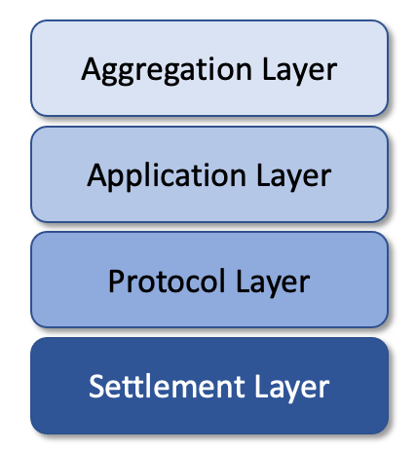
The Layers used in Decentralized Finance (DeFi).
Sharma defines the four layers as:
Settlement Layer is also referred to as Layer 0 because it is the base layer upon which other DeFi transactions are built. It consists of a public blockchain and its native digital currency or cryptocurrency. Transactions occurring on DeFi apps are settled using this currency, which may or may not be traded in public markets. One example of the settlement layer is Ethereum and its native token ether (ETH), which is traded at crypto exchanges. The settlement layer can also have tokenized versions of assets, such as the U.S. dollar, or tokens that are digital representations of real-world assets. For example, a real estate token might represent ownership of a parcel of land. Protocol Layer are the standards and rules written to govern specific tasks or activities. In parallel with real-world institutions, this would be a set of principles and rules that all participants in a given industry have agreed to follow as a prerequisite to operating in the industry. DeFi protocols are interoperable, meaning they can be used by multiple entities at the same time to build a service or an app. The protocol layer provides Liquidity to the DeFi ecosystem. One example of a DeFi protocol is Synthetix, a derivatives trading protocol on Ethereum. It is used to create synthetic versions of real-world assets.Application Layer, as the name indicates, is where consumer-facing applications reside. These applications abstract underlying protocols into simple consumer-focused services. Most common applications in the cryptocurrency ecosystem, such as decentralized cryptocurrency exchanges and lending services, reside in this layer. Aggregation Layer, is the aggregation layer where aggregators connect various applications from the previous layer in order to provide a service to investors. For example, they might enable the seamless transfer of money between different financial instruments to maximize returns. In a physical setup, such trading actions would entail considerable paperwork and coordination. But a technology-based framework should smooth out the investing rails, allowing traders to switch between different services quickly. Lending and borrowing is an example of a service that exists in the aggregation layer. Banking services and crypto wallets are other examples.

1) Rakesh Sharma, Investopedia, 24 March 2021, Decentralized Finance (DeFi) Definition, Accessed 24 May 2021, https://www.investopedia.com/decentralized-finance-defi-5113835

