2.3.4.2.2 Data-in-Motion
Return to State of Data Taxonomy

Overview
Return to Top
Data-in-Motion, also referred to as Data in Transit or Data in Flight, is a Digital Asset transmitted between locations (i.e., between computers or computer components). Data-In-Motion also describes data within Random Access Memory (RAM).
Some examples of Data-in-Motion include data:
Moving from one Endpoint to another Endpoint (e.g., endpoint device to a Web Application (Web App)Moving between Virtual MachinesMoving between Cloud ServicesTraversing trusted private networks (i.e. Intranet) or untrusted networks (i.e., Internet).Once the data arrives at its final destination, it is classified as Data-at-Rest.
Because Data-in-Motion is vulnerable to Man-in-the-Middle (MiTM) Attack attacks, it is often Encrypted to prevent interception. For example, the Internet Small Computer System Interface (iSCSI) transport layer incorporates Internet Protocol Security (IPsec), which can encrypt data as it is transferred between two devices to prevent a Hacker with a sniffer from seeing the contents of that data. IPSec has been used extensively as a transit encryption protocol for Virtual Private Network (VPN) tunnels because it makes use of Cryptography Algorithms such as Triple DES (3DES) and Advanced Encryption Standard (AES). Encryption Platform software can also be integrated with existing Enterprise Resource Planning (ERP) systems to keep Data-in-Motion secure.

DIDO Specifics
Return to Top

Overview
Within DIDOs, the Data-In-Motion refers to data as it moves between the Nodes within a Node Network. The data moves on an infrastructure that includes Hypertext Transfer Protocol (HTTP), Hypertext Transport Protocol Secure (HTTPS), Gossip Protocol, etc. There are any number of Technical and de facto Standards that are relevant to the Transport of the data between the nodes.
Although the Data-In-Motion is dependent-upon and influenced-by the Transport Layer, this section is concerned about the data flowing on the Transport Layer rather than on the Physical Layer and the Protocols.
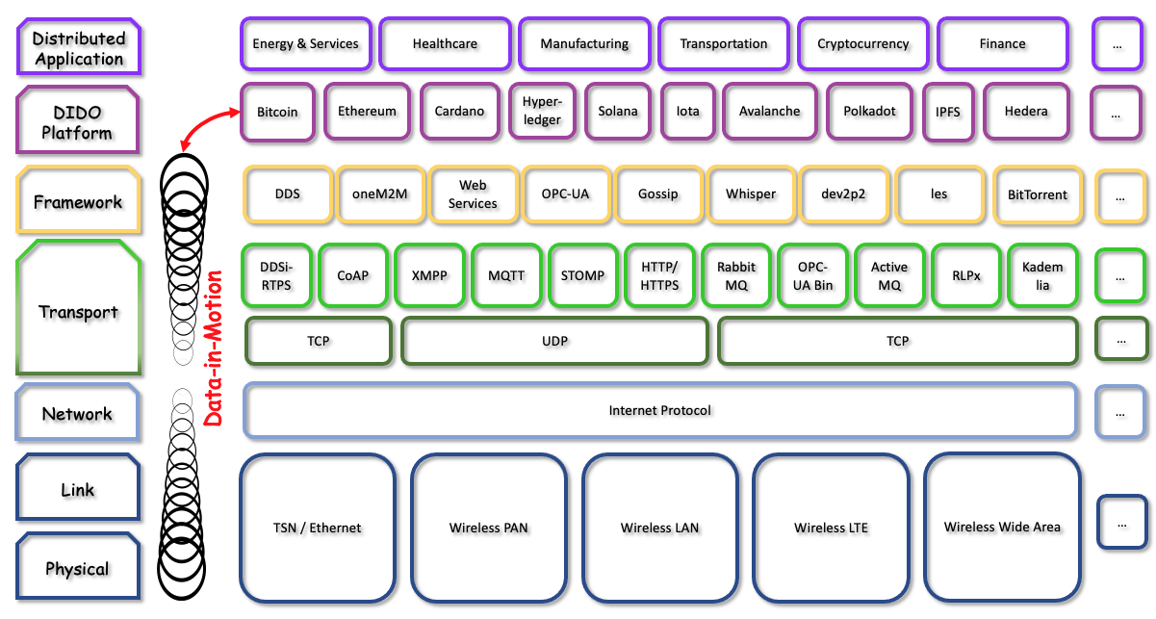
The layers in a DIDO and where the Data-In-Motion occurs.
Note: Also see the figure describing the Industrial Internet Consortium’s Connectivity Framework in 4.3.5.3 System Manageability Issues.
IIOT Level1) | Description
Distributed Application | Distributed Application (ĐApp or DApp) are Applications that exist and run on a distributed Peer-to-Peer (P2P) network of Nodes. DApps are outside the control of a single Governing Body. DApps are created for a variety of purposes, including:  EnergyServicesHealthcareManufacturingSupply ChainTransportationCryptocurrencyFinanceGamingSocial media
DIDO Platform | DIDO Platforms are not a single software entity such as in an Application, but rather a set of components integrated together. In a DIDO, the integration includes Software and Hardware (H/W) Components that are more than just the Software (SW) and Hardware (H/W) components integrated as a Software Stack or Solution Stack residing on a single Node but on a collection of Nodes called a Node Network.
Framework | A Framework is Software (SW) that is a Non-Functional Requirements abstraction of Reusable, generic, tailorable Components by the use of user-written, application-specific Plug In software. Frameworks provide a standardized mechanism for designing, building and deploying Applications. Frameworks leverage either a Software Stack or Solution Stack.  The lowest level of the Framework covers the highest layer of the Open Systems Interconnection (OSI) Model, the Application Layer and includes:
Transport | There are two levels to the Transport Level: one for message transport mechanisms and one purely for connectivity:  The Message Transport Level is analogous to the Open Systems Interconnection (OSI) Model Presentation Layer and includes the following messaging systems: DDSI-RTPSConstrained Application Protocol (CoAP)eXtensible Messaging and Presence Protocol (XMPP)Message Queuing Telemetry Transport (MQTT)Simple (or Streaming) Text Oriented Message Protocol (STOMP)Hypertext Transfer Protocol (HTTP)Hypertext Transport Protocol Secure (HTTPS)RabbitMQOpen Platform Communication Unified Architecture (OPC-UA)Apache ActiveMQRLPxKademliaThe Connectivity Level is analogous to the Open Systems Interconnection (OSI) Model netlayer and includes:Transmission Control Protocol (TCP)User Datagram Protocol (UDP) Port Numbers
Network | The Network Level is analogous to the Open Systems Interconnection (OSI) Model Session Layer providing data routing paths for network communication. Data is transferred in the form of packets via logical network paths in an ordered format controlled by the network layer. Logical connection setup, data forwarding, routing, and delivery error reporting are the Network Layer’s primary responsibilities.  This layer includes:
Link | The Link Level is analogous to the Open Systems Interconnection (OSI) Model Data Link Layer (DLL) controlling connections between multiple computers. The session layer tracks the dialogs between computers, which are also called sessions. This layer establishes, controls and ends the sessions between local and remote applications.
Physical | The Physical Level is more or less a combination of the Open Systems Interconnection (OSI) Model Physical Layer and Transport Layer.  - Pulse-Amplitude Modulation (PAM)Wireless Network - Local Area Network (LAN)Wireless Network - Long-Term Evolution (LTE)Wide Area Network (WAN)Network CablingRegistered Jack-45 (RJ45) ConnectorsWifi Frequencies Network Devices other than Routers :HubSwitchBridgeGatewayModemRepeaterNetwork Appliance

Discussion
An alternate way to view the Stack is to use the TCP/IP Conceptual Model. Figure graphically represents the TCP/IP Conceptual Model.
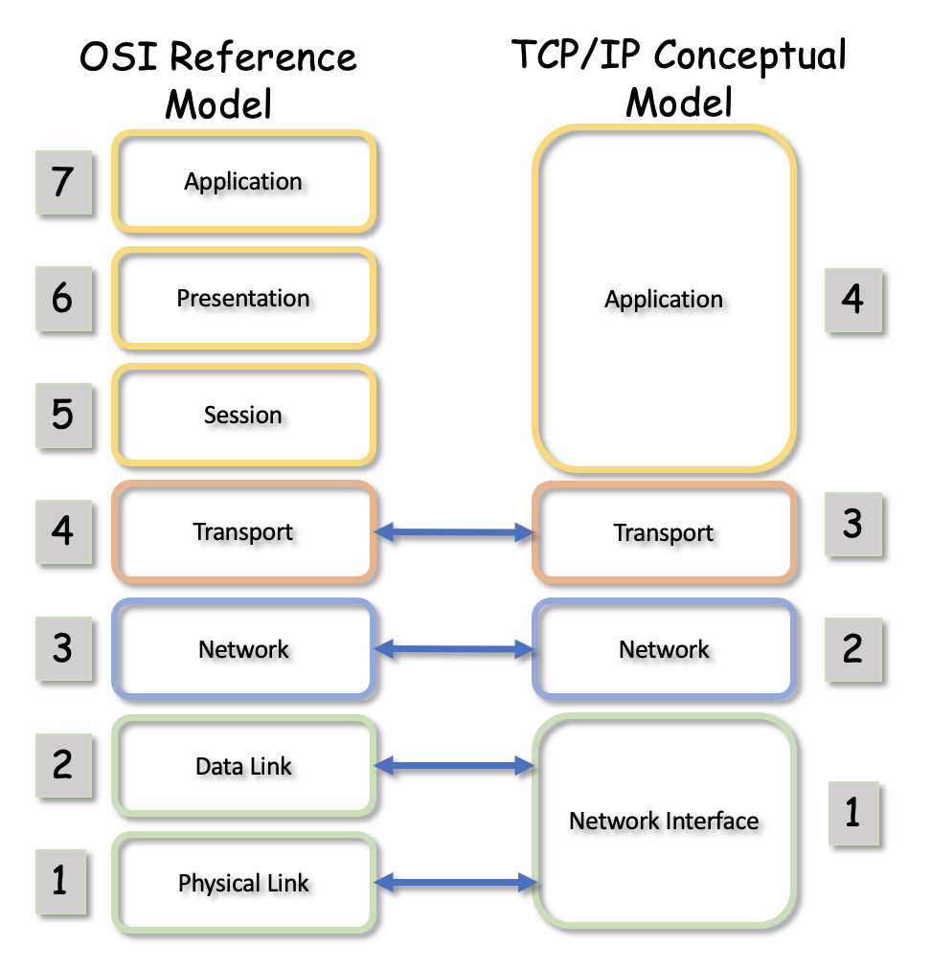
Most of the DIDO Platforms, in combination with the Frameworks and Application Layer, provide a Reusable, general mechanism for Dapps to interact with oither DIDO Nodes in a Node Network. However, this combination of Platforms, Frameworks, and Applications create DIDO Silos thereby inhibiting Interoperability between the silos.
Bridges can be built between the Silos. However, existing DIDO Platforms have no incentive to design or implement Bridges. In fact, as the purveyor of competitive DIDO Platforms, they have a distinct disincentive. Many of the DIDO Platform Application Programming Interfaces (APIs) are also poorly documented and hide behind a curtain of Open Source Software (OSS) as standards.
The Interoperability issues between the various platforms silos can be traced to the lowest level of the DIDO Platform, or depending on the perspective, the upper level of the Open Systems Interconnection (OSI) Model Presentation Layer. For example, the selection of a Framework narrows the Interoperability options to those DIDO Platforms that have selected the same Framework. The same can be said of the messaging systems defined in Transport --> Message Transport Level. Messages are at the core of DIDO Platforms.

1) The Industrial Internet Consortium Levels are similar, but different from the Open Systems Interconnection (OSI) Model Layers. However, there is some overlap between the Levels and Layers especially at the lower rungs. However, it is important to differentiate between the two. Where possible in the discussion of the Levels, the corresponding Layers are provided.

