4.2.6.2 Efficiency Metrics
Return to Usability

About
Return to Top
Efficiency is measured in terms of the time it takes to complete a task from when the task is initiated to when it is successfully completed. The units used to record the time must be uniform for all tasks (i.e., milliseconds, seconds, minutes, etc).
Mathematically The time taken to complete a task can then be calculated by simply subtracting the start time from the end time:
There are two ways to calculate Efficiency:
Time-Based EfficiencyOverall Relative Efficiency

Time-Based Efficiency
Return to Top
In this calculation, the quotient from the division of the success of a task (either one or zero) divided by the time to accomplish a task is an indicator of the efficiency of the task. For example, if a tasks was not successful, then the success of the task is zero and the efficiency is zero. If the task is successful and it takes one minute to accomplish the task, then the efficient is one (i.e., 1/1). If it takes two minutes to accomplish the task, then the efficiency is one half (i.e., 1/2 = .5).
To calculate the Time-Based Efficiency for all tasks and all users, the following equation applies:
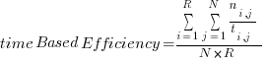
Where:
N : The total number of tasks (goals)R : The number of usersni,j : The result of task i by user j; if the user successfully completes the task, then Nij = 1, if not, then Nij = 0tij : The time spent by user j to complete task i. If the task is not successfully completed, then time is measured till the moment the user quits the taskJustin Mifsud1 provides an excellent example of how for calculating time-based efficiency:
Suppose there are 4 users who use the same product to attempt to perform the same task (1 task). 3 users manage to successfully complete it – taking 1, 2 and 3 seconds respectively. The fourth user takes 6 seconds and then gives up without completing the task.
Taking the above equation:
N = The total number of tasks = 1R = The number of users = 4User 1: Nij = 1 and Tij = 1User 2: Nij = 1 and Tij = 2User 3: Nij = 1 and Tij = 3User 4: Nij = 0 and Tij = 6Placing the above values in the equation:
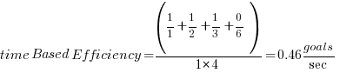

Overall Relative Efficiency
Return to Top
The overall relative efficiency uses the ratio of the time taken by the users who successfully completed the task in relation to the total time taken by all users. The equation can thus be represented as follows1):
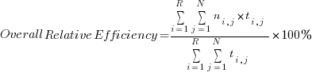
Justin Mifsud1 provides an excellent example of how for calculating Overall Relative Efficiency.
Assume there are 4 users who use the same product to attempt to perform the same task (1 task). 3 users manage to successfully complete it – taking 1, 2 and 3 seconds respectively. The fourth user takes 6 seconds and then gives up without completing the task.
Taking the above equation:
N = The total number of tasks = 1R = The number of users = 4User 1: Nij = 1 and Tij = 1User 2: Nij = 1 and Tij = 2User 3: Nij = 1 and Tij = 3User 4: Nij = 0 and Tij = 6Placing the above values into the equation yields the following:
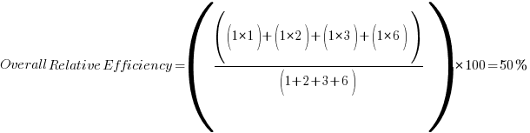

DIDO Specifics
Return to Top

1) UI Designer, Efficiency, Accessed 19 November 2020, http://ui-designer.net/usability/efficiency.htm

