Test Environment (TE) Systems Description
Return to Public Area

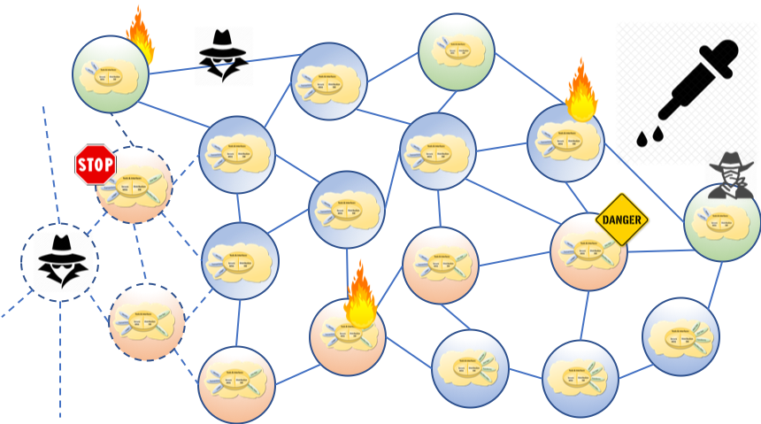
<center style="font-size:30px"> <b>DISTRIBUTED IMMUTABLE DATA OBJECT</b> </center> <center style="font-size:30px"> DIDO </center> <center style="font-size:30px"> Test Environment (TE) <br/> System Description </center> <center> <i>Version 0.2</i> </center> <center> <i>August 2019</i> </center> <center style="font-size:12px"> R. W. “Nick” Stavros<br/> Ian T. Stavros<br/> Bryan Turek </center> <center style="font-size:10px"> <b><i>Jackrabbit Consulting</i></b> </center> <center style="font-size:12px"> Marc Abrams<br/> John Black </center> <center style="font-size:10px"> <b><i>Harmonia Holdings, LLC</i></b> </center>

Abstract
The excitement, expansion, and advancement in Distributed Computing resulting from Satoshi Nakamoto’s paper Bitcoin: A Peer-to-Peer Electronic Cash System 1) paper has highlighted the need for an easy, secure, isolated, sandbox containing a wide assortment of virtual computer nodes that supports the needs of a community of users to experiment with different and diverse DIDO platforms supporting a wide range of Distributed Immutable Data Objects (DIDO)s, where it is understood that DIDOs include, but not limited to cryptocurrencies, original blockchain, distributed ledger technologies, files and communications. This paper, an OMG Discussion paper, presents an TE for DIDOs.

1) S. Nakamoto, “Bitcoin: A Peer-to-Peer Electronic Cash System,” 24 May 2009. [Online]. Available: https://bitcoin.org/bitcoin.pdf.

