Object Management Group
140 Kendrick Street
Building A, Suite 300
Needham, MA 02494 U.S.A.

Telephone: +1-781-444-0404
Facsimile: +1-781-444-0320
The OMG
Information Exchange Framework:
A White Paper

DRAFT

OMG Document: mars/08-12-12

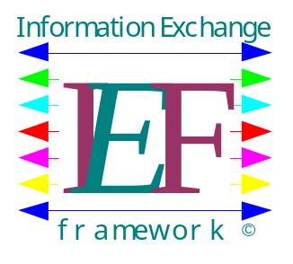
Table of Contents

Purpose 1
Introduction 3
Semantic Interoperability 6
Motivation 7
Description of Key Elements of the IEF 8
Exchange Mechanisms 11
Application Transport Mechanisms 14
Policy Management and Enforcement 15
Information Models 18
Guidelines 19
The IEF Roadmap 20
Communications Plan 22
Additional References 23
Appendix A. The IEF Information Model 24
Appendix B. US Federal Enterprise Architecture Data Reference Model - 26
Appendix C. The Open Group’s Boundaryless Information Flow - 27
Appendix D. National Information Exchange Model (NIEM) 28
Appendix E. Universal Data Element Framework (UDEF) 29
Additional Notes 31

Purpose
(1 pp)

The purpose for this OMG White Paper is to describe the Object Management Group (OMG) Information Exchange Framework (IEF) and to provide the following:

A guideline for developers to help understand what the key elements of policy driven information exchange are, given the myriad approaches available with today’s technologies,

The identification of a set of standards with which to implement policy driven information exchange using OMG and complementary standards bodies sponsored standards,

A brief description of each of these standards,

A roadmap for the development of OMG RFIs, RFCs, and RFPs to consistent with and supportive of the IEF, and

To provide a reference to other efforts involved in the development of information exchange concepts.

The contributors to this paper include (but a not limited to, and in particular order):
Char Wales, MITRE
Kenny Cason, Boeing
Rother Hodges, US Navy, NUWC
Paula Moss, Raytheon Company
David Chizmadia, Promia
Paul Work, Raytheon Company
Mike Abramson, Advanced Systems Management Group
Gary Sikora, Progeny Systems
Tom Burns, Progeny Systems
Larry Shirley, Progeny Systems
Jeremiah Albrant, SSC San Diego
John Thier, General Dynamics
Nick Stavros, MITRE
Andrew Morin, Progeny Systems
Craig Campbell, DND

Thanks also to …
Chairs from C4I DTF, ADTF, SwA ABSIG, Ontology PSIG, TOG Semantic Interoperability Forum and others that helped in the cross coordination within the OMG and outside of the OMG.

Introduction
The last decade there has been a broad community appeal to dramatically improve information interoperability (quality, availability, usability and protection). This parallels the broadening appreciation that the exploitation and sharing of information, in a secure and trusted manner, is the cornerstone of effective management and acts as a resource multiplier in the operational environment. Access to quality information improves understanding of the situation; improves decisions; and aids in planning. Management and operational teams are seeking ACCURATE, RELEVANT, TIMELY, USABLE, COMPLETE, BRIEF, SECURE information in a form that facilitates their decision making and planning processes.
Terrorist attacks, peacekeeping, re-building failed states, pandemics and natural disasters require both rapid and prolonged responses from public security community, comprising federal, state/provincial and municipal government agencies. In many instances, these coalitions will involve international cooperation, non-governmental organizations (NGOs) and Private Volunteer Organizations (PVOs). The cycle of planning, preparations, response and reconstruction requires continuous collaboration of potential participants to mitigate the impact on citizens, critical infrastructure and the economy. It is widely known that the effectiveness of government is determined by its ability to quickly, efficiently, and securely share quality information amongst responding public and private agencies. And, it is well documented the current information systems fail to deliver the core capabilities across a broad cross-section of agencies.
The challenge emergency and crisis management organizations is the advancement of a process for transforming an assortment of information and security systems into a pan-agency interoperable environment, while laying the foundation for continual change and expanding requirements. The real-world environments are dynamic, asymmetric and time-critical; and the partners a culturally diverse public security, medical, first responders, police, fire service, military, OGDs, NGOs at the municipal, state/provincial, federal and international levels; each of these organization or agency having a different financial capacity and legislated mandate.
Out of this plethora of environments there is a desire, from a broad cross-section of this community, to deliver the capacity to provide context sensitive information; targeted at mission, operation, situation and user specified needs; if and when it is required to protect the public and national interests. In techish terms, this translates to a set of services that deliver flexible, agile and adaptive information exchange mechanisms that can be rapidly deployed in a cost effective manner, across a broad cross-section of the emergency and crisis management communities. It also means than propose solutions must leverage and integrate legacy investments in people, processes and technologies and overcome inflexible and often brittle technologies that are proving costly to integrate, deploy and maintain.
The Information Exchange Framework (IEF) is targeting the integration of many standards efforts in the areas of architecture, ontology and infrastructure across many domains to deliver a framework of publically accepted specifications and standards to address the needs of the community. The goal of the IEF is the provision of semantic interoperability within and across communities – ensuring that community specified languages and ontologies, e.g.:
- Disaster Management Ontology (DMO: http://esw.w3.org/topic/DisasterManagement);
- Geospatial Emergency (http://www.geospatialmeaning.eu/tag/emergency-management/);
- Emergency Management Information Standards
- Common Alerting Protocol (CAP)
- Emergency Data Exchange Language - Distribution Element (EDXL-DE)
- Emergency Data Exchange Language - Resource Messaging (EDXL-RM)
- Emergency Data Exchange Language - Hospital Availability Exchange (EDXL-HAVE)
- Cyclone Warning Markup Language (CWML)
- Tsunami Warning Markup Language (TWML)
- People Finder Interchange Format PFIF
- Tactical Situation Object TSO
- 3 Geospatial Standards
- GeoRSS
- Geography Markup Language (GML)
- Miscellaneous
- ISO 8601:2004 Representation of dates and times
- The National Information Exchange Model (NIEM),
- HL7
In addition, the IEF will seek other related initiatives in the areas of architecture, services and technologies to the delivery interoperable emergency and crisis response services, e.g.:
- Initiatives:
  - Crisis Response Executive Advisory Team (CREATe: http://www.itcm.org/approach/create.html);
  - Information technology for Crisis Management (ITCM: http://www.itcm.org/);
  - Shared Operational Picture Exchange Services (SOPES: http://www.omg.org/c4i);
  - Multilateral Interoperability Programme (MIP: http://www.mip-site.org);
  - Other.
- Services
- Web Feature Service (WFS)
- Web Mapping Service (WMS)
- Sensor Observation Service (SOS)
- SensorML
- Sensor Planning Service (SPS)
- Common Object Request Broker (CORBA)
- CORBA (Internet Inter-ORB Protocol) IIOP
- Data Distribution Service (DDS)
- Hypertext Transfer Protocol (HTTP)
- Web Services Description Language (WSDL)
- Simple Object Access Protocol (SOAP)
- Universal Data Element Framework (UDEF)
- Web Services Policy Framework (WS-Policy)
- Semantics of Business Vocabulary and Business Rules (SBVR)
- Knowledge Domain Meta-model (KDM)
- Common Warehouse Meta-model (CWM)
- Ontology Definition Metamodel (ODM)
- UML Profile for DODAF and MODAF (UPDM);
- DODAF, MODAF, NAF, PSAF, TOGAF, …
- Model Driven Architecture (MDA)
- Other

Traditional interoperability initiatives have focusd on the user interfaces and network infrastructures rather than the challenging task of understanding and managing the information environment. This lack of focus on the information environment resulted in the generation of a large number of incongruent specifications, applications, languages, and data sets without any real focus on achieving integration or interoperability (stove-piped environments). The IEF will target the semantics and release-ability of information - so critical to delivering the capability to effectively share digital information in a secure and trusted manner and features so often neglected by stakeholders, integrators and developers.
The target for the Object Management Group (OMG) IEF initiative is a set of specifications for a policy (or rule) based services, which combine to deliver a flexible, agile and secure information sharing capability. As illustrated in Figure 1, there are a number of elements that comprise an adaptive information exchange capability. These mechanism and services include such elements as:
- An Application interface that supports the integration of both new and legacy systems and applications.
- A data service that serves up semantically complete information in a secure and trusted manner.
- Data distribution services that support Web, network and realtime environments.
- Security services that protect information as it transits the operational networks.
- Logging and auditing services, which support operations and governance.
- A Policy Management capability that enables the user communities to specify their ontological commitments, which are enforces by the APIs and Data Services.
Several of key elements of flexible, agile, and adaptive information sharing to be addressed by IEF developed specifications include:
- Information exchange policy management;
- Architecture based information exchange policy development;
  - Operational, system, security and information views,
  - Community of interest specification,
  - Information semantics specifications, and
  - UPDM compliance;
- Policy based business object and/or message construction;
- Policy based Business object and/or message parsing and processing;
- Semantic, referential and data validation;
- Data Transformation;
- Global Unique IDentifier (GUID) management;
- Information release-ability and security (guard);
- Information suppression and filtering;
- Semantic Guards;
- Tagging and Labeling; and
- Quality of Service (QoS).
The IEF initiative is seeking to integrate exiting specifications and standards, and where needed, develop new standards underpinning the development of adaptive and secure interoperability solutions for a wide range of operational domains. Through agreed policy and ontological commitment, the individual domains will tailor the operations of these mechanism and services to their precise needs.

Semantic Interoperability
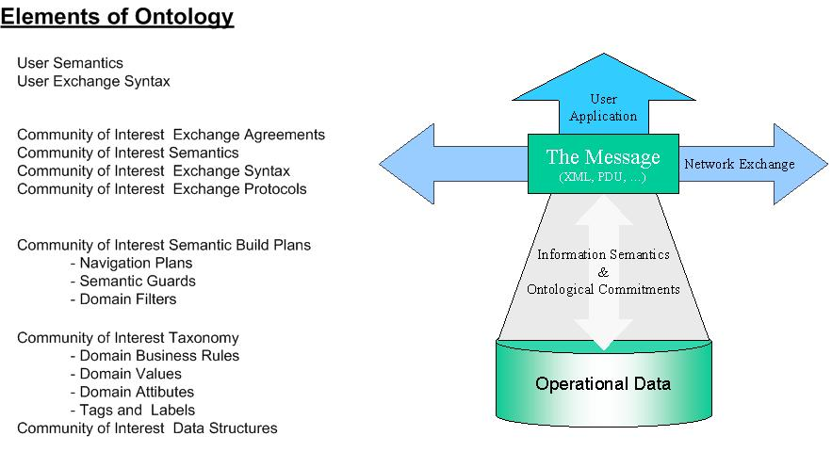
Figure 1 – Elements of Ontology
Semantic Interoperability is the ability of two or more digital systems to exchange information and interpret the meaning of the information automatically. This interpretation by the receiving system should be accurate accurately enough to produce meaningful useful results, as defined by the end users.

Motivation
(2 pp)

The kernel for the development of the concept of an Information Exchange Framework or IEF came out of recent work over the past few years within the OMG and companion standards organizations, such as the W3C and The Open Group.

Within the RTESS and MARS Platform Task Forces, we have a set of information exchange mechanisms that have developed to now include such standards as the Data Distribution Services (DDS) for Real-Time.

The incorporation of the BPMI into the OMG now brings with it the means to address policy mechanisms and controls.

Within several Domain Task Forces (DTFs), such as C4I, Healthcare, Space, and Finance, there has been considerable work going on in the standardization of a managed exchange of information for their various domain users.

And within the several of the Platform and Domain Special Interest Groups (PSIG/DSIG), such as Software Assurance (SwA) and Ontology that have been working on standards that apply in the policy space.

We now see the opportunity to bring together some of these separate standardization efforts to provide for a general purpose solution with which to focus the common elements of the problem of policy based information exchange.

Description of Key Elements of the IEF
(5 pp)
The IEF has 3 key elements which are illustrated in Figure 1. The first is the Exchange Mechanisms and Services element which focuses on the standards that apply to the distribution and transliteration of information. The second is the Policy Management and Enforcement which covers the standards that apply to discovery, filtering, correlation / aggregation, de-confliction, and Quality of Service as applied to information exchange. The third element is associated with the models of information, are specific to the individual domains.

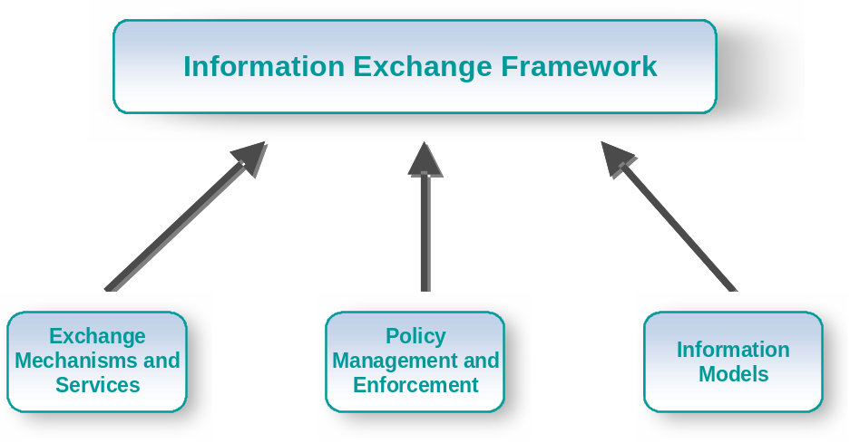
1. Information Exchange Framework

In Figure 2, these are further decomposed into some of the types of standards that belong to each of the elements. And in the case of the Information Models, some example domain information models that may exist are identified.

Figure 3, simply provides another way one can view the general framework and the domain specific portions. Either way that these elements are shown, like that illustrated in Figures 1, 2, or 3, these all represent the same Information Exchange Framework.
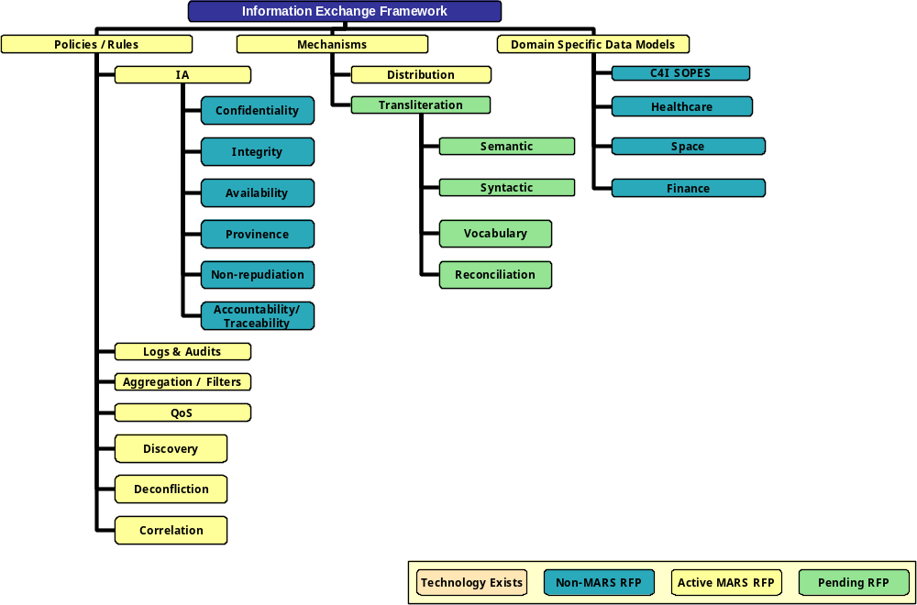
2. IEF with Example Elements – The Original View

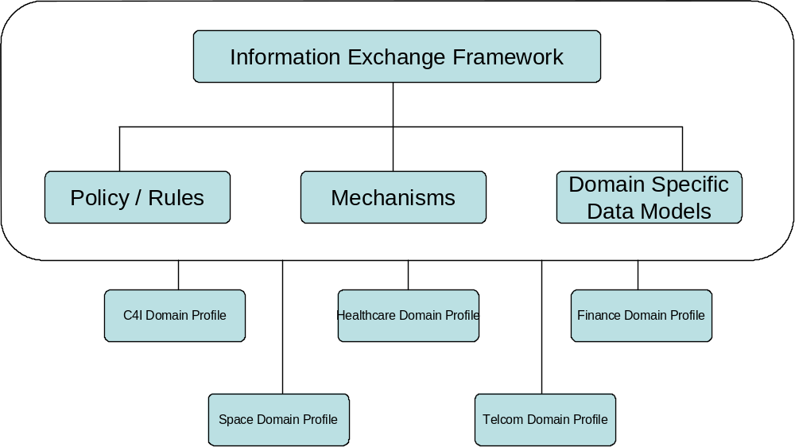
3. IEF with Example Elements – Another View

In the following sections, some of the standards that either exist already or are in the development “pipeline” are identified within the appropriate element of the IEF.
Exchange Mechanisms and Services
The management teams of and modern organization warship requires timely and accurate information in a form that facilitates the decision making process. The exploitation and sharing of information, in a secure and trusted manner, is one of the age-old tenets of effective management practice and of command and control; heart of the ongoing transformation of organizations in the information age; and a major focus of knowledge and information management projects. Equipping a management team and decision makers with the tools to discover, access, assimilate and understand the volumes of information now available over the host of stove-piped local and wide area networks is critical to exploiting information and achieving network (or information) centric capability.
The most difficult part of organizational transformation is the engineering of the information environment, while laying the foundation for continual change. Many organizations operate in dynamic, asymmetric, time-critical real-world environments, which require the delivery context sensitive information; targeted at mission, operation, situation and user specified needs. This differentiates the IEF information exchange mechanisms and services from currently deployed capability, based inflexible and brittle technologies, which prove to be costly to maintain.
As illustrated in Figure xx, there are a number of elements that comprise an adaptive information exchange capability. These mechanism and services include such elements as:
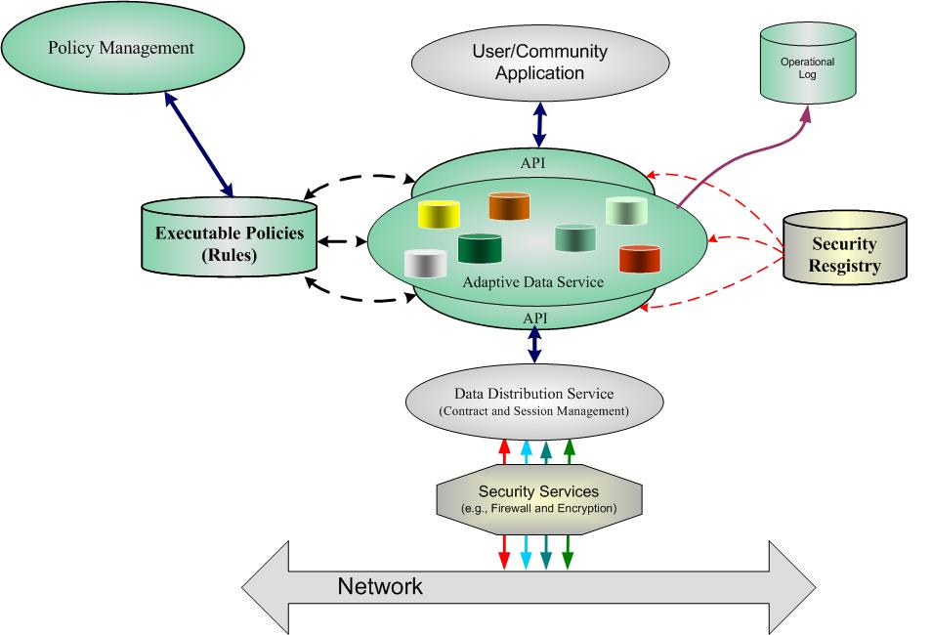
Figure xx – Positioning the IEM
- An Application interface that supports the integration of both new and legacy systems and applications.
- A data service that serves up semantically complete information in a secure and trusted manner.
- Data distribution services that support Web, network and realtime environments.
- Security services that protect information as it transits the operational networks.
- Logging and auditing services, which support operations and governance.
- A Policy Management capability that enables the user communities to specify their ontological commitments, which are enforces by the APIs and Data Services.

The core element is the adaptive data services which controls the processing of information. Some of the services that make up an adaptive and secure data environment include:
- Business object and/or message construction;
- Business object and/or message parsing and processing;
- Semantic, referential and data validation;
- Global Unique IDentifier (GUID) management;
- Data Transformation;
- Information Exchange Policy Enforcement;
- Information release-ability and security (guard);
- Information suppression and filtering;
- Data store interfaces;
- Tagging and Labeling;
- Data Aggregation; and
- Quality of Service (QoS).
The IEF initiative within OMG will seek to integrate exiting specifications and standards, and where needed, develop new standards underpinning the development of adaptive and secure interoperability solutions for a wide range of operational domains. Through agreed policy and ontological commitment, the individual domains will tailor the operations of these mechanism and services to their precise needs.
Existing specifications and standards relevant to this discussion are grouped into two areas: Exchange Mechanisms and Application Transport Mechanisms.

Exchange Mechanisms
The Exchange Mechanisms standards cover the means for encapsulating the information for the purposes of exchange.

Examples of these are:

Common Warehouse
- StdsOrg: = OMG/Analysis & Design PTF
- Version: = 1.1
- DocNumber: formal/2003-03-02
- Dependencies: =

The main purpose of CWM is to enable easy interchange of warehouse and business intelligence metadata between warehouse tools, warehouse platforms and warehouse metadata repositories in distributed heterogeneous environments. This specification proposes that XML Metadata Interchange (XMI) is used to interchange data warehouse metadata based on the CWM metamodel. The CWM metamodel is specified using the Meta Object Facility (MOF) Model, allowing XMI to be used to:
- transform the CWM metamodel into a CWM Document Type Definition (DTD),
- transfer instances of warehouse metadata that conform to the CWM metamodel as XML documents, based on the CWM DTD, and
- transform the CWM metamodel itself into an XML document, based on the MOF DTD, for interchange between MOF-compliant repositories. Thus these specifications work together to allow warehouse metadata and the CWM metamodel to be interchanged using W3C’s Extensible Markup Language (XML).

XMLTelemetricAndCommandExchange
- StdsOrg: = OMG/Space DTF
- DocNumber: = formal/2005-08-01
- Version: = 1.0
- Dependencies: =

This specification is an information model for spacecraft telemetry and commanding data. For a given mission there are a number of lifecycle phases that are supported by a variety of systems and organizations. Additionally, many of these organizations support multiple heterogeneous missions using a common ground segment infrastructure. Telemetry and command definitions must be exchanged among all of these phases, systems, and organizations. This is made difficult and costly because there is no standard method for exchanging this information. The lack of standardization currently requires custom ingestion of the telemetry and commanding information. This customization is inherently error-prone, resulting in the need to revalidate at each step in the lifecycle.

The scope of this specification is limited to satellite telemetry and commanding data constructs necessary to support satellite and payload data design:
- Telemetry data definitions including support for CCSDS packets as well as TDM frames.
- Data manipulation algorithms to support packaging and unpacking of individual data items.
- Commanding data definitions including command identification, argument specification, and validation criteria.
- Data representation definitions.
- Data properties including such things as its default value, validity criteria, and data dependencies.
- The definition of extensible formats such that blocks of information (whether frames of data that are not decommutated or object references or object method calls) can be portrayed in this architecture.

WSDL
- StdsOrg: = W3C
- Version: = n.m
- DocNumber: = http://specs.xm...
- Dependencies: = SOAP

WSDL is an XML-based service description on how to communicate using the web service; namely, the protocol bindings and message formats required to interact with the web services listed in its directory. The supported operations and messages are described abstractly, and then bound to a concrete network protocol and message format. This means that WSDL describes the public interface to the web service.
WSDL is often used in combination with SOAP and XML Schema to provide web services over the Internet. A client program connecting to a web service can read the WSDL to determine what functions are available on the server. Any special datatypes used are embedded in the WSDL file in the form of XML Schema. The client can then use SOAP to actually call one of the functions listed in the WSDL.

SOAP
- StdsOrg: = W3C
- Version: = n.m
- DocNumber: = http://specs.xm...
- Dependencies = HTTP

SOAP (originally Simple Object Access Protocol) is a protocol for exchanging XML-based messages over computer networks, normally using HTTP. SOAP forms the foundation layer of the Web services stack, providing a basic messaging framework that more abstract layers can build on.
There are several different types of messaging patterns in SOAP, but by far the most common is the Remote Procedure Call (RPC) pattern, in which one network node (the client) sends a request message to another node (the server), and the server immediately sends a response message to the client.

Application Transport Mechanisms
The Application Transport Mechanisms standards cover the means of moving the information encapsulated by the exchange mechanisms, at an application level. That is, the framework does not address the layers below the OSI application layer.

Examples of these are:

CORBA IIOP
- StdsOrg: = OMG/Middleware and Related Services PTF
- Version: = n.m
- DocNumber: formal/yyyy-mm-nn

The Internet Inter-ORB Protocol (IIOP) element specifies how GIOP messages are exchanged using TCP/IP connections. The IIOP specifies a standardized interoperability protocol for the Internet, providing “out of the box” interoperation with other compatible ORBs based on the most popular product- and vendor-neutral transport layer. It can also be used as the protocol between half-bridges

The protocol is designed to be suitable and appropriate for use by any ORB to interoperate in Internet Protocol domains unless an alternative protocol is necessitated by the specific design center or intended operating environment of the ORB. In that sense it represents the basic inter-ORB protocol for TCP/IP environments, a most pervasive transport layer.

The IIOP’s relationship to the GIOP is similar to that of a specific language mapping to OMG IDL; the GIOP may be mapped onto a number of different transports, and specifies the protocol elements that are common to all such mappings. The GIOP by itself, however, does not provide complete interoperability, just as IDL cannot be used to build complete programs. The IIOP and other similar mappings to different transports, are concrete realizations of the abstract GIOP definitions.

DDS
- StdsOrg: = OMG/Middleware and Related Services PTF
- Version: = n.m
- DocNumber: formal/yyyy-mm-nn

This specification describes two levels of interfaces:
- A lower DCPS (Data-Centric Publish-Subscribe) level that is targeted towards the efficient delivery of the proper information to the proper recipients.
- An optional higher DLRL (Data Local Reconstruction Layer) level, which allows for a simple integration of the Service into the application layer.

The expected application domains require DCPS to be high-performance and predictable as well as efficient in its use of resources. To meet these requirements it is important that the interfaces are designed in such a way that they:
- allow the middleware to pre-allocate resources so that dynamic resource allocation can be reduced to the minimum,
- avoid properties that may require the use of unbounded or hard-to-predict resources, and
- minimize the need to make copies of the data.

QoS (Quality of Service) is a general concept that is used to specify the behavior of a service. Programming service behavior by means of QoS settings offers the advantage that the application developer only indicates ‘what’ is wanted rather than ‘how’ this QoS should be achieved. Generally speaking, QoS is comprised of several QoS policies. Each QoS policy is then an independent description that associates a name with a value. Describing QoS by means of a list of independent QoS policies gives rise to more flexibility.

This specification is designed to allow a clear separation between the publish and the subscribe sides, so that an application process that only participates as a publisher can embed just what strictly relates to publication. Similarly, an application process that participates only as a subscriber can embed only what strictly relates to subscription.

HTTP
- StdsOrg: = W3C
- Version: = n.m
- DocNumber: http://specs.xm...

Policy Management and Enforcement
(3-5pp discussion of policy management and enforcement, with the starting point is the material in Appendix A)

These standards cover the …

Examples of these are:

ResourceAccessDecision
- StdsOrg: = OMG/Healthcare DTF
- Version: = 1.0
- DocNumber: = formal/2001-04-01

PartyManagementFacility
- StdsOrg: = OMG/Finance DTF
- Version: = 1.0
- DocNumber: = formal/2001-02-68

A key requirement for financial service organizations is to effectively manage the parties, people, and organizations that relate to their business. They must have efficient and consistent access to party related information including relationship and contact information. The vast majority of organizations have many different computer systems operating their daily business processes that all need access to “name and address” information. Unfortunately, this information is generally embedded within each system in a proprietary manner resulting in an environment that is very expensive and difficult to maintain. As a result, redundant, inconsistent information is often proliferated throughout the organization. The Party Management Facility (PMF) defines a standard set of interfaces that will enable a consistent integration strategy for consumers whether they are software vendors, other systems, or end users.

ClinicalObservationsAccessService
- StdsOrg: = OMG/Healthcare DTF
- Version: = 1.0
- DocNumber: = formal/2001-04-06

{Unable to find document.}

TrustedInformationExchangePolicyAndRulesManagement
- DocNumber: = DRAFT RFP MARS/...
- StdsOrg: = OMG/MARS PTF

{TBS}

SemanticsOfBusinessVocabularyandBusinessRules
DocNumber: = dtc/06-
StdsOrg: = OMG
Version: = Draft 1.0

{TBS}

WS-Policy
- StdsOrg: = W3C
- Version: = 1.5
- DocNumber: = http://specs.xml...

Web Services Policy 1.5 - Framework defines a framework and a model for expressing policies that refer to domain-specific capabilities, requirements, and general characteristics of entities in a Web services-based system.

A policy is a collection of policy alternatives, where a policy alternative is a collection of policy assertions. A policy assertion represents an individual requirement, capability, or other property of a behavior. A policy expression is an XML Infoset representation of a policy, either in a normal form or in an equivalent compact form. Some policy assertions specify traditional requirements and capabilities that will ultimately manifest on the wire (e.g., authentication scheme, transport protocol selection). Other policy assertions have no wire manifestation yet are critical to proper service selection and usage (e.g., privacy policy, QoS characteristics). Web Services Policy 1.5 - Framework provides a single policy language to allow both kinds of assertions to be expressed and evaluated in a consistent manner.

Web Services Policy 1.5 - Framework does not specify policy discovery or policy attachments. A policy attachment is a mechanism for associating policy with one or more policy scopes, where a policy scope is a collection of policy subjects to which a policy may apply. A policy subject is an entity (e.g., an endpoint, message, resource, interaction) with which a policy can be associated. Other specifications are free to define technology-specific mechanisms for associating policy with various entities and resources.

Source: W3C Web Services Policy 1.5-Framework Working Draft, Nov 2006

Information Models
(1-2pp discussion on the general topic of information model as they apply to IEF and then provide one or two example information models, starting with SOPES)

The information models …

The following information models have been identified, to date:
- SOPES IEDM
- JC3IEDM
- HL7
- Dublin Core
- DDMS (DISA)
- The Open Group Universal Data Element Framework (UDEF)

Guidelines
(2-5pp)

The following are a small set of guidelines for developers to help leverage the key elements of information exchange and to help sort out the myriad approaches available with today’s technologies.

The IEF must provide an integrated approach and set of standards to meet mission objectives. Based on Exchange mechanisms & Protocols , Policy & Rules, and data exchange models, IEF may provide the simple meta models, list of standards, and profiles sets of these to address information exchange applications

For example to provide a C4I secure information release-ability environment for community of interest exchange, and IEF environment would provide :
- An exchange mechanism:
  - DDS / DEM
- A set of polices and rules
  - Role based access control
  - OWL-RDF
- An exchange data model
  - SOPES –Shared Operational Exchange Services model
  - Contains a set of common exchange semantics

-- This is the “how” section – and requires a couple of examples.

-- Add discussion on ESB and SOA to emphasize that IEF is stds based

The IEF Roadmap
This section addresses the current and proposed RFIs/RFPs/RFCs for the multiple standardization efforts that OMG Task Forces and other standards bodies are working that are considered to be included in the IEF.

As of December 2007, the following RFIs have been issued related to the IEF:

mars/07-09-15: Information Transformation Services RFI

mars/07-09-14: Transliteration and Transcription Services RFI

omg/07-09-04: Data Tagging and Labeling for Security and Privacy RFI ?????? as per discussion – use cases to support for all environments

c4i/08-06-nn: Trusted Information Exchange RFP

Some questions from previous discussions:

- How does one develop a profile that is OMG IEF compliant?
  - Derive a PIM from the metamodel and the PSM(s) from the standards identified in the IEF? OV-37 model

- What is minimum necessary and sufficient to be compliant with the framework?
  - Use only those listed/contained in the metamodel, but this list can be updated via the OMG P&P (RFT/FTF)?

- How do we leverage The Open Group’s Boundryless Information Flow (Appendix D) approach to help with developing an IEF compliant profile? To be done in future releases
  - This would then become the architectural framework that the IEF supports

- How to leverage the TOGAF ADM – MDA Synergy Project to help to do this as well? To be done in future releases
- Develop a Metamodel – Type system for IEF – allows Systems Integrators to use MDA? Base model plus ov-37 other support arch views

Communications Plan
The current means of socializing this concepts in this paper are:

• Complete and Publish this White Paper
• Standup Wiki, populate with initial information, and guidelines for updating it – future- , initial post of the paper with get feed back to chairs for building a baseline critical mass – then allow group updates
• Hold Information Day
• Future work In parallel, visit the TOG, ISO, and other standards bodies to socialize the IEF

Additional References
omg/2006-11-01, TOGAF ADM – MDA Synergy Project, Interim Report
omg/07-10-01: TOGAF ADM / MDA Synergy Project Joint Report
mars/08-06-29: Enterprise Information Security Environment (EISE) Security Architecture

Appendix A. The IEF Information Model
The following diagram represents the IEF Information Model and denotes what the relationships of each identified standard are within the framework.

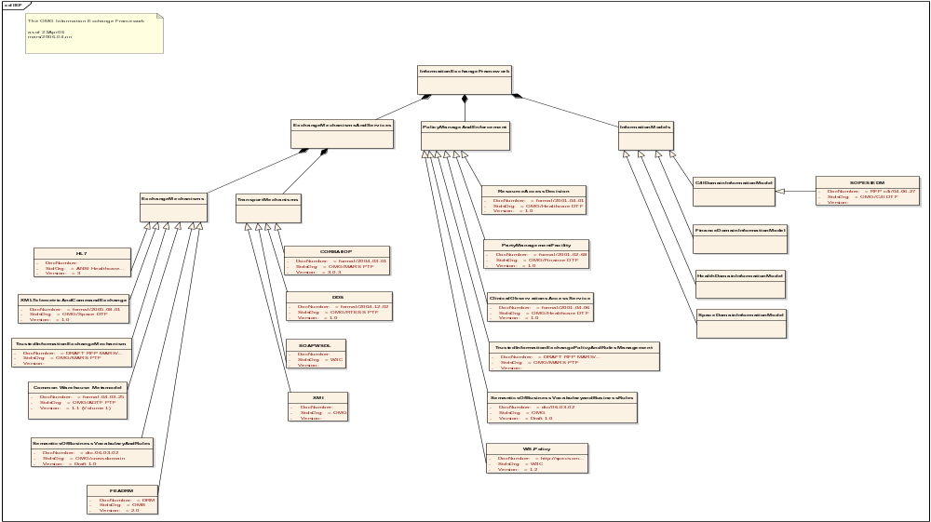

Appendix B. US Federal Enterprise Architecture Data Reference Model -

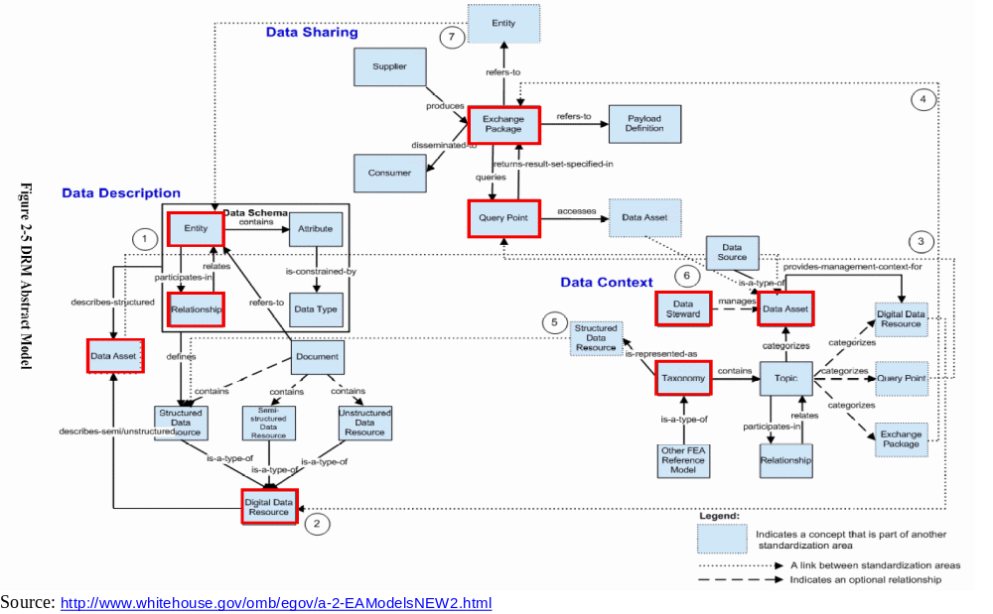

Appendix C. The Open Group’s Boundaryless Information Flow -

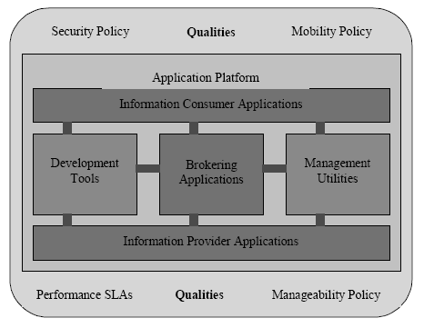
Boundaryless Information Flow: Technical Taxonomy

Source: “An Introduction to Boundaryless Information Flow: Including Business Process and Web Services”, Phil Holmes, Director Consortia Relations, The Open Group, July 2002

Appendix D. National Information Exchange Model (NIEM)

NIEM, the National Information Exchange Model, is a partnership of the U.S. Department of Justice and the Department of Homeland Security. It is designed to develop, disseminate and support enterprise-wide information exchange standards and processes that can enable jurisdictions to effectively share critical information in emergency situations, as well as support the day-to-day operations of agencies throughout the nation.

NIEM enables information sharing, focusing on information exchanged among organizations as part of their current or intended business practices. The NIEM exchange development methodology results in a common semantic understanding among participating organizations and data formatted in a semantically consistent manner. NIEM will standardize content (actual data exchange standards), provide tools, and managed processes.

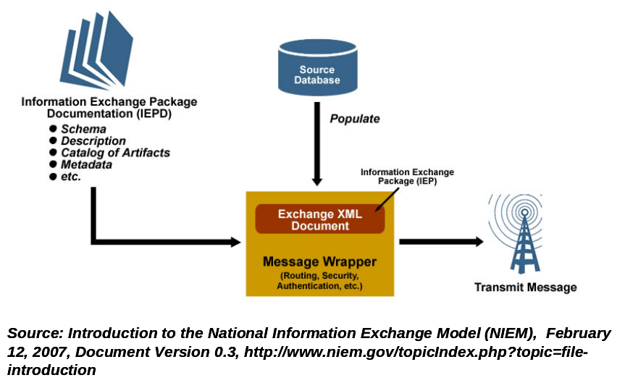

More details to come.

From: http://www.niem.gov/

References:
http://www.niem.gov/files/NIEM_Introduction.pdf

Appendix E. Universal Data Element Framework (UDEF)

The Universal Data Element Framework, or UDEF, effort comes out of The Open Group Semantic Interoperability (SI) Forum and is …

UDEF is a proposed universal instantiation of ISO/IEC 11179-5.

ISO/IEC 11179 - Metadata registries (MDR), addresses the semantics of data, the representation of data, and the registration of the descriptions of that data. It is through these descriptions that an accurate understanding of the semantics and a useful depiction of the data are found.

The purposes of ISO/IEC 11179 are to promote the following:
- Standard description of data
- Common understanding of data across organizational elements and between organizations
- Re-use and standardization of data over time, space, and applications
- Harmonization and standardization of data within an organization and across organizations
- Management of the components of data
- Re-use of the components of data

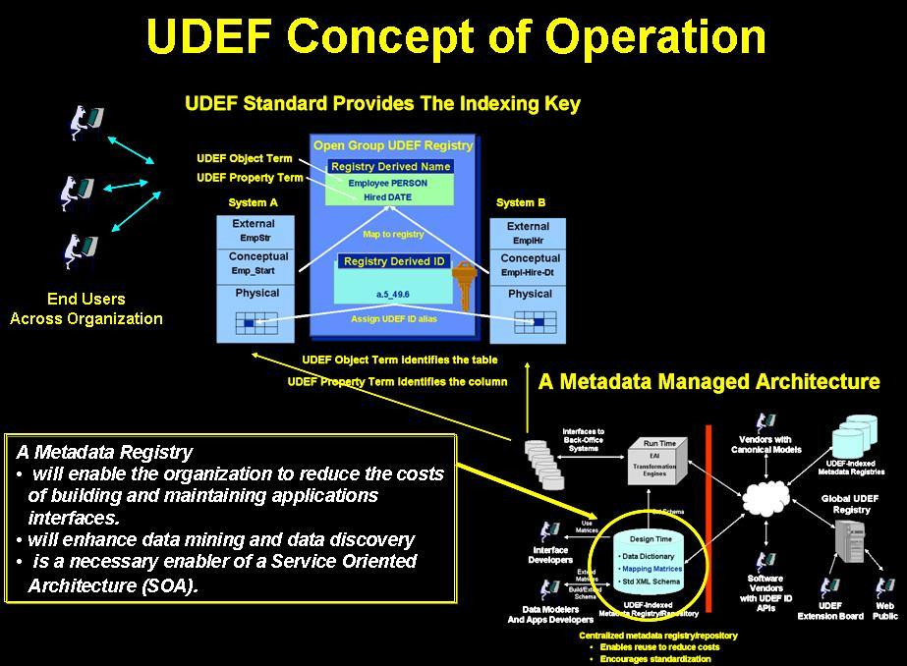

More details to come.

From: http://www.opengroup.org/projects/si/

References:
http://www.opengroup.org/udefinfo/defs.htm
ISO/IEC 11179-1, Second edition, 2004-09-15, Information technology — Metadata
registries (MDR) —Part 1: Framework

Additional Notes
The following are the comments/recommendations/suggestions (in particular order or priority) for this White Paper from the IEF Working Group meeting on Tuesday 11 Dec 07, in Burlingame. The completed ones has been removed in this version.

-- Need to add more detail to figures
-- Add discussion on ESB and SOA to emphasize that IEF is stds based
-- Look into using some wiki (OMG?) to stand up IEF materials – which will others to add more stds to the IEF (and we will use a Wikipedia-like gardening process on the wiki) and use the “categories” capability to help “organize” these until sufficient materials are available to allow for any more formal classification process to be used
-- Convert all of the separate appendices that describe related efforts into a single appendix
-- Question was raised as to whether or not “RPC” should be added
-- The whole topic of Governance (see the above wiki discussion) to deal with “What’s in” and “What’s out” of the IEF – and who governs this
-- Need to add more descriptive materials about what is the IEF

The following are the comments/recommendations/suggestions (in particular order or priority) for this White Paper from the IEF Working Group meeting on Tuesday 23 Sep 2008, in Orlando.

-- Metadata for IEF model
- Std ID
- Organization
- Standard
- Version (to also cover “Profiles”)
- Description
- Rationale
- Verification/Eval Criteria
- Relationship = n/n

mars/07-03-18: IEF Overview presentation , ASMG

