This is a candidate MVF model that, we think, meets all the requirements. It may be less constrained that some of the alternatives but provides a framework for discussion. Note it is still a very informal model. Two examples are provided.

# MVF Model

## Diagram: MVF



1. MVF

## Diagram: MVF Perspective



1. MVF Perspective

## Class Citation

A citation is an external normative source for a MVFEntry.

Direct Supertypes

MVFDenotation

Attributes

CitationText : String



## Class Community

A community is any group, speech community, organization or discipline that may contextualize denotations.

Direct Supertypes

Context

## Class Context

A context is a way to identify and differentiate vocabularies denotations (terms, definitions and citations) for a set of MVFEntries.  
Where a context contextualizes another context, all denotations within that context implicitly are contextualized.

Direct Supertypes

Contextualized, MVFEntry

Associations

contextualizes : Contextualized [*]



A context contextualizes MVF Denotations (Terms, definitions and citations) as being relevant within that context.

: Perspective



hasPrimary : MVFDenotation [*]



A denotation may be marked as primary (ore preferred) within a context.

## Class Contextualized

Associations

inContextOf : Context [*]



## Class Definition

A definition is text describing an MVFEntry.

Direct Supertypes

MVFDenotation

Attributes

DefinitioonText : String



## Class MVFDenotation

A denotation is anything that ascribes meaning to an MVFEntry

Direct Supertypes

Contextualized

Attributes

externalReference



Associations

denotes : MVFEntry [1]



definedIn : MVFVocabulary [1]



isPrimaryIn : Context [*]



## Class MVFEntry

An MVFEntry is an element representing a business, domain or modeling concept.

Direct Supertypes

Element

Associations

: MVFDenotation [*]



isProxyFor : Element [*]



Any MVF entry may be a proxy for model elements. This means that the MVFEntry has the same meaning as the model element for which it is a proxy.

definedIn : MVFVocabulary [1]



sameAs : MVFVocabulary [1]



MVF Entry represents the same concept as another

represents : MVFVocabulary [1]



specializes : MVFVocabulary [1]



MVF entry is a more specialized (narrower) concept.

## Class MVFVocabulary

A vocabulary is the owner for a set of MVF entries and denotations (terms, definitions and citations)

Direct Supertypes

Context

Associations

: MVFEntry [*]



: MVFDenotation [*]



## Class NationalLanguage

Direct Supertypes

Context

## Class Perspective

A perspective identifies an ordered set of context that the MVF tool can use to present the most relevant terms to that perspective.

Associations

applicableContext : Context [1..*]



## Class Term

A term is a text string that denotes an MVFEntry in a vocabulary.

Direct Supertypes

MVFDenotation

Attributes

name : String



# ISO 1087 Example

This example assumes ISO1087 was imported into MVF, defining both English and French terms & definitions linked to common MVFEntries.

It then assumes that the MVF model (above) was imported and the MVF concept “NationalLanguage” represents the ISO concept “language identifier”. The connection between the MVF model and ISO is a “represents” relationship between the MVF Entries in the 2 models.

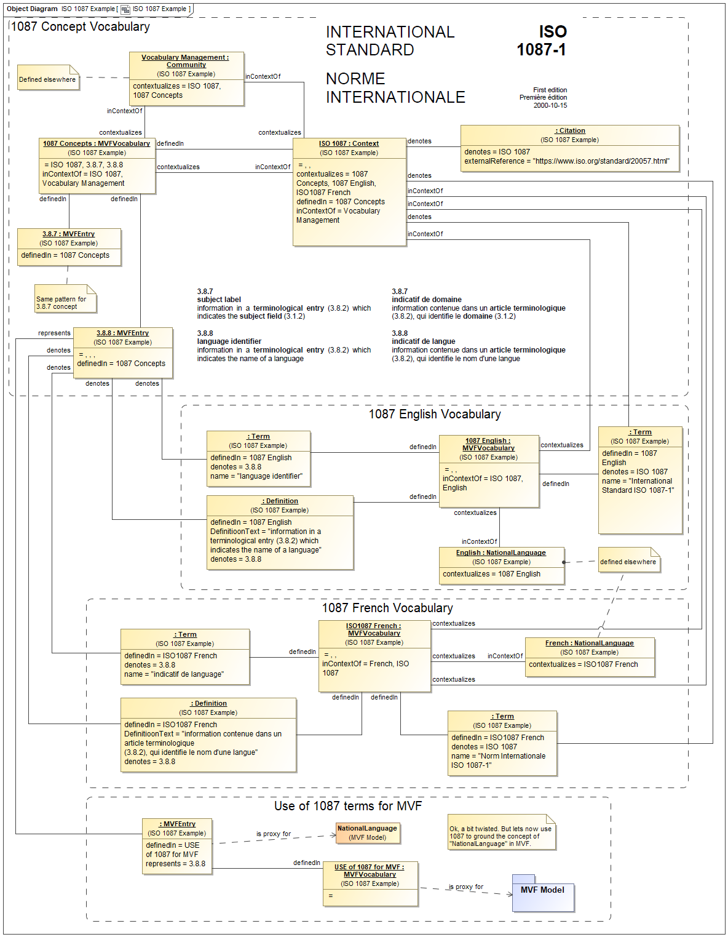

# STIX/NIEM Example

This example assumes that UML representations of both “STIX” and “NIEM” were independently imported into MVF. It then asserts that a German term for “PersonNameText” in NIEM is “individueller name”. I business “legal community” vocabulary is then defined with both English and German terms for the legal names of persons with a cooresponding MVFEntry. “represents” relationships are created from both the NIEM and STIX entries to the term from the legal community.

