1.0 Introduction
return to Top of White Paper
“Today’s successful organizations understand the power from developing knowledge services to achieve organizational goals.” We have all heard the term “knowledge is power.” Today, knowledge is business—“big business.” Organizations have learned it is not only what they produce that makes them successful. It is also the knowledge of how they improve products and services, and the use of that knowledge to further benefit from continuous improvement that sets them apart from their competition. Amazon started as a homebased online bookseller in 1994, competing against Borders, and Barnes and Noble. By 2011, the company had expanded into selling music, clothes and Web services, to name a few. Borders had filed for bankruptcy and Barnes and Noble was just holding steady. By 2018, Amazon “[accounted] for nearly half of [all] online retail sales.”1) So what set Amazon apart from its completion?
Amazon has always been good at using its knowledge from continual process improvement (CPI) as a business asset.2) In 2003, Amazon launched its first knowledge service, based on the online retail platform it had been developing and perfecting since opening in 1994. Amazon effectively took a byproduct of service delivery (knowledge of perfected business practices), created a technology platform to support its practices, used the platform internally to gain a competitive advantage, and then opened the platform to the public as a service in 2006. Amazon Web Services is now “one of the company’s biggest revenue drivers.”3) Amazon’s development pattern is consistent with the stages of knowledge service development (See Figure ) to refine its data, information and knowledge into valuable digital services that first generate internal efficiencies, and then are opened up to the public to generate revenue.
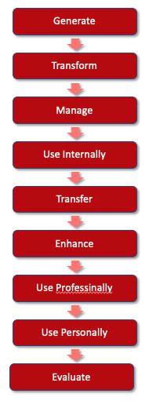
Stages of Knowledge Service Development.

1) DePillis, Lydia, and Ivory Sherman. Amazon's Extraordinary 25-Year Evolution. CNN. Cable News Network, July 5, 2019. https://www.cnn.com/interactive/2018/10/business/amazon-history-timeline/index.html
2) Marc Onetto. When Toyota Met e-Commerce: Lean at Amazon.. McKinsey & Company. Accessed January 24, 2019. https://www.mckinsey.com/businessfunctions/operations/our-insights/when-toyota-met-e-commerce-lean-at-amazon
3) Michael E. D. Koenig. What Is KM? Knowledge Management Explained. KMWorld, January 15, 2018. http://www.kmworld.com/Articles/Editorial/What-Is/What-is-KM-Knowledge-Management-Explained-122649.aspx

