VCOI Call Notes
19 October 2020

Attendees
- Bobbin
- Claude
- Cory
- Frederic
- Rob
- Mike

Agenda
- Wiki / topics
- Continue from last week:
  - Languages / file formats
  - Technologies
  - Re-use of reusable external concept sources

Meeting Notes

Recap
Recall we want to have a progression of kinds of resource on the LHS.
- Diagram update not ye done for this
Recall that we wanted to figure out what goes in the box ‘Vocabulary Resource’
- In terms of what kind of thing we are defining (a language, a toolset, something else?)
- In terms of whether this can be a vocabulary or an ontology, and if ontology, a conceptual ontology or some other style
From last week:
- Liked the idea of a solid reference / conceptual ontology here at first
  - But in any case the TF-owned ‘Local Ontology’ no the LHS is already to be one of these (to rules yet to be determined by this WG)
- However this has maintenance overheads x2:
  - Logistical maintenance – someone has to maintain it
  - Intellectual maintenance: someone has to know (and agree!) how to maintain it – what kind of thing it has to be
The maintenance would also include how to reconcile external concepts in (a) different styles of ontology (FIBO, pure operational, highly contextual (e.g. GoodRelations), and Conceptual; and (b) for those that are conceptual there will be a TLO but these may not all be the same or aligned. It is a major research project (AKA philosophically impossible) to guarantee to always be able to reconcile these, and a lot of work to do so for those cases where it could be done
And in any case, this particular box has to simply have what’s needed to derive the 3 kinds of ‘content’ described as output (regardless of format at this point) i.e.
- Term/Definition (vocabulary) resource;
- Acronyms / initialisms / symbols resource;
- References (laws, documents etc.) resource
So a SKOS-like vocabulary can originate that stuff.
With all that in mind…

Comments?
Middle box is probably not one thing – probably modular connected resources.

Reasons:
- Given that the things on the LHS are various, would need something modular on that.
- We have different things we can do with SKOS versus MVF.

For example:
MVF opens up a new kind of output (that wasn’t asked for but is possible) – the annotation of models.
MVF also segregates the Word from the Concept.

Follow-up Comments
That thing there (Vocabulary Resource)
- Needs to be rich enough to reflect all the material gathered by the TF/SIG
- Needs to be rich enough to generate the 3 things we have promised
  - Plus the 4th thing from MVF – model annotations
- Needs to be simple enough to have one unifying format
Then:
TF maintains its own Reference Ontology
- Generate diagrams from etc.
Could use SKOS to provide taxonomy hierarchy views (enough for SMEs anyway – no Restrictions and other blank nodes); and can generate the required outputs
- Would need to figure out a way across to MVF from SKOS (or vv).

Revisit the Output Formats
We say we want 2 styles of output:
- Table (Term / Definition / Synonym) per our XLS prototype
- Single page wiki page (the Stavros Approach)

Question:
For the Single page format:
- What does the page represent?
  - A word (or acronym etc.)
  - A Concept
Continued below after this intermission…

Aside: Considering Toolsets
Other things to consider: Metadata systems like Collibra
Collibra does a good job of presenting vocabulary to a business audience.
CC has only seen Collibra used for metadata e.g. data lineage, key data elements.
Tend to support lots of terms with minimal interconnection.
Vocabulary is basically a list of terms with definitions with the ability to bucket them into categories.
Collibra does not ingest SKOS or anything else as far as we are aware. Is aimed at data stovepipe problems.
Supports the separate use case of integration of a vocabulary with other tools at that level (e.g. IBM BDW etc. and metadata thing).

Other Resources
You have
- Collibra
  - A technology
  - NOT a content resource
- Wordnet is
  - a technology – has a file format and tools)
  - a content resource it has a list of words and definitions
  - An interface:
    - http://wordnetweb.princeton.edu/perl/webwn
- Wikidata / wiki family of stuff
  - Relates to DBPedia
    - More of an ontology
  - Has a technology
  - Has resource (content) (Q types and Z types)
For our ‘thing’ (the box in the diagram), we are talking about Tooling and Format.

Split our question (of that middle box) into two
- File formats
- Tooling
To support
- The content itself.
Obviously as OMG we want to specify standards FFs wherever we can.
Some of the LHS external resources would be expressed in GIST, WikiData etc.
We need to split the box into 3 things not 2.
Thing 1: The file format
This has a metamodel
May have multiple file formats per logical model (as does RDF)
Thing 2: the Tooling to manipulate things in the file format.
Thing 3: the content (words, definitions, etc.) maintained somewhere by someone

Then our list becomes:
- Collibra
  - On (1) A technology
  - On (2) No visible file format
  - On (3) NOT a content resource
- Wordnet is
  - On (1) a technology – has tools
  - On (2) has a file format
  - On (3) a content resource: it has a list of words and definitions
  - An interface:
    - http://wordnetweb.princeton.edu/perl/webwn
- Wikidata / wiki family of stuff
  - Relates to DBPedia
    - Which is more of an ontology
  - On (1) A technology
  - On (2) has some internal format? Or maybe RDF
  - On (3) Has resource (content) (Q types and Z types)
- Tools (on (2) specifically
  - TopQuadrant (with data governance and vocabulary management
    - See https://www.topquadrant.com/products/topbraid-enterprise-data-governance/
- On content (on (3) specifically
  - Semantic Arts (GIST UO + Tooling)
- Schema.org
  - On (1) – no real technology
  - On (2) – does have a file format
  - On (3) – does have published content
These are all things a TF or SIG may choose to use as 3rd party resources
Some will have more of a story on context than others.

File Formats
See list for SKOS:
https://en.wikipedia.org/wiki/Simple_Knowledge_Organization_System#Tools

Unilexicon
See also Unilexicon (1st in the above list)
- Visual taxonomy editor but imports, export in JSON, SKOS and Excel and does tree viz
- So all the things we need for a TF
- Also pre-populated with licensed vocabularies
  - Available and licensed under a suitable CC license
Also provides a ‘Hyperbolic Tree’
https://en.wikipedia.org/wiki/Hyperbolic_tree
And also:
https://unilexicon.com/vocabularies/beverages/
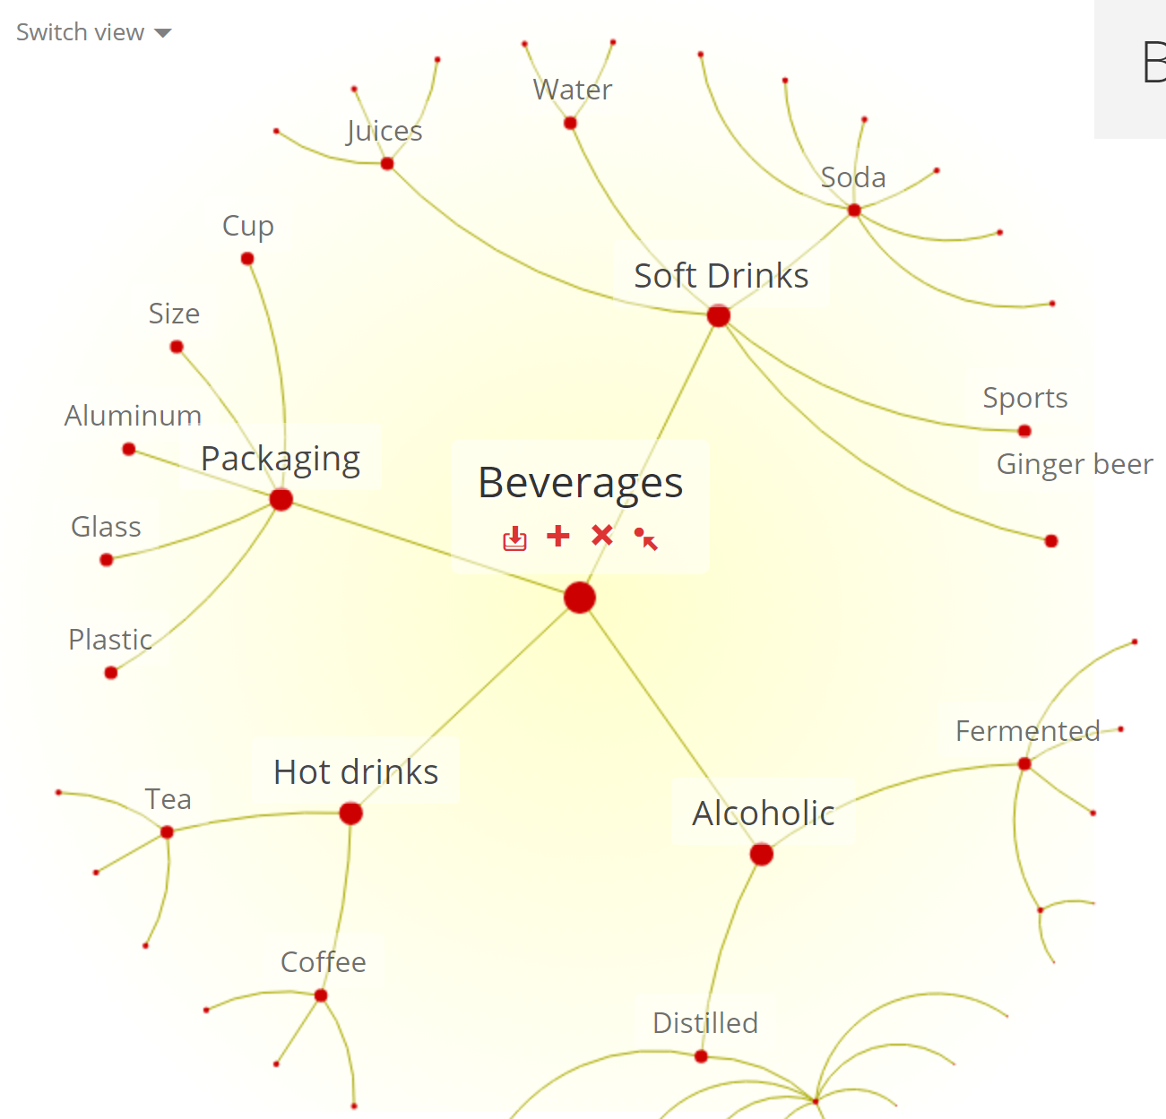

And Tree View:
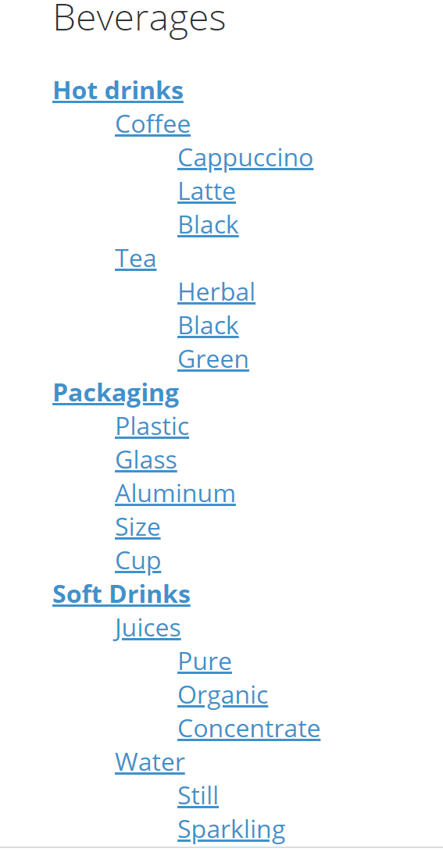

Aside: See also CCM Vocabulary
Prompted by the above: Look at CCM alphabetic Vocabulary report output.
As a Vocabulary report that reflects the logic with the generated definitions.

/Aside

Back to Unilexicon
The viz lets you see 2 levels at a time and click from one to another – just as we’ve always needed but didn’t know what it would look like.
- Is it free? = probably not
- Is it affordable (can we get a ‘standards’ license for free or cheap)
- Is it standard – yes, uses SKOS
- Is it open source? Yes
It seems you can sign in and play with the taxonomies they have provided there.
Also has some specialized stuff e. g. in medicine and medical devices. Based on existing (in this case the UK’s NHS dictionary); converted to a data stored in Unilexicon and therefore (presumably) available as SKOS.

For Another Time: Naming and Definition Rules
Looking at the example stuff on drinks, and likely also in the NHS work – we have terms, definitions etc., in non standards ways, e.g. Juices, Software Drinks use plural while others use singular
- We can expect this from 3rd party resources
- To the TF has to at least adapt these into some kind of consistency
We need to revisit this.
Look at ANSI Z39.19 for guidelines for reuse of plurals and singulars. Also check the usual ISO 1087, 307 etc. or whatever on that.
Definitions is for another time (one of our 5 streams)
May also have separate kinds of definition
- Normal human
- ISO-style (replaceable)
- Autogenerated reflection of the logic
May even have all 3.

Outcomes
So we want to use SKOS but also MVF (for model support and distinction between Concept and Word). Tools can be at the discretion of the TF.

Proposals:
Proposal: The Physical representation will be some RDF format
- All agree
Proposal: The central resource owned by the TF is in SKOS (expressed as RDF)
- Is it too soon to say that yet? Yes
- Working assumption for now
- Need to think about how it relates to MVF
  - i.e. is MVF to the left or the right of it or somewhere else?
  - MVF publishes an RDF vocabulary
May even see another pure RDF or RDF(S) to the left of that??? To be figured out

Why we Mentioned Collibra
An important use of this methodology we are developing is to integrate with existing data management tools like Collibra.

Use Cases redux (we now have 3)
- The original client brief: Terms and Definitions (plus acronyms and stuff)
- The ability to annotate models with references to terms OR concepts or both (MVF)
- The ability to integrate with existing tools
  - This is more of a client use case than a use case for this TF’s Methodology which to deliver something OMG TFs and SIGs for them to define stuff;
  - A TF might also use these;
  - When a TF does this, then some enterprise with the relevant tool can simply import the work of the OMG TF

The Diagram
Which of these is that diagram showing? It’s a bit vague at present.
i.e. Collibra (tool) versus SKOS (format)
What it is: is that from which the required Output Formats are to be extracted.
- The Terms / Definition / Synonym; the Acronym / Reference etc.
Also we talked about the MVF.
Before we answer this question we need to return to…

Question:
For the Single page format:
- What does the page represent?
  - A word (or acronym etc.)
  - A Concept
Nick has page per word so that was the default assumption.
We want a definition per Concept, so we can link the Word W to the concept C (from the TFs curated Concept Library) in Context X (the context of the TF).
Proposal: Both
What does ‘both’ look like?
Would work like synsets in WordNet.
Synsets is the set of words that all mean the same thing (a lot like a Concept).

Next Meeting
MB will run next week’s call
Then turn around Cory / Mike alternating so we can focus on different areas.
Request: Can we move these- overlaps with a Cloud meeting from 4 – 5.
To discuss next time. Next week will be 4:30pm ET as usual.

