VCoI Call Notes
19 July 2021

Attendees
- Mike
- Rob
- Claude

Agenda
Dig into the Context Ontology from the PoV of organizational structures, responsibilities, lines of business etc.

Meeting Notes

Aperitif
Why / What – the Ws. Cognate to Qu- in Latin languages; Hwaet in (very) old English (Beowulf)
Homonyms / homophones (that change over time e.g. Qu/Hw- to wh- to w-)
This was an aperitif with which to whet (and wet) our appetites.

Wiki Actions Review
- New heading numbers
- Split between Components (the to-be spec) and work-in-progress
- Started to create pages for WiP
  - Annotations Wishlist
From today we should add to that a page with our workings to date on the Context Ontology and relations to BM, org structure, services, lines of business, responsibilities, etc. And Process.

Comments / Reactions on the Wiki
(not had time to review these changes off line yet)
Good that it is coming along, as a resource people can consult and can give feedback on.
Better than shared documents. Provides a persistent output state from any ongoing work in eg. shared documents (Google Docs), meeting notes etc. In other work it's also been seen that a wiki is a better way to share knowledge and invite comments.
Google Docs is OK for prototyping a document, to share among a smaller group, but once you publish to a wider audience, issues around access, feedback, processing of comments etc. can become problematic (lack of control) whereas a wiki page is better for this. Also Wikipedia gives reviewers a good familiarity with that form of information sharing.
Also easier to create links between things than in a set of Google Docs.
In Google Docs there is no sense of location but also no dependence on the location or title of the file.
(a bit like Barry Smith's ontology element labels)
Whereas in a wiki changing a page title does invalidate references, the Google docs does not.

Context Ontology
Dig into the Context Ontology from the PoV of
- organizational structures
- responsibilities
- lines of business etc.
- Also BMM etc.?
These provide a large part of the conceptual notions we need in the Foundational Ontology for our Context Ontology.

BMM
CB has been working on BMM recently on another activity stream.
Making people think of these notions enable all sorts of distinctions to come out
e.g.
- Goal v Objective.
- Policy v Strategy?
Useful for business architects.
Clarify 'Business Architect': architecting the business, not BA for IT solutions.
e.g. one client:
- needs process improvements.
  - For that they need Capability Map
  - For that they need Value Stream Analysis etc.
So that they get a complete map of the concepts in order to fix things
Another client:
Roadmap creation – needed to understand their BMM today and in 3 years i.e. what is the vision under which they operate now so we can identify how it may need to change in 3 years.
Same for each component of BMM.
Can present BMM as diagrams or as tables e.g. a column for now and for 2024.

BMM Concepts
Concepts include
- Objectives
- Strategies
- Influencers
- Etc.
Can use as a roadmap for digital transformation in the firm.
Also find out how well they have understood thee things today.
e.g. the perceived meaning of each of the concepts may be meaningful but the meanings may not be shared among people.

Business Concepts Requirements
Need:
- A good description of the concepts (and their distinctions) (written)
- A better ontological representation of those things
e.g.
'What is the difference between a Goal and an Objective?'
- easy to describe but may have differing understanding by stakeholders.
Easier: Strategy v Tactic – because examples are more clear from military (battle v war)
Main BMM Diagram: has horizontal lines between means and ends. Between the main boxes but not between the ones people wanted to able to disambiguate e.g. Strategy and Tactic .
So you can't interrogate the BMM main diagram to find out all the relationships between these things, as you would see in a concept ontology for these concepts.
Question: was that deliberate?
e.g. Strategy – in fund management is the % holdings of specific kinds of security.
Generally, words that are used interchangeably in Human but need disambiguating ad have specific labels er concept in BMM, in our FO and so on.
Includes:
- Business Policy v Business Rule
- Goal v Objective
- Strategy v Policy
- Strategy v Tactic

Rules
People may mix and match Policy and Rule.
Orthogonal? To that: IT may define 'Rule' or 'Business Rule'
Business Rule – whether the predicates it acts upon are data objects or business objects.
Also whether 'Rule' is generative or Descriptive.
e.g. 'Data Quality Rules', 'Data format rules'
and more complex ones:
- Rule 1: Such a thing may not exist
- Rule 2: if Such a Thing turns up, do this about it
e.g.
Rule1: 'ZIP Code has … digits' (a Data Formatting Rule)
Rule2: If ZIP Code starts with '100' and City='null', replace City with 'New York City'

Formatting Rules v Procedural Rules
(2 different things in math; a third is Predicates)
Eg. = in Mathematics: does it say they are 'equal' versus 'let's assign this vaue to that variable'
(often == in recent languages I think)
Distinction is between stating (asserting) versus stipulating (specifying)
So
Then in Fortran the actual equals is .=. instead of =
Others use := for assignment and = for equality tests
C: = versus ==
This distinction is the same as the 2 meanings of the term 'Rule'
This is separate from other distinctions e.g. whether the predicates are data or things – that's orthogonal.
That is:
- I say that… (with associated levels of confidence e.g. in data quality, lineage)
  - See Pedigree and Provenance notation at OMG
  - BPMN – was this a model of how you state the object should be derived, or a log of how it was in a specific instance produced?
  - See also UML Activity models – issues around instance v schema
  - Wine making – rules or provenance: where this individual bottle came from
- Make it so

Kinds of Rule
These are:
- Prescriptive
- Descriptive
The 3 things we derived in earlier (Semantic Shed) work – via Bill McCarthy:
- Plan: Make 100 bicycles
- Specification: first take 200 wheels
- History (log): we used 201 wheels and made 100 bicycles and one circular piece of scrap

Look at BMM first:
This:
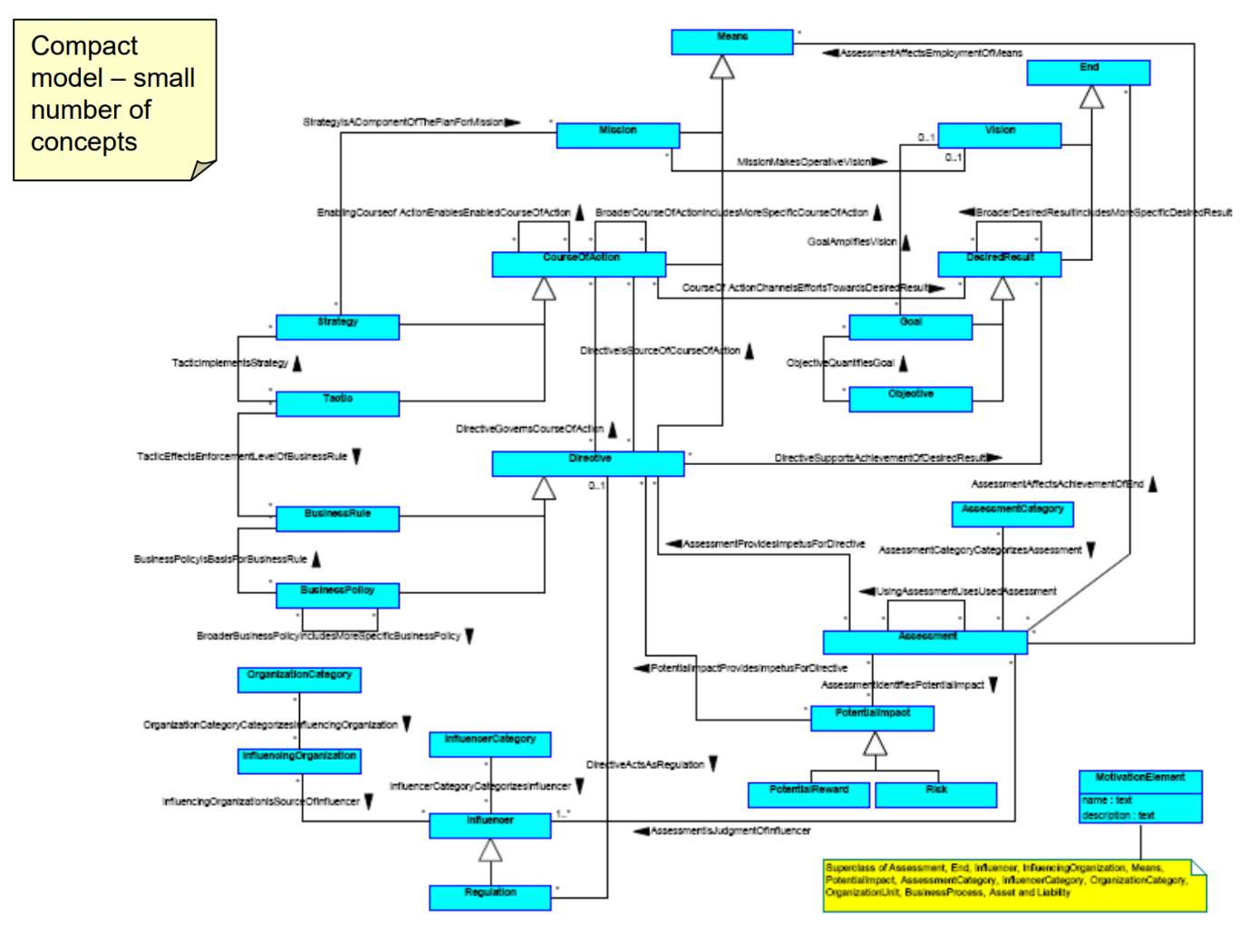
Figure 1: BMM UML Diagram
Is really a UMLization of the BMM model diagram itself.
Reference: here is that:
https://www.researchgate.net/profile/Knut-Hinkelmann/publication/286592121/figure/fig3/AS:669044025864196@1536523934230/BMM-IT-Extending-the-OMG-Business-Motivation-Model-from-23.png

Compare with: (Fig 2)
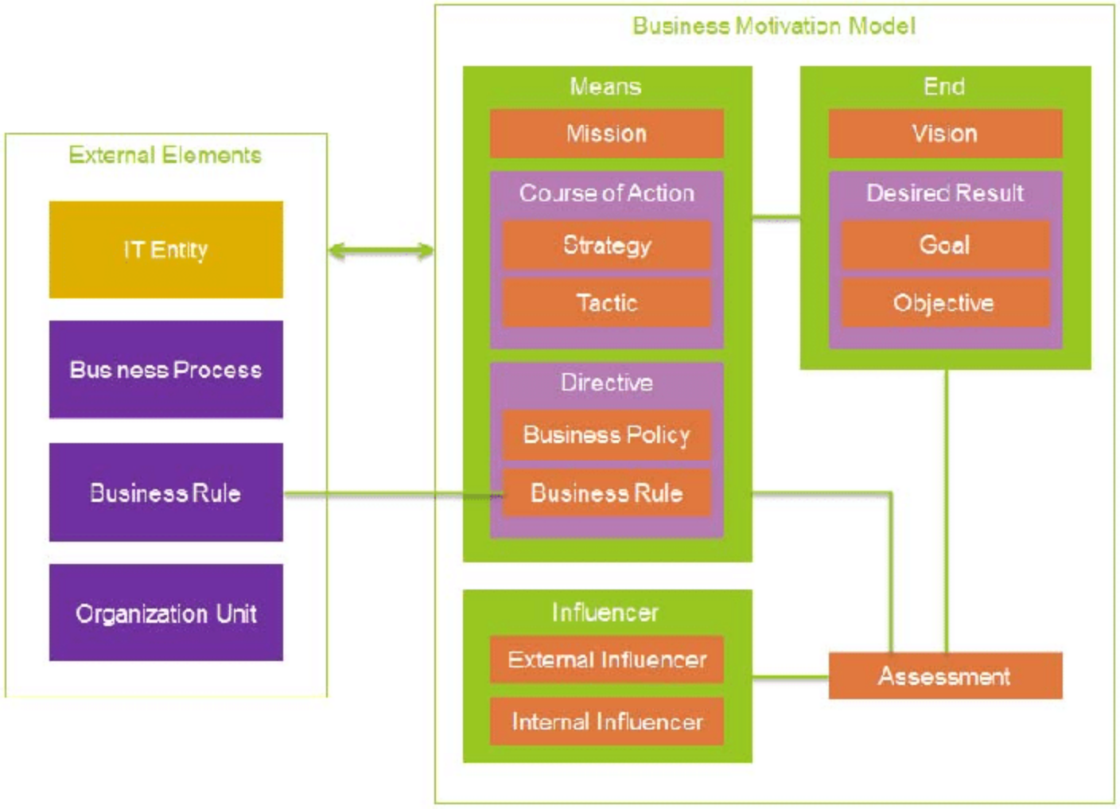
Fig 2: BMM Diagram (in BMM Specification
Then:

BMM Relationships
See green line between End and Means
Does not specify the finer relationships between the things in the boxes.
Options:
- May all be 'is a way to achieve' (restriction)
- May need sub properties for specific, named connections as sub properties of those.
Transforming these into UML diagrams causes labeling of the verbal phrases.
Diagram above: simplicity is appealing to business managers.
CB has a version in Excel for business domain interaction. Can put text in boxes and have them expand when you do.
Proposal: We take the original BMM and ontologize it, in an analogous way to how someone UML-ized it before.
For next time: MB to have a go at doing the ontology; identifying are what the desired FO concepts to support those.

BMM Resources
https://www.omgwiki.org/soagov/lib/exe/fetch.php?media=bmm_overview_pv_.pdf

Wikipedia:
https://en.wikipedia.org/wiki/Business_Motivation_Model

OMG PDF File Page
https://www.omg.org/spec/BMM/1.3/PDF
There is a BMM 1.4 being prepared now (in RTF). We don't know the scope right now. Might be processing open Jiras or there may be new scope being considered.

Claude's cleaner diagram
https://www.researchgate.net/profile/Knut-Hinkelmann/publication/286592121/figure/fig3/AS:669044025864196@1536523934230/BMM-IT-Extending-the-OMG-Business-Motivation-Model-from-23.png

Next Call
July 26th.
Agenda as above.
[Update: we actually covered SKOS at the 26 July call; above agenda still to be covered]

