VCoI Call Notes
01 Feb 2021

Attendees
- Cory Casanave
- Stephen Powley
- Rob Nehmer
- Mike Bennett
- Bobbin Teegarden
- Claude Baudoin

Agenda
Crack on…
- Focus on deliverables

Meeting Notes

Things to pick up
Using the vocabulary in one of the Blockchain docs (RFP or RFI) as a test case for this methodology and deliverables.
We are working on another RFI in the BC-PSIG so it gives an opportunity to have some activity on concrete deliverables for this group.
Use this to focus our conversation.

Deliverables
The ‘End Deliverables’ are a good place to work back from. One of those is the OMG template / document insert for:
- Terms and Definitions
- Symbols and Abbreviations
- References
See original list from GovDTF – we have a number of things that were references – but these also had abbreviations (or even partial abbreviations like the GREAT Act)
So any table of abbreviations would have cross reference both to TERMS and to REFERENCES.
Note that in some sources, the Terms and Definitions table might include acronyms as the entry for a term. If we have a separate table of acronyms then we would want the long-form name of the term in the Terms and Definitions section.
Taxonomically, an abbreviation is a kind of synonym
- But it’s worth distinguishing as a specific kind of synonym.
- See e.g. RDF stores
  - Rdfs:label
    - Sub-thing of rdfs:label e.g. ‘abbreviation’ as a sub-type of that
    - See what the FIBO AV stuff does
Abbreviations may convey different (contextual) meaning to a full usage, particularly in speech. The act of spelling out the abbreviation carries some meaning (really, it conveys a usage context)

Naming and Definition Rules

Term Names

Casing
Proper nouns are always upper case.
In normal human usage, we use lower case for both nouns and verbs (in English; German uses capital case for nouns).
Also some terms evolve, e.g.:
- The Internet
- An internet
  - Actually an ‘intranet’
  - (disambiguation – we are using the ‘internet’ word here to range over both concepts)
Wikipedia reflects the above usage (from an IBM report quoted in wikipedia):
"The words internetwork and internet is [sic] simply a contraction of the phrase interconnected network. However, when written with a capital "I," the Internet refers to the worldwide set of interconnected networks. Hence, the Internet is an internet, but the reverse does not apply."
Evolution: we would tend to use lowercase ‘internet’ in any case, as usage becomes more common. This happens with a lot of words.
Etymological comment: vocabularies built on whatever we produce would provide evolutionary information on that.

Definitions
These separately have a casing convention choice:
- The ISO approach: definition is intended to be substitutable in a sentence
- The human approach: users like to see leading capital and ending period (full stop)
Is it the case that individual terms also have the same casing question? Trivially yes – words are only capitalized if they are a proper noun (in English).

Model Maintenance considerations

Metadata
There is standard metadata:
- RDF / RDFS
- SKOS
- DC
Local variants:
- OMG AB Specification Metadata
- FIBO Annotation Vocabulary (AV)
  - Term Origin, definition origin etc.

Origin of that Origin stuff
MB standardized the way I wrote notes in the single UML Notes field in the original Sparx EA UML model for FIBO:
- First part: definition
- ‘Further Notes’ became av:explanatoryNote and / or skos:editorialNote
- Term and definition origin / adapted from
These became the FIBO AV elements
Were each an ‘annotation property’ in OWL.
Where possible we extended existing standards (RDF, SKOS and DC) to create these.
So a sub-property of SKOS:Note would be AV:explanatoryNote
SKOS had a few we could use e.g.
- editorialNote (which itself extends SKOS:note)
- scopeNote (ditto)
In RDF we had
rdfs:label
We needed synonym
We then needed to distinguish kinds of synonym:
- abbreviation

Standardized Usage of Metadata Standards
So to the issue:
- We have standards for metadata
- We DON’T have a standard way of using that metadata
e.g.
- explanatory note – we defined our own, do others have one we weren’t aware of?
- definition origin – we should have been able to use something from Prov-O
There is not a standard for how to use the standards for the metadata.

Other ways this is done
See WordNet
There is a multilingual version of wordnet
There is a separate verbnet, since wordnet did not have verbs.
See also last week’s’ notes on Wikipedia (in terms of how context was used – and the metadata elements for that). The Wikipedia ‘categories’ meta-tag that themselves reflected a concept taxonomy.
So the question of standardization of metadata applies to:
- Terms
  - Things about terms
    - E.g. Term Origin
- Definitions
  - Things about definitions
- Contexts
  - Things about context
- References
  - Well known
There doesn’t seem to be a home for this?
How the OMG uses metadata – converging in on the FIBO + AV +/- any variations on that.
(We weren’t able to use Prov-O in FIBO and some other OMG things, for Reasons)
We would like to use Prov-O? Or annotation properties derived from those.

Maybe:
Prov-O has the classes and properties
(something else) has the OWL Annotation Properties
THEN you can use the relations in Prov-O to back up the meaning of the metadata annotations in annotationProperties - e.g. adaptedFrom, adoptedFrom.
Perhaps we should set out a wish list first, on the annotations we need, then figure out what to use and standardize on that.

Wishlist
adaptedFrom, adoptedFrom
We need both. FIBO AV has only adaptedFrom (meaning: we changed the definition in some way from the root definition)
adaptedFrom: if the source body changes the definition, do we need to update our adaptation?
adoptedFrom: what standard is that in? Seen it in the IIC Vocabulary. So it does exist in some standard.

The ICC Vocabulary
- What lessons are there from there?
- What standards do they use for metadata?
- From which standard does this originate?
Action: Look at IIC Vocabulary

ISO
Uses ‘source:’ for the origin.
So there are several places with the same semantics but with different origins for the metadata.
ISO also uses concept diagrams in appendices, showing richer relationships between the concepts (or the terms) and references to what sections these are in.

ISO Example
Example exists in: ISO 56000 Appendix A.
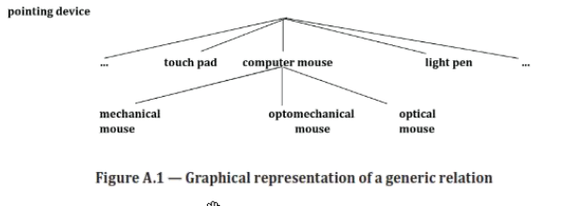
And
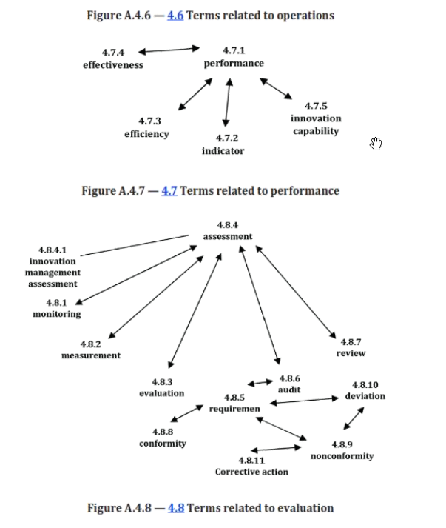

References

Parenthetical references in definitions.
If you move things to a table that cites sources, its not clear if a parenthetical matter is from the same source or not. Need to support that.
Treat hyperlinked reference as a special type of parenthetical reference.

The Work
- The wishlist – what annotations do we need?
- The standards to use as the origin of each of these
And on (2) whether there’s some further extension.
Can we standardize that across the OMG (Elisa’s work)
- How far along is that work?
- Whether we can help with it?
Action: Provide our wishlist.

Sources
- ISO
  - Also another ISO INCOSE led initiative
  - Which would likely impact SysML
- IEC
- Also IIC
- SKOS
- Dublin Core
- OMG
  - AB Specification Metadata
  - FIBO Annotation Vocabulary
    - And adaptations of this in other OMG ontologies?

Idea:
Use the concept map idea from the ISO 56000

For our Deliverable:
We will work on the upcoming OMG BC-PSIG RFI for Smart Contracts, as a running example of what guidance and deliverables we can aim to provide to SIGs and TFs.
Look at existing Blockchain PSIG RFP/RFI documents:

Terms and Definitions
Deliverable has 3 columns
BUT
You don’t really want to just blat something into those columns without retaining some record of where you got it from. When I created the Terms and Definitions sections for the most recent Blockchain PSIG document, I had to retain that information somewhere else so we did not lose it. That’s the information we want OMG document creators to be able to retain and maintain.
As a minimum:
- Term origin
  - Place
  - The name of the term at that place (casing etc.) as this may differ
- Definition origin
- Definition adapted from
- Possible others
  - If we go with Elisa’s thing where the definition has to NOT have a leading capital and trailing period
  - And if the origin had normal human stuff
  - IS IT ‘adaptedFrom’ or the same definition if we have merely changed the casing / period convention?
  - If not, would need a refinement of adaptedFrom to accommodate these
- adaptedFrom refinements
  - may merit other refinements of that as well.
  - We could even adapt the SKOS broader and narrower notions, for broader and narrower adaptedFrom

Examples:
A word like Stakeholder may be framed more broadly in one source than another e.g. might be limited to an entity
Then narrower refers to the fact that that is actually a narrower concept.
i.e. adapted narrower: term for this (broad) concepts is borrowed (and adapted) from a term in XYZ source for that narrower concept (or vv).

Outcomes
We will work with the next BC-PSIG RFI (Smart Contracts)
We will complete an example of each of the 3 tables
In doing that we will capture additional stuff we don’t want to lose
In doing that we will identify what metadata we need, to record those things.
Do as:
- Wishlist (the meanings of the annotation that we need)
  - Own local names
- What standards have that annotation as a concept
- Which ones are strongest
- Maybe combine some
- Maybe have an ontology for the concepts
  - Class hierarchy where each class is reflected by some Annotation Property
  - Then converge on a solution.
- Multilingual stuff has a meta-standard on how you populate the field
  - {fr} or {en-us}
  - This convention may be applicable within one or more of the existing metadata elements we are dealing with (or to all of them??)

Proposal for our Plan:
- Start with the above and work through it.
- Expect everything else to drop out from that
  - e.g. whether the maintenance thing is SKOS or OWL or MVP
  - or MVP generated from OWL
  - or something else.
Rather than think about the specific implementation up front, we work through it using that example.

For next time:
BT: Could you use a 'contextual ontology' as a metaphor...?
There was just a talk in Semantic Arts Data-Centric Forum by Dave Pool which addressed this...
https://www.semanticarts.com/fractal-data-modeling

AoB
MVF RFP not publicly available since this is still an RFP.
So we need to dig that out some time.

