VCoI Call Notes
19 April 2021

Attendees
- Mike Bennett
- Rob Nehmer
- Claude Baudoin
- Bobbin Teegarden

Agenda
- Process
  - Based on IIC
  - How ours differs

Meeting Notes

Process

IIC Vocabulary Task Group Process
Last week we looked at the IIC Vocabulary Task Group’s process.
This week we should be able to adapt this e.g. for definitions belonging to a Concept
CB has a diagram of this:
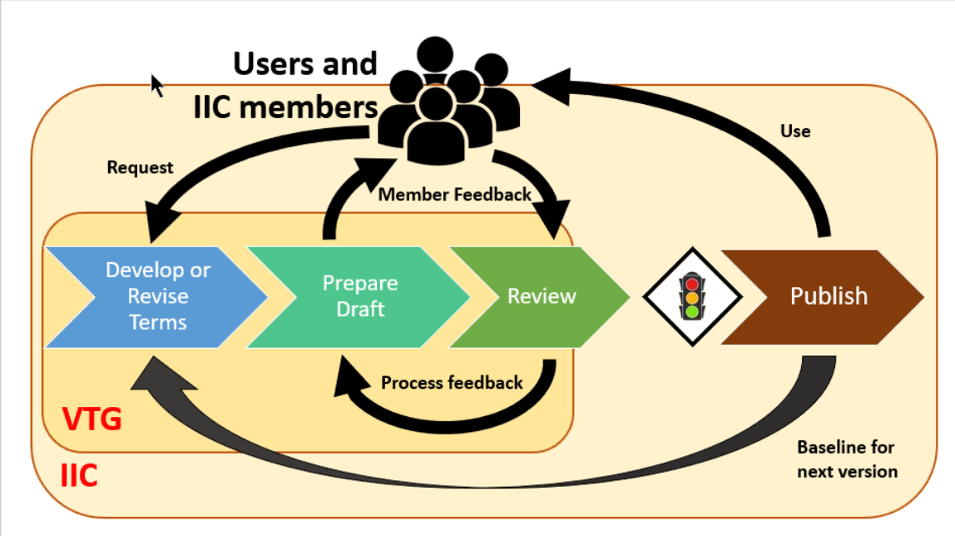

Member feedback loop
- Every 2 weeks
- 4 – 5 active members
- Results in a proposed update (traffic light)
- CTO signs off on this
  - Reports to Marketing WG
That clump of people straddles the internal and external (public)

Criteria
– when do we add a term or not
e.g. to include a term it has to have a unique meaning for IIC people. Distinct from regular dictionary or Wikipedia.
e.g. ‘Gateway’ has a specific IIC usage.
Edge case: e.g. Cloud. Resisted defining that. IIC does not have a different usage.

Definitions Requirements
Definitions substitutable for a term in a sentence that uses it. Cut and paste idea.
So:
No leading capital no period
Also has to be same part of speech.
So no ‘pertains to’ etc. or ‘That is’. Can say ‘capable of’ as that can be substituted.
Have codified those rules.
Explicit reference to ISO 1087? (these rules appear to reflect that directly)
No. Will raise as a suggestion in the VWG.
Have someone from NIST. Injects standards knowledge – may have been responsible for the ISO 1087 usage.

Distinction between IIC and OMG VcoI:
At IIC the vocab is centralized. Global vocab for everyone.
At OMG VCoI assumption is to create more rules and process so other groups can contribute or define their vocabularies. Domain specific vocabularies, federated in some way.
Only the rules and process are centralized, with recommendations. Not going to control the terms people put in.
‘Process feedback’ is the group processing the feedback from the reviews. e.g. if a term comes from a given contribution group (e.g. distributed computing) we present them the definition as we see it. Also find if other groups in IIC also need to give feedback. E.g. a communication WG – want to rename e.g. Connectivity as a term, then the Connectivity WG also needs to review that term.
Also how much the term is being used, whether docs contain footnotes or proposed definitions, and whether these are different. Would not expect to ask a group to re-publish a document but would encourage them to change the definition next time they publish the document. So that when they get to the traffic light gateway there are no surprises.
So ‘Process feedback’ may include a WG chair mailing someone for feedback on a given term proposal.
Updated on the slide, to ‘VTG Processes feedback’

Comments
RN: Given we are dealing with generic process for groups, this could be part of a recommended governance structure, fine tuned according to who their public is and who their gatekeepers are.
Rather than totally take it over.
We may use the same kind of graphic informal model to set out our proposed process. Define it to be more federated:
- VCoI updates its own guidelines
- Feeds these to other groups (not their vocabulary but standards for capturing those)
- Then SIG, TF etc. SubGroup takes that as an input along with their domain knowledge to produce their own specific vocabulary in an interactive manner
- Then the multiple specific TF/SIG gets federated
  - Identify conflicts or overlaps
  - ?...
We have not explicitly said that is part of this project.
No definition is wrong they are just contextual.
What would be a conflict? If the Context is too broad in one or the other.

Process Considerations

Things to capture
- There is a process of governance in developing the vocabulary
  - Not previously discussed
- Make recommendations e.g. other TF considers a proposed definition

Differences in VCoI from IIC:
- Definition belongs to a Concept not a Word
- Word usage is Contextual (pinned to a Context)
The contexts in (2) are:
- Origin context
- Usage context
Need careful management of different definitions (for concepts) in different TFs e.g. Gov, Blockchain PSIG, FDTF.

Process challenge:
What if say:
- BC-PSIG authoritatively defines X
- Other TFs use X
- BC-PSIG identifies a needed change to X
- How does that impact the existing users?
  - Cf IIC process on that
- E.g. point to this standard on this date.
Another thing that might a happen is that there may be a standard (RFP or an RFI even) that defines a word and concept in a specific way – that gives more authority to that definition.
= and later for actual Specifications (standards)
e.g. I want to use the definition of Metamodel in the MOF spec.
The same thing we might say for an OMG spec, might also be said for someone else’s spec or document, i.e.:
- ISO
- IEEE
- W3C
As well as e.g. Federal Register and other authoritative sources

Process requirement:
- Identify issues
- The group may need to determine, if you are pointing to external definitions, how you propose to govern changes to those
On this:
Need an ‘As of’ statement (metadata) for any definition adopted from some external (or other OMG?) source. So you point to the source, identify a clone and the cloning date
- Same for ontologies: when to reuse versus when to snapshot
  - see also FIBO FND first version Annex C
See e.g. in a document Reference, you always put the document and the year. For example ISO uses the year number as a sufficiently unique year designation as a unique key e.g. ISO 2001:2000 versus ISO 2001:2022
Then you know that you are not making claims of something existing in a future version.
Consensus: this is cleaner – another signal to a user of the item (document, standard, wiki page) you are saying that the last time we looked at that, this was the reference.
So for URIs e.g. W3C – never use the ‘latest’ URI but use the versioned URI.
i.e. are you referencing a specific year / versus because that is the one you want or because that was the most recent when you looked.
- include in process / guidance.

Aside Suggestion
3 kinds of thing we define that people process / maintain:
- Terms and Definition
- Abbreviations
- References
So:
The rules for References qua references as one of the outputs, are the same as the rules for using references within a Vocabulary Maintenance Thingy, where something is referenced.
That is, the Reference as a formal kind of thing, would be the same referencing we would use in Terms and Definitions if a Term referenced in the Terms section needs to make reference to a source.
Does that work?
There is a question of potential self-referencing
Some maybe would be in the references and some might not?
Eg in articles, any time you mention something in a footnote (being a separate section) also pops into the Reference? Versus something in the text of the article.
So: if I define a term using the references method, would the user expect that also to be in the references? Or is that overkill?
e.g. a reference may be more internal to the TF e.g. to an RFI, or to a Standard or to a law. Rather than to a definition. Might pick up a sentence or two whereas the broad reference is to entire standard versus a specific.
e.g. FIBO references from each term to the ISO FIBIM model
- The reference is to the individual term NOT the overall spec
- The term referenced may not have the same name
  - We are referencing concepts
  - E.g. ‘Share’ may refer to a Concept (Definition) in FIBIM that is ‘EquityV02’
- This was in FIBO metadata as informal text, now rendered as annotation properties
- There was not a definitive URL in those cases, so the reference was (informally) a combination of the name of the referenced standard / document / report (e.g. ‘FIBIM’) plus the name of the term.

/Aside

Action:
- Identify the differences
- Draft a suitable (slide-ware) diagram

The Differences

Concept Centricity
Difference one: the definition belongs to the Concept
So in the process, the groups concerned, is identifying a written definition (a set of words) of the Concept, regardless of the word or words used.
Has some interesting challenges for the ISO 1087 method: the definition must be substitutable for WHATEVER word someone wants to use in a given context, for that concept.
New Rule: Every word that references a given concept (for use in different contexts), MUST be the same part of speech.
Possibility: people might have similar concepts that are different parts of speech.
Process requirement (tentative): how to deal with similar or conceptually overlapping terms usage in different groups where they are different parts of speech
Also granularity issues – definitely
- Do that first
- Then look at the parts of speech idea
Granularity also relates to scoping
- E.g. are you talking about a process or static thing
  - Different conceptualizations
  - Foundational ontology (including TLO e.g. Continuant v occurrent)
- How do you link that to the ontology
Lexical v semantic space question.
- Communicate that to the TF with examples
When looking at word: identify the scope over which the person proposing it, intends it to range.

Difference 2: Context
Also relates to scoping: in what range of contexts is the term usage defined.
Scoping
Top down (MDA) approach
- Start with scope
- Then concept
- Etc.
If I change the scope of a word usage, I am including other concepts from the ontology and even from an upper ontology.
So a response to a group that was having that problem is they are referencing different concepts, and if you want to use a term of phrase, and if you want to reflect the narrower usage.
Context 1 – broad
Context 2 – narrower
You need some level of foundational ontology federated across in order to describe the scoping to even have the discussion.
Where scoping = what is the conceptual space that this lexical item is intended to range over?

IIC Principles
(to adapt):
IIC's four principles for inclusion of a term in the vocabulary:
PRINCIPLES
We adhered to the following principles in this document:
• The definition of a term provides an in-place replacement for that term in a sentence.
• A term whose English dictionary definition is considered sufficient is not included.
• A new definition is created only when that term is not already defined in an existing specification or standard, such as ISO/IEC JTC 1 International Standard, or its definition is not appropriate for use in the industrial internet.
• In selecting appropriate references for existing terms, international standards are preferred over regional or national standards.

Next time:
Take those principle and the IIC process
Identify the divergences and things to add (based on today’s conversation)
Adapt these for our process.

AoB
Next call next week
Agenda as above.

